Individual Project Report

Demonstration Of selected vulnerabilities

the top 10 of owasp

**Emmanuel Ofori Mintah | 18/10/2020**

## ABSTRACT

The project is a demonstration of selected categories of the top 10 Owasp (Open Web Application Security Project) web vulnerabilities of 2017.

Owasp refers to an entity, which promotes to the world, web application security.

The general idea is that, there are 10 issues, ranked in order of commonality that change as time goes by.

A spiral model methodology was adopted to complete the project.

This paper, also cover a section for research and investigation to find proficient methods to locate weaknesses and ways to remove risks.

Demonstrating those vulnerabilities, means breaking into a website.

Two sites were developed, to highlight the differences that they have, in order to educate students on potential risks that could occur, if appropriate defense measures were not correctly used to protect the application.

The report discusses on how to the protected site can be improve.

­

Contents

ABSTRACT 1

acknowledgementS 2

Chapter 1.0: Introduction 5

1.0 Introduction 5

1.2 Background 6

1.3Project Aim 7

1.3.1 Project objectives 7

1.4 Methodology 8

1.4.1 Research and Investigation 9

2.0 Chapter 2: Academic Literature Review 9

2.1 Introduction 9

2.2 VULNERABILITIES 9

2.2.1 Injection 9

2.2.2 Broken Authentication and Session Management 10

2.2.3 Cross Site Scripting 11

2.2.4 Cross Site Request Forgery 12

2.2.5 Broken Access control 12

2.2.6 Security Misconfiguration 13

2.2.7 Sensitive Data Exposure 13

2.2.8 Using components with known vulnerabilities 13

2.3 secure development lifecycle 13

2.3.1 Sdl 13

2.4 Conclusion 14

3.0 Chapter 3: About the Project Similar projects 15

3.1 Investigation 15

3.0 Chapter 4: Product Model 15

3.1 Conceptual MODEL 15

3.1.1 SECTION Hardware requirements 15

3.1.2 Software requirements 15

4.0 Chapter 4: Design 16

4.1 Functional requirement 16

4.1 Non-Functional requirement 17

Chapter 5.0: Rationale 17

Chapter 6.0: Web Application Vulnerability Assessment 18

6.1 Introduction 18

6.2 BACKGROUND 18

6.3 VULNERABILITIES 19

6.3.1 Injection 19

6.3.2 Cross-Site Scripting 31

6.3.3 Broken authentication and session management 41

6.3.4 Security Configuration 45

6.3.5 Sensitive data exposure 84

6.3.6 Cross-Site Scripting 91

6.4 Broken Access control 106

6.5 Database 113

6.4 ABOUT SECURE CODING 118

6.5 AUTOMATED TESTING TOOLS 120

Chapter 7.0: Evaluation 122

7.1 evaluation 122

Chapter 8.0: CONCLUSION 123

8.1 Conclusion 123

REFERENCES 123

# Chapter 1.0: Introduction

This report supplies information acquired through application security risks analysis of two prototypes.

## 1.0 Introduction

It will focus on selected categories of the top 10 Owasp: Sql Injection, Cross-Site scripting, Broken Authentication and Session Management, Security Misconfiguration, Cross-Site Request Forgery, Sensitive Data Exposure and Broken Access Control.

It will point up weaknesses and strengths of two similar websites, followed by the recommendation of best practices to mitigate the risks.

It includes step-by-step examples of how to exploit and rectify those vulnerabilities.

## 1.2 Background

The Owasp is a world-wide not-for profit charitable organization focused on improving the security of software.

It can be viewed as a guide who encourages innovation and supports companies or any individual interested in the understanding of security flaws; also on solving them as well by offering resources filled up with articles, philosophies, documentation and tools.

The catalog of the 10 Web Application Security risks listed starting from the most prevalent vulnerability exploited by attackers are: Injection, Broken Authentication and Session Management, Sensitive Data Exposure, XML Eternal Entities (XXE), Broken Access Control, Security Misconfiguration, Cross-Site Scripting (XSS), Insecure Deserialization, Using Components with known Vulnerabilities.

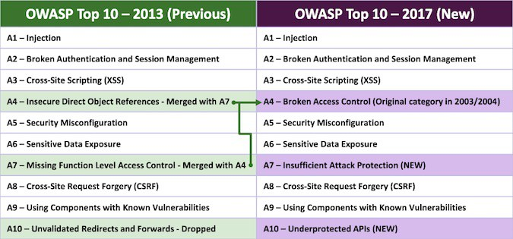

Figure 0 - Owasp, Security Affairs (2017)

Those above mentioned are not the only vulnerabilities in existence, the list becomes bigger as time goes by as new other ways to degenerate data are found.

The general idea is that there are 10 vulnerabilities positioned in arrange of commonality which are renewed every four years as new security breaches are reported.

For this project the selected vulnerabilities chosen are: Sql Injection, Broken Authentication and Session Management, Sensitive Data Exposure, Cross-Site Scripting, Security Misconfiguration and finally Cross-Site Request Forgery, not present on 2017 list, but 2013.

Demonstrating those vulnerabilities means breaking into a website to verify if it is vulnerable or not, but to be able to break into a website you firstly need to have the necessary permissions and contract in place unless you are the owner.

That being said, a banking website was developed as prototype, which is poorly developed, meaning that of all vulnerabilities above mentioned, were considered as an after-thought.

To find weaknesses in the first prototype, manual and automated web application analysis were performed, using “owasp-zap”, a free open-source which it is already pre-installed by default in a kali linux machine.

After found those vulnerabilities a second prototype was developed, taking in consideration the flaws that the first version had.

## 1.3Project Aim

The aim is to design a website framework that is able to demonstrate OWASP selected vulnerabilities, this project focuses on correcting the weaknesses in the system that can be used as an entry point from another party.

### 1.3.1 Project objectives

1. Research and Investigation on how to write insecure code and experiment how vulnerabilities are exploited in websites with lack of security.
2. Starting from the user’s point of view design a banking website vulnerable to the top 10 OWASP vulnerabilities such as:

* Injection
* Authentication or session management
* Cross-site scripting(XSS)
* Broken Access Control
* Security Misconfiguration
* Sensitive Data Exposure
* Cross-site request forgery(CSFR)
* Using components with known vulnerabilities
* Underprotected APIs

1. Evaluate success of respecting those requirements by testing web application

security with tools such as vulnerability scanners, penetration testing tools or static analysis.

1. After discovering those weaknesses, the idea will be to act based on the information found on the previous stage.

Appropriate countermeasures will be taken, after exploring basic security

concepts regarding standards of do’s and don'ts to help the user learn from the

mistakes made by others. The disclosure of the best ideas and approaches will

take place to make a final decision on how to behave to address the issue.

The correction of the source code will be followed by an evaluation to confirm

that the problem has been solved.

This process will loop until all the vulnerabilities belonging to selected

categories of the Top 10 have been addressed.

1. Formally document the project process in a formal report.

## 1.4 Methodology

An iterative model would be appropriate because the project is based on hypotheses of what may work to address detected or assumed vulnerabilities found in the phase of testing.

Useful information will be gathered in order to classify risks, giving the priority first to the most dangerous ones and from that point a decision will be made on whether the problem does need to be fixed or It does not, giving also justifications.

If it does need changes, an implementation of a solution will take place and then follow an examination to see if the fix applied to the application, managed the whole system to behave and perform as expected or if further new vulnerabilities were to be discovered.

Finally, an iteration will occur until all the vulnerabilities are addressed.

The Spiral model, a risk-driven process model generator was chosen for the fact that it guarantees flexibility on choosing what kind of way those vulnerabilities assumed or not assumed to exist are going to be rectified and the survey that will take place after the implementation of every solution to verify the level of satisfaction of the objectives predetermined.

This model is complex and it will require a lot of resources and risks analysis that can be difficult, there will be lots of challenges, but with a well-planned schedule with

well-estimated time will help to break down the project and finish on time.

### 1.4.1 Research and Investigation

I did not have any experience in application security at the beginning of the project, he appeared to have a vague idea of how to bring to an end the project, so about a month and half was dedicated to research and investigation on how to write insecure code, how vulnerabilities are exploited and the drafting of an Academic Literature Review.

# 2.0 Chapter 2: Academic Literature Review

## 2.1 Introduction

This paper focuses on methods to enhance the security of Web Applications. It covers selected vulnerabilities of the Top 10 OWASP of 2013 and 2017, the Secure Software Development Life-cycle.

## 2.2 VULNERABILITIES

### 2.2.1 Injection

It is a code injection technique of malicious code transmitted to a system through a web application which get executed by an interpreter that can not differentiate between trusted and untrusted data.

There exist many types of Injection flaws such as SQL Injection, LDAP Injection and OS command Injection (Sushila Madan & Supriya Madan 2010).

A successful structured query language injection can permit an attacker to bypass the authentication process, conceal the identity of other users, execute commands on the operating system or capture full control of the Database (Linghuan Xiao, Shinichi Matsumoto & Tomohisa Ishikawa 2016; Amit Banchhor &Tushar Vaidya 2015).

According to the source of input and technique used, SQLi can be further classified into different areas (Amit Banchhor &Tushar Vaidya 2015; William G.J. Halfond, Jeremy Viegas & Alessandro Orso 2006).

Researchers have discovered viable methods to mitigate the risks of SQLi and the correct use and combination of countermeasures that can minimize attacks, for instance

the use of parameterized queries, input validation and the adoption of Web Application firewalls (Hsiu-Chuan Huang, Zhi-Kai Zhang & Hao-Wen Cheng 2017);

the use of static pattern matching algorithms, intrusion detection systems and monitoring the execution of queries.

The first three approaches are partially efficient, but they do not provide a strong protection against complex attacks as the last three approaches might do(Sruthi Bandhakavi 2011; William G.J. Halfond and Alessandro Orso 2005; Rahul Shrivastava, Joy Bhattacharyji & Roopali Soni 2012; William G.J. Halfond and Alessandro Orso 2005; Gregory T. Buehrer, Bruce W. Weide & Paolo A. G. Sivilotti 2005; M.Amutha Prabakar, M.KarthiKeyan & K. Marimuthu 2013; Swapnil Kharche, Jagdish Patil, Kanchan Gohad & Bharti Ambetkar 2015; Sampada Gadgil, Sanoop Pillai & Sushant Poojary 2013; Hussein Alnabulsi, Rafiqul Islam & Quazi Mamun 2014; Abdelhamid Makiou, Youcef Begriche, Ahmed Serhrouchni 2014)

A complete protection could be found using ASCII values to store protected personal information (PPI) such as username and password to prevent the SQLi, but it would be highly inefficient for companies that holds big data because for each data stored in a database a new data must be created (Indrani Balasundaram & E. Ramaraj 2011).

### 2.2.2 Broken Authentication and Session Management

It involves flaws in functions that handles the authentication and session management of users.

The building of authentication and session management functions is difficult and complex.

The issues of this vulnerability are often caused by amateur developers who leave flaws in their source code, offering to hackers open doors into their own systems.

There are many causes for this vulnerability such as weak or absence of encryption in connections, the use of weak passwords and session IDs etc. (Daniel Huluka & Oliver Popov 2012).

Appropriate defenses to this weakness are: the use of SSL or TLS for encryption and identification reasons; the use of cryptographically strong algorithms such as PGP(symmetric and asymmetric encryptions) and AES-256 (symmetric); the creation of new session ids from servers; the denial of the opportunity to users to choose weak passwords (it is recommended to review the “Password Storage Cheat Sheet” of OWASP which provides guidance on how to address the issue in a complete manner); to finalize Daniel and Oliver proposed the utilization of CAPTCHA as a defense against brute-force, but this anchor has been already bypassed by researchers and in order to remedy this issue a new invention of Google has been released, which is a more sophisticated one named reCAPTCHA that can determine if a user is human or a robot based on its browsing patterns.(Google 2017; Mary-Ann Russon 2017).

### 2.2.3 Cross Site Scripting

It is a malicious payload injected into a website which is sent to a user’s computer and that get executed on its web browser.

The most used script language on a client-side is JavaScript, but this attack could be performed also in Active X, Java, Vb Script, Flash and HTML.

This attack can increase the surface area to other vulnerabilities such as Cross Site Request Forgery, session hijacking.

There are four types of Cross-Site Scripting: reflected, stored, DOM-based attacks and induced (Abdalla Wasef Marashdih & Zarul Fitri Zaaba 2017; Vikas K. Malviya, Saket Saurav & Atul Gupta 2013).

In order to detect this vulnerability, developers make use of two methods: static analysis for troubleshooting purposes and also dynamic analysis to further analyze potential malicious scripts that managed to bypass the technique just mentioned above, which uses the same concept discussed for the detection of SQL injections.

Static code analysis can be subdivided in data flow analysis, control flow graph, taint analysis, lexical analysis.

Defenses that developers take to prevent XSS are: the set of basic constraints regarding the length and data type of input fields provided to users and data encoding; the devotion to validate input on both server-side and client-side accompanied by JavaScripts code analysis and the utilization of frameworks, libraries and tools to accomplish multiple tasks (William Robertson & Giovanni Vigna 2009; Prithvi Bisht &V.N. Venkatakrishnan 2008).

### 2.2.4 Cross Site Request Forgery

In this attack, the hacker coerces the victim to execute unwanted commands without his or her consent and knowledge, in a trusted website in which he or she happens to be already authenticated.

It is a concept not well understood by developers and a vulnerability which has affected well-known companies such as Netflix, YouTube, uTorrent and Google.

This attack exploits the fact that web applications cannot distinguish a legitimate request from a user and an unwanted request originally sent by a hacker (Nenad Jovanovic, Engin Kirda & Christopher Kruegel 2006).

There are two types of CSRF attacks: reflected and stored.

It has been proved that existing techniques to mitigate this vulnerability such as the use of a POST request instead of a GET method, the inspection of an HTTP referer header, the verification of a valid token or the use of CAPTCHA proved to be partially effective or even ineffective.

Superior solutions supplied by computer scientists are: the usage of a proxy to examine and establish if requests are legitimate, the application of random tokens, the stipulation of when cookies are to be considered no longer valid, the re-authentication of valid users and the obligation of clients to utilize forms arranged by the administrator (Shadab Siddiqui 2011).

In the case scenario, when appropriate precautions are not taken against XSS, the defenses mentioned above will not be able to resist against CSRF attacks.

### 2.2.5 Broken Access control

It occurs on a system where the coding relevant to access control presents defects and does not verify properly the function level of access of its information.

So due to this leak, the web application might concede access to its resources to unauthorized users.

Most companies put in place an access control system which can be partitioned into three different areas: access control policies, model and mechanism (P. Samarati & S. De Capitani 2001).

In addition to these measures, administrators prefer to place a proxy in-between the system and clients for further protection purposes.

### 2.2.6 Security Misconfiguration

This vulnerability occurs when configurations are not set correctly.

It is a must to check that security settings are secured properly and no default configurations that usually result as weak are left in place; unused ports, accounts, privileges, services and administration interfaces should be disabled.

Automated tools and systems for monitoring security configurations to catch this vulnerability have been built.

### 2.2.7 Sensitive Data Exposure

This exposure can be found when the system does not protect correctly sensitive data.

It is important to understand which data on your system must be kept secret and which does not or when some data is not of any use anymore, so that it could be removed.

Same measures discussed previously in Broken Authentication and Session management and Cross Site Scripting can be applied here.

### 2.2.8 Using components with known vulnerabilities

Vulnerabilities found in components such as libraries, frameworks can be exploited by hackers who can cause damage such as modify or delete existing data and take over a server as well.

It is proposed an automated technique for the detection of risky components.

## 2.3 secure development lifecycle

### 2.3.1 Sdl

It was published in 2004 by Microsoft and since then it has been embedded in all project’s software development. [54]

“The primary goal of SDL is to increase the quality of functionality-driven software by improving its security posture.” (Johan Gregoire, Koen Buyens, Bart De Win, Riccardo Scandariato & Wouter Joosen).

It includes security activities that software development teams and software vendors must use in order to minimize vulnerabilities during the software development process; the adoption of such methodology resulted in a success based on Microsoft experience.

Its composed of seven stages: training, requirement, design, implementation, verification, release and response.

The first phase is about the investment that tech firms make in employees.

The next level outlines the requirements of an application agreed between a customer and a company, which are then reviewed and supplemented with more details.

The design step gathers all the requirements and initiate to plan the conceptual construction of the product which involves areas such as the business rules, the layout of a website, the programming language and the frameworks designated, the design of the client and server model, the database relationship chosen and the architecture of the whole application.

Following the scheme, the design stage is the next step. This is the implementation where the coding take place and even in this moment, penetration testers start to look for flaws that might arise. By visualizing the usability of the application and its control flow at the real beginning of development process of the application, before a thorough testing with automated and manual tools today available. There exist different types of testing: quality assurance testing, system integration testing and user acceptance testing.

After a satisfactory test result, the product is released and the all system is being monitored, maintained and tested.

There are different Software development life-cycle models and methodologies used; the factors to be considered in the selection of a suitable SDLC scheme, are based on constraints and requirements that a specific project may present.

## 2.4 Conclusion

In the 1990s, since the introduction of the first Web browser and the Worldwide Web, web applications have been the most targeted by hackers.

Products always get released to the public with vulnerabilities and the prevention of these is usually considered an after-thought.

Different approaches and measures of defense are introduced to deal with the problem the best way.

# 3.0 Chapter 3: About the Project Similar projects

## 3.1 Investigation

By investigating publications by others on the same topic, it was discovered that the product that will be designed, it has already been invented by entities such as OWASP (Website – Hacme Bank, Faux Bank Project) and by IBM Security Ethical Hacking team (Website – Altoro Mutual).

The creation of such websites and tools on the world wide web are performed to share vulnerability knowledge, so that it could be of profit to developers, who need some guidance in application security. Also interested in some directions of proficient methods to adequately discover web application vulnerabilities. Given an initial product fully vulnerable, at the beginning, for then provide directions on how security weaknesses are recognized and rectified, using tools and languages that are commonly used by undergraduates.

# 3.0 Chapter 4: Product Model

## 3.1 Conceptual MODEL

A banking static website created with HTML, CSS, but also with PHP and JavaScript to create dynamic pages.

## 3.1.1 SECTION Hardware requirements

- Personal Computer or Laptop with at least 1-GHz processor

-1 GB of RAM minimum

- Hard Disk with 5 GB minimum

## 3.1.2 Software requirements

- Web Server Software Application (Apache LAMPP, XAMPP)

- Browser updates applied periodically to improve security (Mozilla Firefox,

Google Chrome; JavaScript and Cookies must be enabled)

- Vulnerability Scanner (Owasp-Zap, Burp Suite)

- Operating System (Linux new versions, Windows 7/8/10, Macintosh new versions)

# 4.0 Chapter 4: Design

## 4.1 Functional requirement

- A customer can transfer money to another account holder in the same bank and

withdraw money through an ATM simulator

- A customer can view his account and edit his details

- A customer can login and logout

- A customer is request to the administrator to be registered- A customer can

update personal details

- The administrator provides multiple services to customers. (E.g.) Add or delete

an account, view transactions etc.

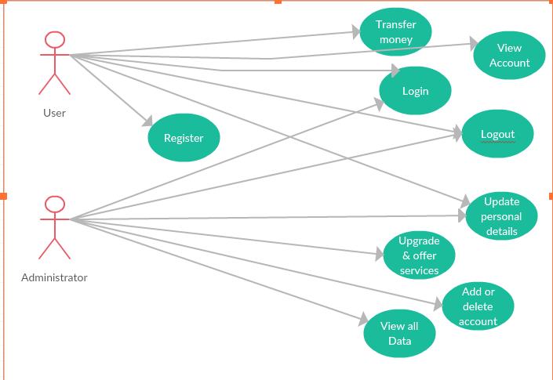

Figure I – System

## 4.1 Non-Functional requirement

Preserve the CIA triad (confidentiality, integrity and availability)

Security requirements to be present in the first prototype (Project X) and to be dealt with in the second prototype (Project Y)

* Injection
* Broken authentication
* Cross-Site scripting
* Broken access control
* Security misconfiguration
* Sensitive Data exposure
* Cross-site request forgery

# Chapter 5.0: Rationale

This project is a process that will lead users to gain a better understanding of web applications vulnerabilities from a previous or current perspective of the user to an incipient one that will lead the individual to relinquish old notions or habits by using this knowledge responsibly to adopt new ones.

# Chapter 6.0: Web Application Vulnerability Assessment

## 6.1 Introduction

After the discovery of the selected vulnerabilities, an action was taken based on the information found from the previous stage.

Appropriate countermeasures were applied to the second prototype, after exploring basic security concepts regarding standards of do’s and don’ts.

A walk-through technique was employed to minutely step through the various stages of the demonstration of web vulnerabilities and the disclosure of a systematic approach to address the issues that could occur in order to help students keening to learn about web security flaws, so that they can learn about what to look out for when discussing web vulnerabilities.

The amend of the source code of the first prototype would be followed by an evaluation to confirm that the vulnerability has been solved by testing the second model.

This process looped until all the selected vulnerabilities were addressed followed by a formal documentation at the end.

## 6.2 BACKGROUND

Before we dive explicitly to map out the technical the fundamental differences between the two prototypes, it is imperative that there is a clear understanding about web application vulnerabilities.

Hence, web applications are vulnerable, because they are dynamic and they require user input which is not handled with the proper degree of scrutiny.

A few examples of dynamic web applications are PHP, AngularJs, Ruby and many others; any one thing that is able to receive a script and execute it.

## 6.3 VULNERABILITIES

### 6.3.1 Injection

It occurs when a malicious user injects a command that can run everything from database commands to system commands.

There are various types of injection, but we are going to cover Sql injection which is the most prevalent one.

An Sql injection occur on the first prototype as you can see in Figure 1 when insert a query string, that is going to concatenate or replace the existing query programmed by the developer, by inserting some special characters like a single (‘) or double quote (“), a hashtag (#) or a dash (-), which will then change the existing query logic and bypass the authentication process that was set in the first place.

Syntax is very important, failure to use it correctly will cause errors would be thrown to user.

#### ProjectX

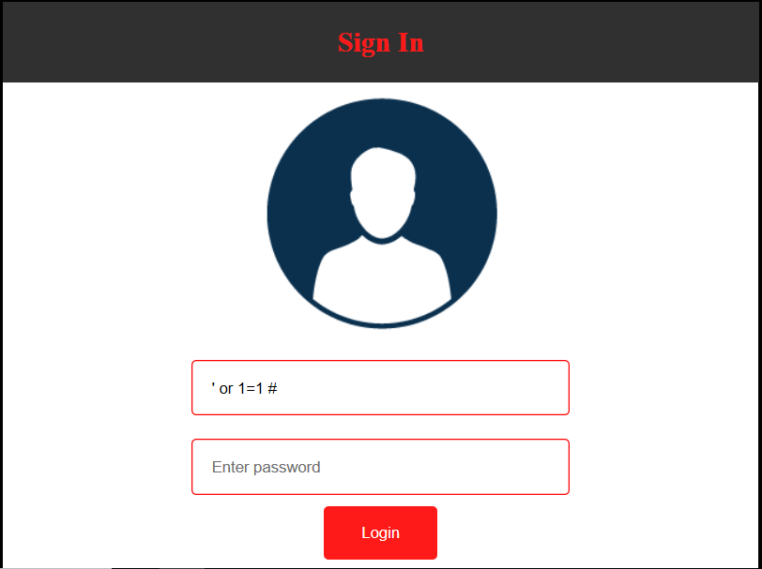

Figure 1 – Sql injection

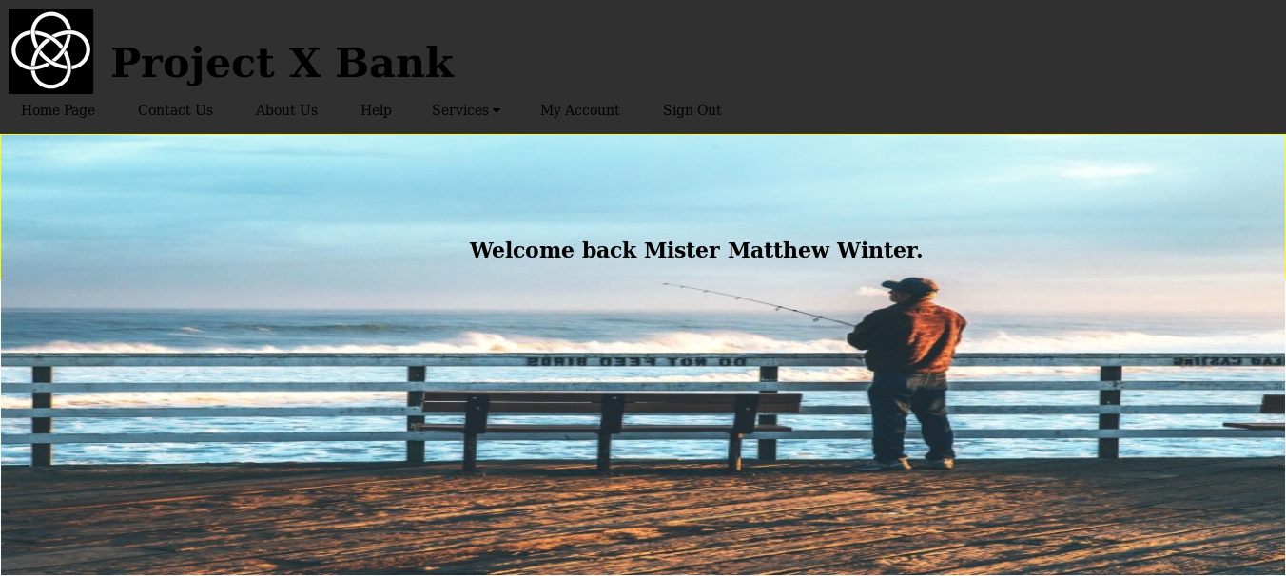

Figure 2 – Index client page

It is plain to see in the source code shown in Figure 3, the inputs are received through a POST method on line 9 and 10 and each value is assigned to the its corresponding variables (user and pwd).

Thereupon, the program will check if the value of the variable user is equal to admin and because it is not then on line 13 both variables are passed to the SQL query.

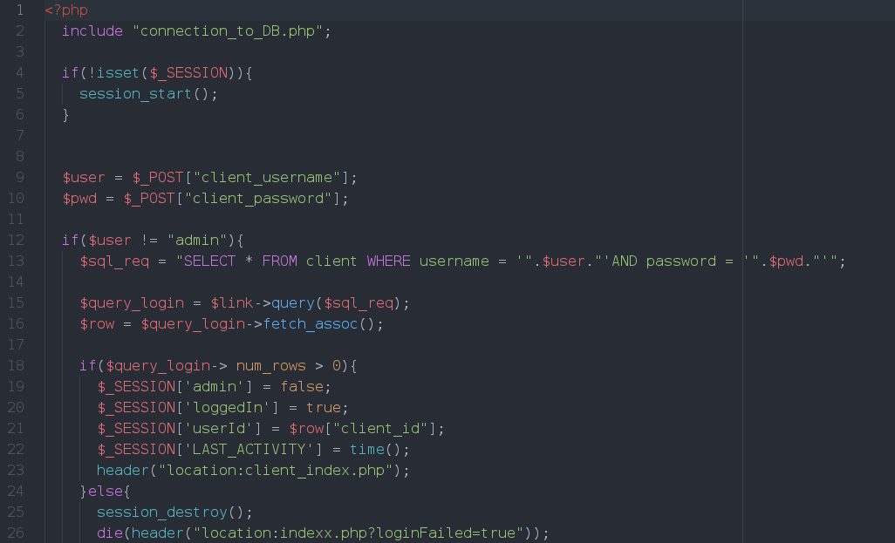

Figure 3 – Php file that handles the login request – User is a client

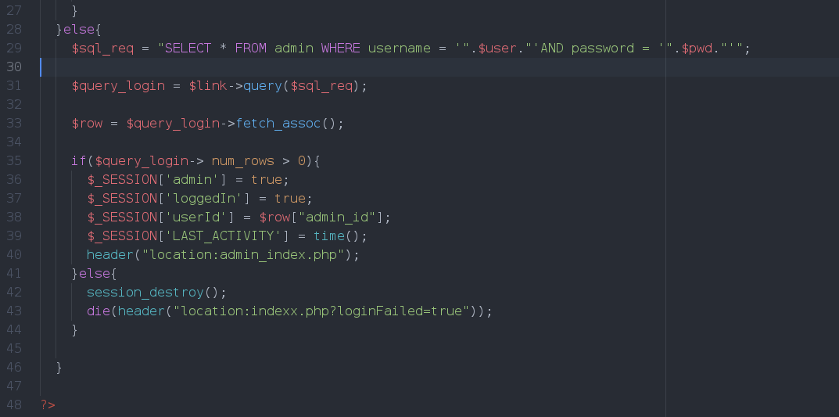

Figure 4 – Php file that handles the login request – User is an admin

When the query gets executed, the quote will be in a specific position in the query to be sent to the database, and as a consequence of that, the username field will to terminate and any character that comes afterwards will no longer be considered as a parameter string, but as SQL command as pointed out in Figure 5.

As a result, following the quote the keyword OR is interpreted as a bitwise operator.

Coming immediately after that, a tautology 1=1, which it is always true and the hashtag comment will cause to what comes next to be ignored by the interpreter.



Figure 5 – SQL query

This query will return will select from the table “client” the first user on the table as portrayed in Figure 6, who happens to be a user named Matthew Winter.

An attacker by entering this command will bypass the login authentication and be able to use the online banking website as a client with the identity of someone else.

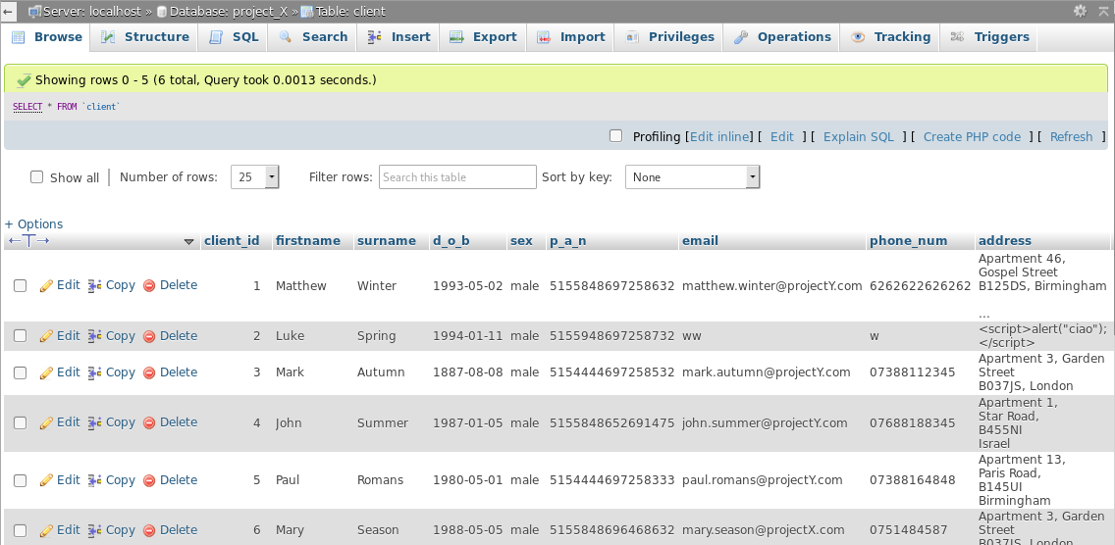

Figure 6 – Table client of ProjectX

This malicious code can also successfully execute, if inserted in the input field of password and the username field substituted by “admin” in order to fall into the block of code that handles the authentication process of an administrator, found from line 29 to 43 in Figure 4.

Thus, the query would appear as reflected in Figure 7.



Figure 7 – SQL query

The first user in the admin table is admin as shown in Figure 8.

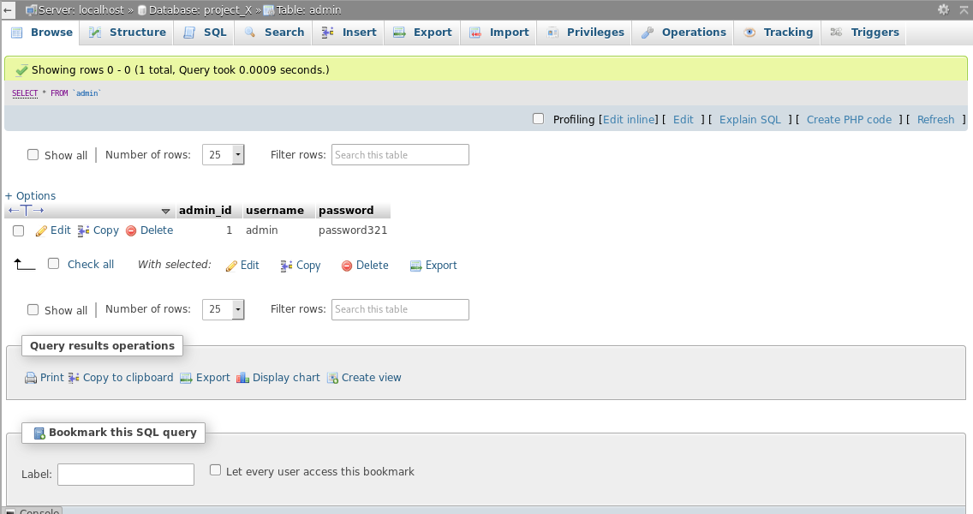

Figure 7 – Table admin of ProjectX

The web application will grant the user access as an administrator as demonstrated in Figure 8.



Figure 8 – Index admin page

#### ProjectY

In the case where the same attack was attempted in the second model, it would not succeed, because of input validation and SQL prepared statements.

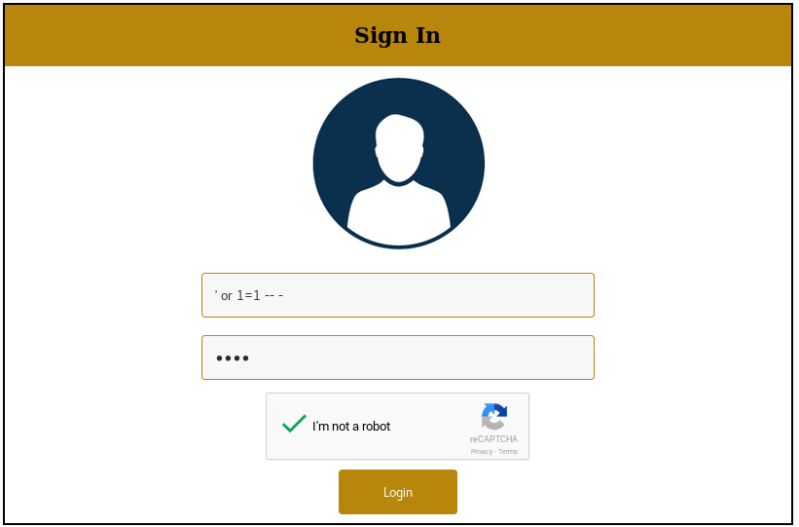

Figure 9 – Sql injection

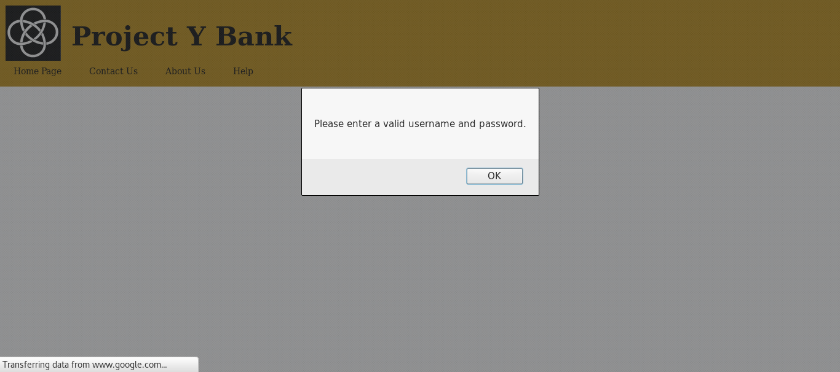

Figure 10 – Sql Injection phase 2

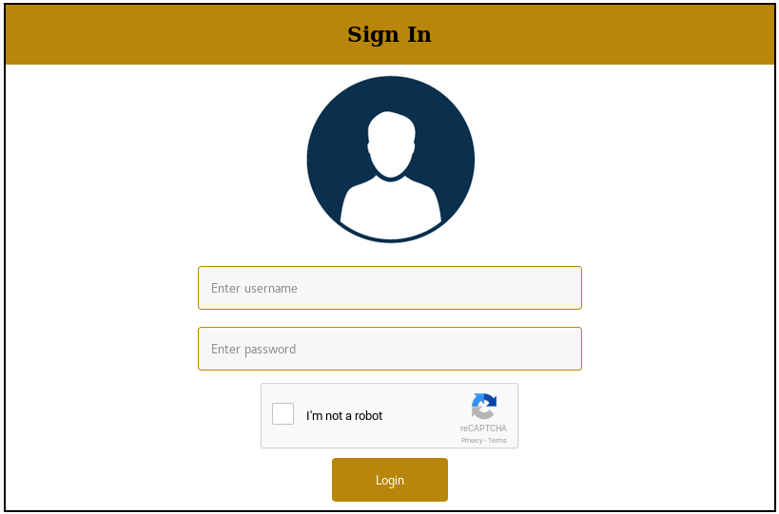

Figure 11 – Sql Injection phase 3

As it is evident in Figure 12, rather than imputing the user input directly to the correlative variables which will then be put into to the Sql query, they will be first examined through an input validation test.

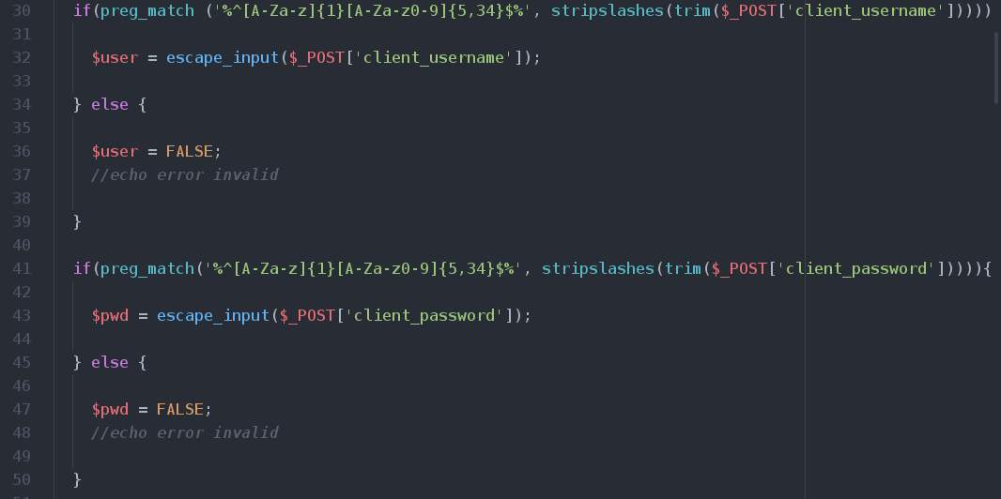

Figure 11 – Regular expression

Regular expressions are used to verify whether a certain user input match against a pattern.

As it might be seen on line 30 and 40 in Figure 11, there are rules in place for the data to be accepted, if they meet the criteria that have been established or rejected, if they not.

Both inputs ought to be alphanumeric to gain a pass in.

Other functions to strip white spaces and to get rid of slashes, which are escape characters, are utilized.

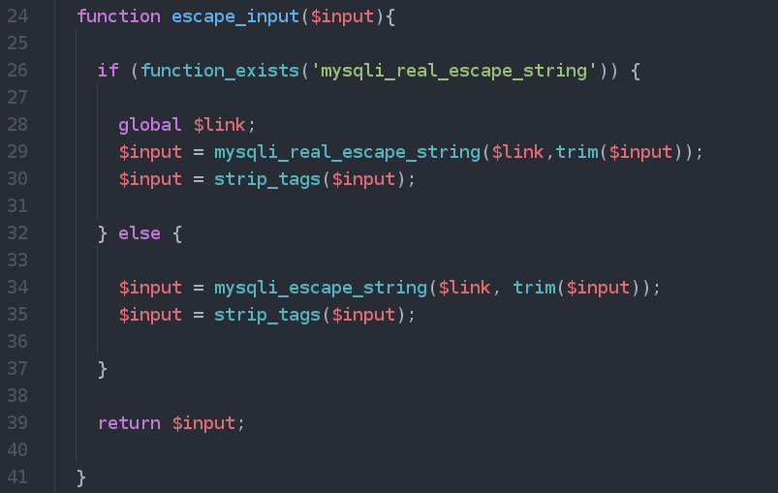

Figure 12 – Input validation

The use of other methods such as “mysqli_real_escape_string’ to escape strip special characters and “strip_tags” to pull out HTML, PHP tags from a string as shown in Figure 12.

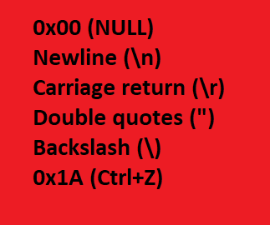

Figure 13 – List of characters escaped by mysql_real_escape function

Nevertheless, these defenses measures are not enough to defend against SQL injection that is why, it is appropriate to use prepared statement.

Initially, a prepared statement delivers a query to the database short of parameters and after sends the data, clearly visible in Figure 14, beginning on line 56 which almost solves the problem of SQL injection, because there exist uncommon situations in which it could cause damage.

By any means, going back to ordinary circumstances of SQL injection, its success is due to variables being sent to the database at the same time, which will result as a dynamic program and the data which is combined with the query may alter the existing query logic.

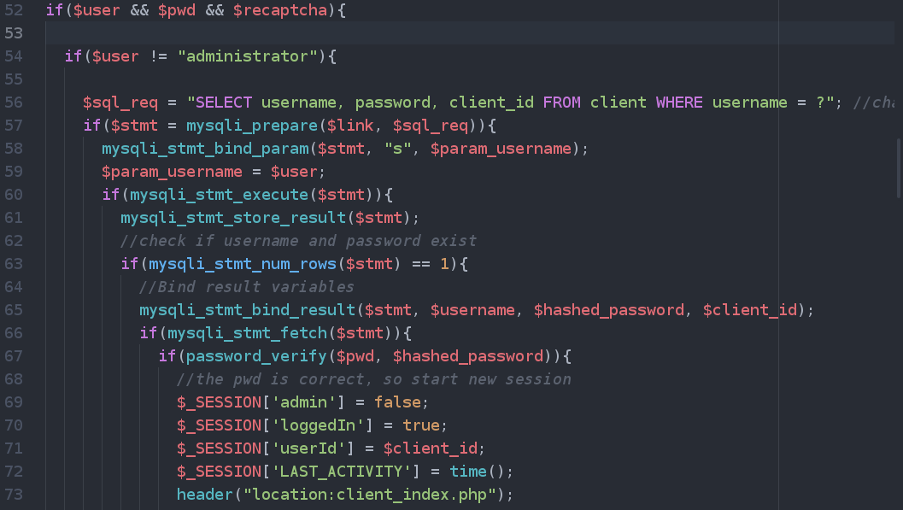

Figure 14 – Prepared statements

On line 57 the query has been sent containing a question mark, an unspecified parameter, with the function of replacing the string username.

On line 58 to 59 the parameter value has been assigned a value which gets finally sent to the server and gets executed on line 60.

Another measure of defense not present in ProjectX is the use of autocomplete which is normally by default turned on as indubitably displayed in Figure 15 and disabled in Figure 16.



Figure 15 – Autocomplete form enabled by default, depending on browser



Figure 16 – Autocomplete form disabled

It is a feature that from a security perspective should not have been created in the first place, because as you fill in forms when browsing on numerous sites, it stores your details you have inputted and when you encounter a similar form asking you to enter the same details, it will fetch the data you previously inserted with your consent, saving time to users, but as well as sharing your information from one website to the other; it can lead to leak of sensitive information to untrusted parties as it happened for LinkedIn and its Autofill plugin. (Swati Khandelwal, Flaw in LinkedIn AutoFill Plugin Lets Third-Party Sites Steal Your Data).

Furthermore, the deploy of other attributes such as “maxlegth” to restrict the number of characters and “required” to state that a certain field cannot be left blank as it was possible for the broken model as previously pointed out in Figure 16A.

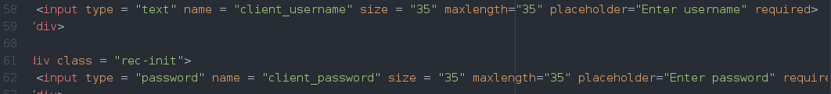

Figure 16A - required

Those attributes just covered can be altered by a user by making use of the Developer Tools on a browser, but it is good practice to do so.

The use of reCAPTCHA to counteract automated SQLinjection attacks even though it has been proved that this defense is no more unbreakable ([Rene Millman](https://www.scmagazineuk.com/rene-millman/author/3644/), 2016).

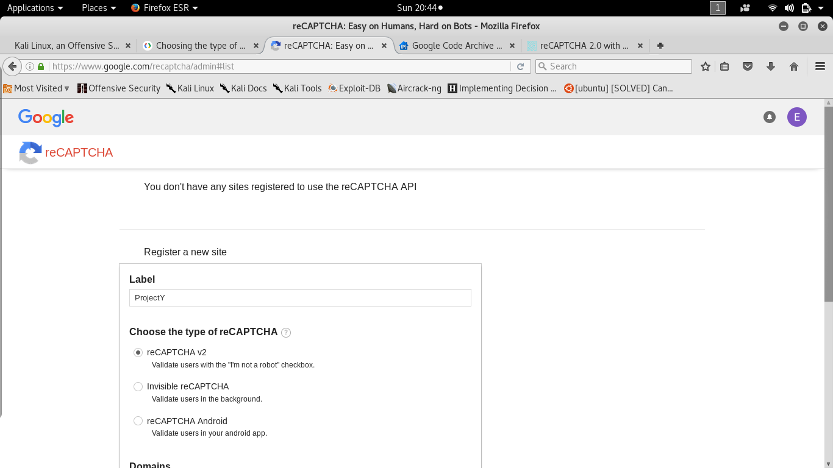

Figure 17 – reCAPTCHA registration

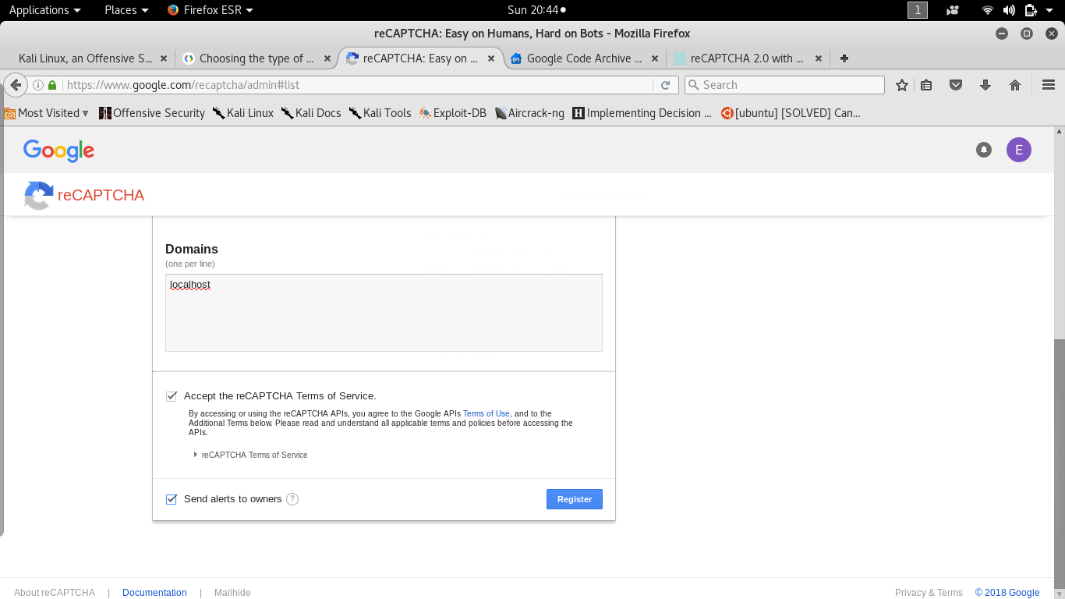

Figure 18 – reCAPTCHA registration stage 2

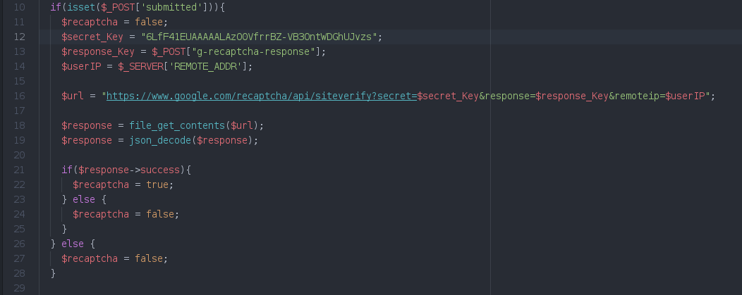

Figure 19 – reCAPTCHA source code

As it can be seen the registration a website to use reCAPTCHA API is simple and the latest version with the checkbox was chosen.

All the validation to check whether a user has answered correctly the question posed or not is processed by google and the result is then retrieved and stored in a variable named response on line 18 of Figure 19.

If all the variables muddle through to pass all barriers of defenses heretofore discussed, subsequently the program will commence to query the database (Figure 20).



Figure 20 – Source code of login system

To improve security, reCAPTCHA should be updated to the latest version which is v3, not yet available, at the present time in beta phase, soon to be released.

### 6.3.2 Cross-Site Scripting

It is like an injection, but it is JavaScript, thus the injection of a payload which gets executed by the browser.

#### Project X

In the weaker prototype the website is vulnerable to cross-site scripting attacks such as persistent, which does not require a user to click a malicious link, but to simply visit a web page which contains in itself the code because it is stored in the server as demonstrated in Figure 21, 22, 23.

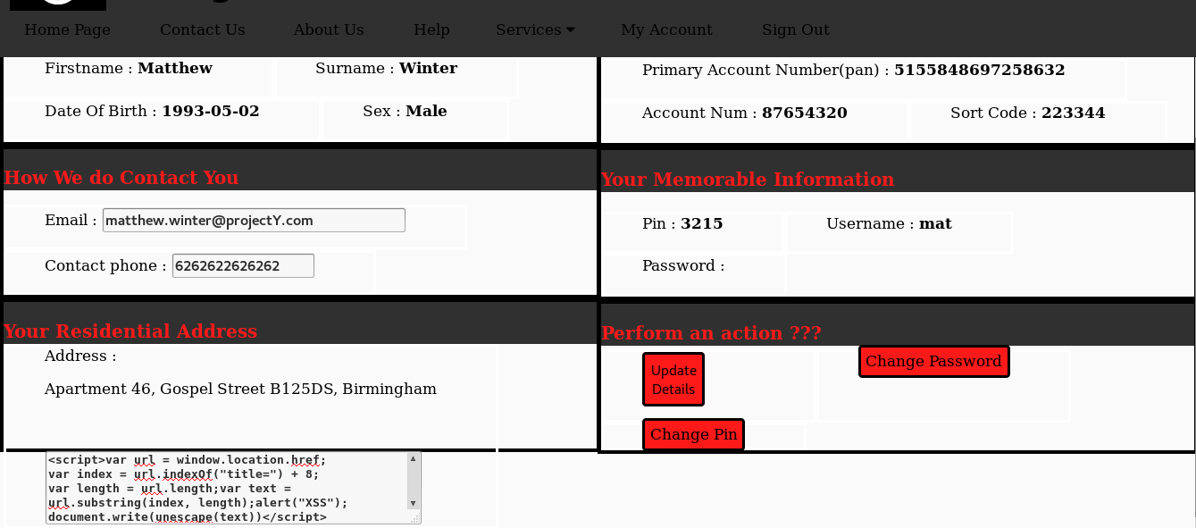

Figure 21 – Cross-Site scripting persistent attack

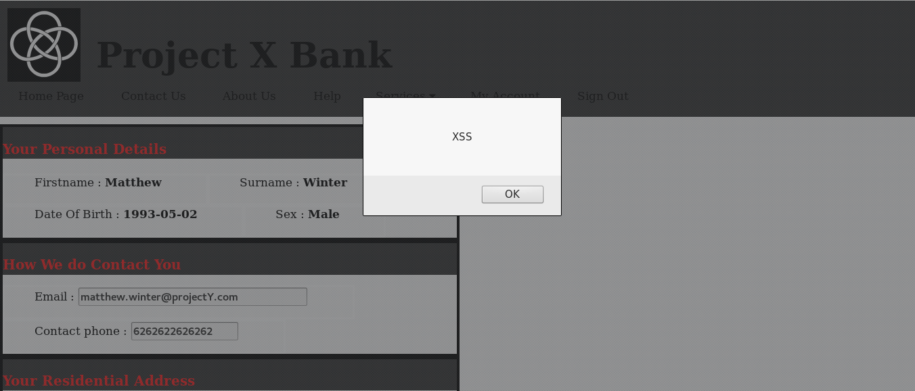

Figure 22 – Cross-Site scripting persistent attack stage 2

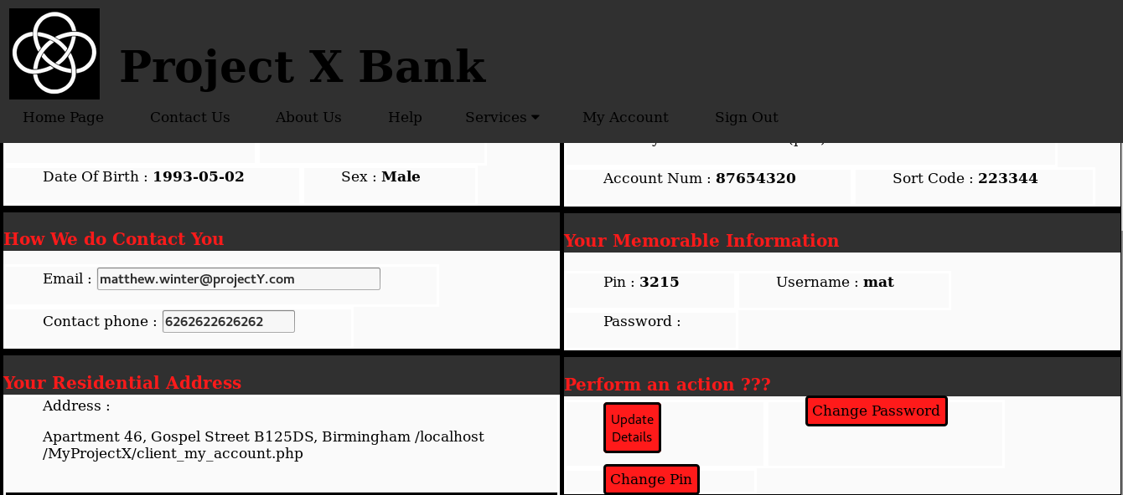

Figure 21 – Cross-Site scripting persistent attack stage 3

It is easy to see how facile is to store a variable which contains JavaScript code to run and to change the content of an HTML document.

As a result of not sanitizing the input before storage and when the value of the variable is displayed (line 94).

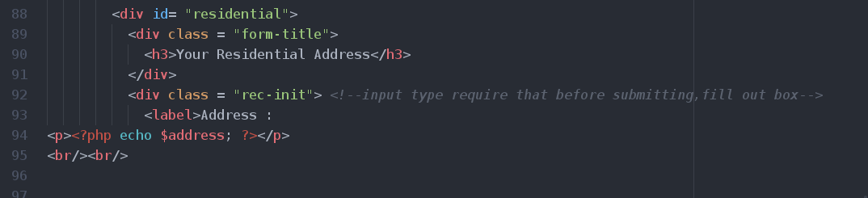

Figure 22 – JavaScript source code issue

Another example of attack is cross-site scripting reflected which involves echoing back an untrusted user input into the browser instance as shown in Figure 23 and 24.

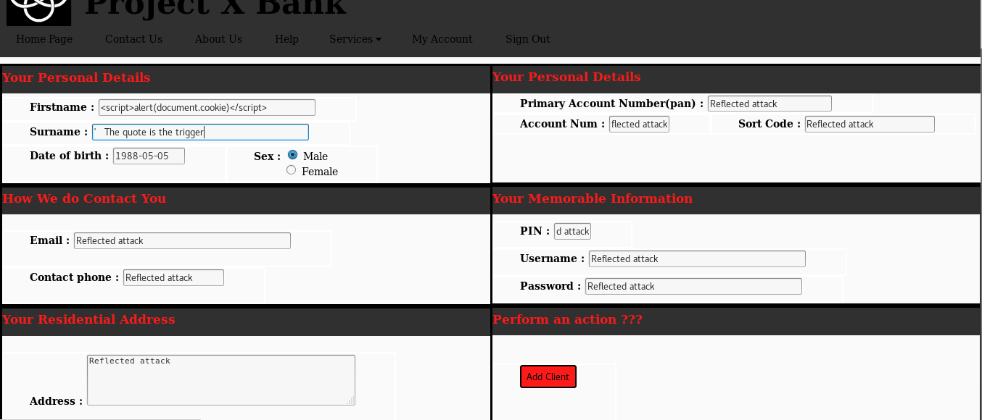

Figure 23 - Cross-Site scripting reflected attack stage 1

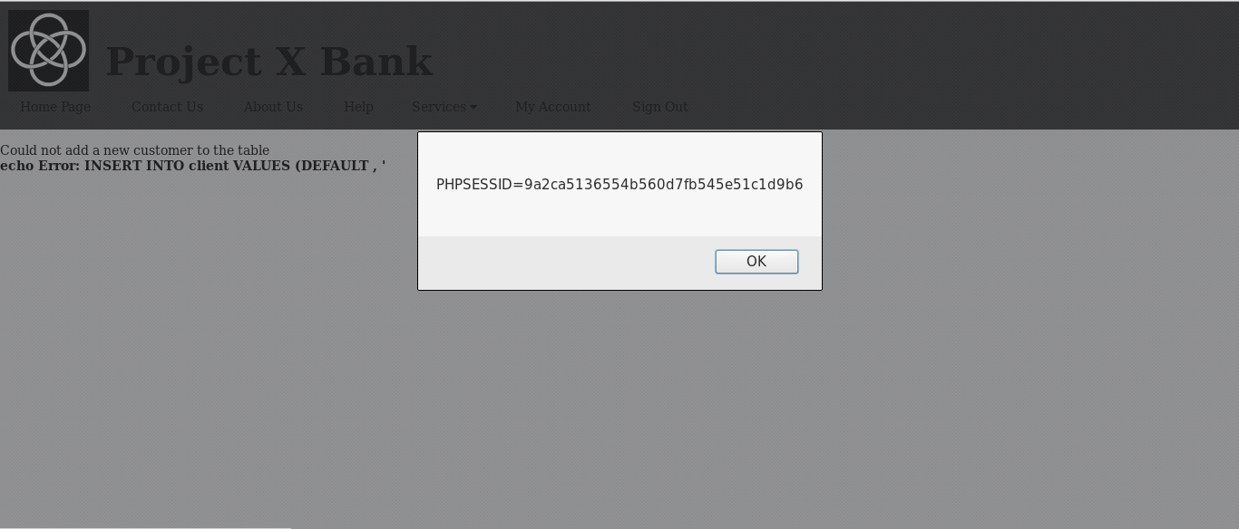

Figure 24 - Cross-Site scripting reflected attack stage 2

When the malevolent individual manage to execute some JavaScript code on the user browser, the code will run inheriting the privileges that the web application offers to the user, giving the possibility to him or she to be able to read, modify or send any sensitive data that the browser has access to.

It is evident to see that the query in Figure 24 utilize single quotes to delimiter string variables.

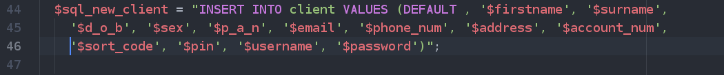

Figure 25 – Query to add a new client to the online banking website

It is evident that, by inserting in the input field “surname” a single quote, the application would inevitably abend for syntax error on account of not being able to sanitize input.

Ergo, the website will echo back the query received to the user, however the browser instead of displaying the content as pure text, it interprets it and runs the code.

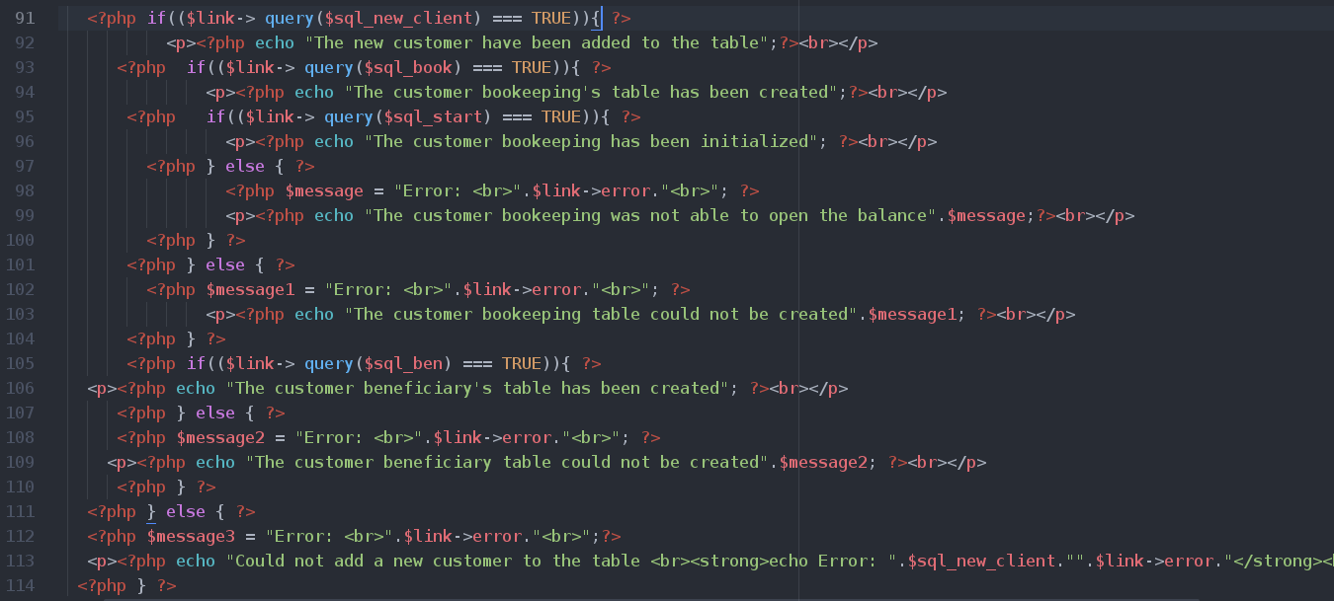

Figure 26 – Block of code where query is executed

#### ProjectY

The same defense measures, discussed for injection, are also to be applied here.

In addition to that, the use of “htmspecialchars” function to converts special characters to HTML entities for untrusted user input as pointed out in Figure 27.



Figure 27 – Displaying user untrusted input with htmlspecialchars

Another counter measure is encoding.

The aim is to change the original text format into something else to resist against XSS, which relies on the injection of some html entities which are not encoded, therefore the browser parse them into HTML.

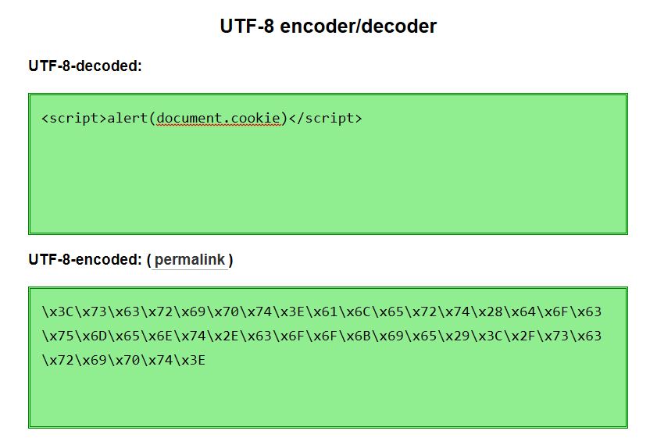

Figure 28 – Example of UTF-8 encoding

By means of encoding text into UTF-8, the injection of a payload would be just displayed as text and not as HTML entities to be interpreted by the web browser and the user would still be able to view the same text in a readable format.

To set character encoding in the web application, firstly the “php.ini” file was edited of Apache Server located in the etc directory folder of apache to accept as a default charset UTF-8 instead of ISO which is an ASCII character-set and the same adjustment were made also for clients as illustrated in Figure 28, 29, 30 and 31.

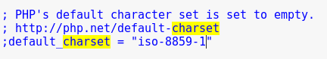

Figure 28 - pwd /opt/lamp/etc/php.ini

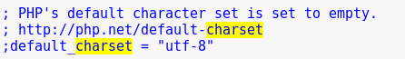

Figure 29 - pwd /opt/lamp/etc/php.ini

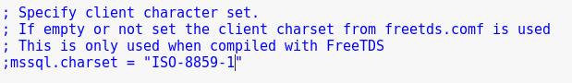

Figure 30 - pwd /opt/lamp/etc/php.ini

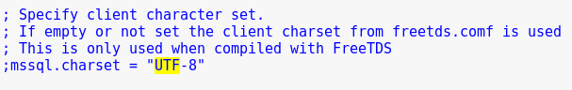

Figure 31 - pwd /opt/lamp/etc/php.ini

Secondly, modifications were made in the source code itself.

Prior displaying any output in every page where there is some text shown to the client, using the function header, the UTF-8 has been set as the character format as it is plain to see on line 10 in Figure 32.

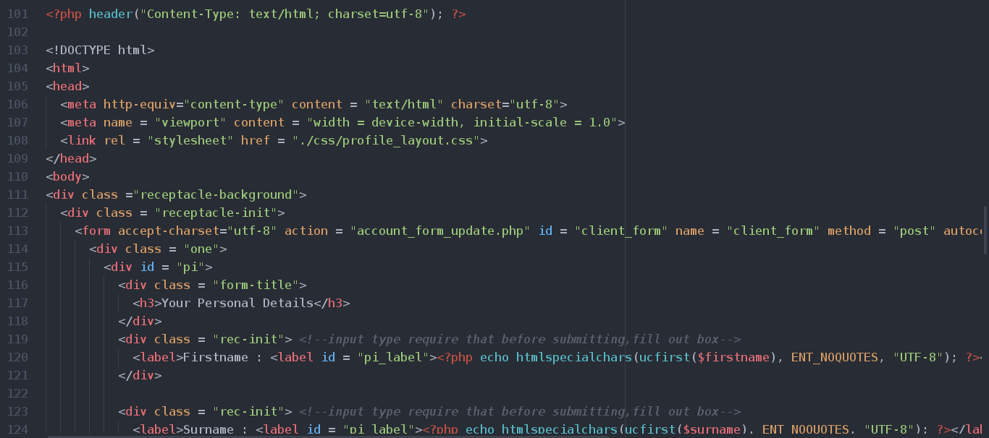

Figure 32 – UTF-8

As it is evident to see that it has been also specified for all html content, for instance on line107, for all forms on line 113 and for all calls made to the function “htmlspecialchars” on line 120.

This should be done also for the “htmlentities” method, but it was not deployed in the web application.

Thirdly, other adjustments were directed to the “my.cnf” file located in the same directory.

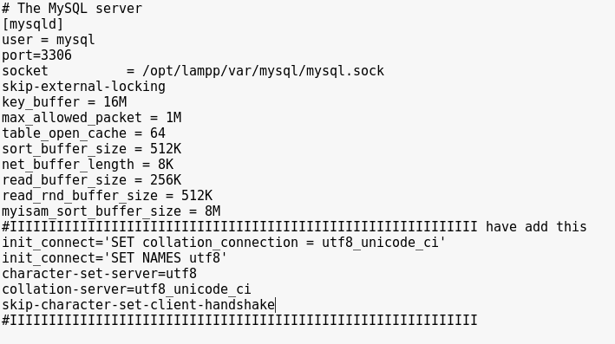

Figure 33 – pwd /opt/lampp/etc/my.cnf

Subsequently, the character was specified for all MySQL connections as it is clear to see on Figure 34.

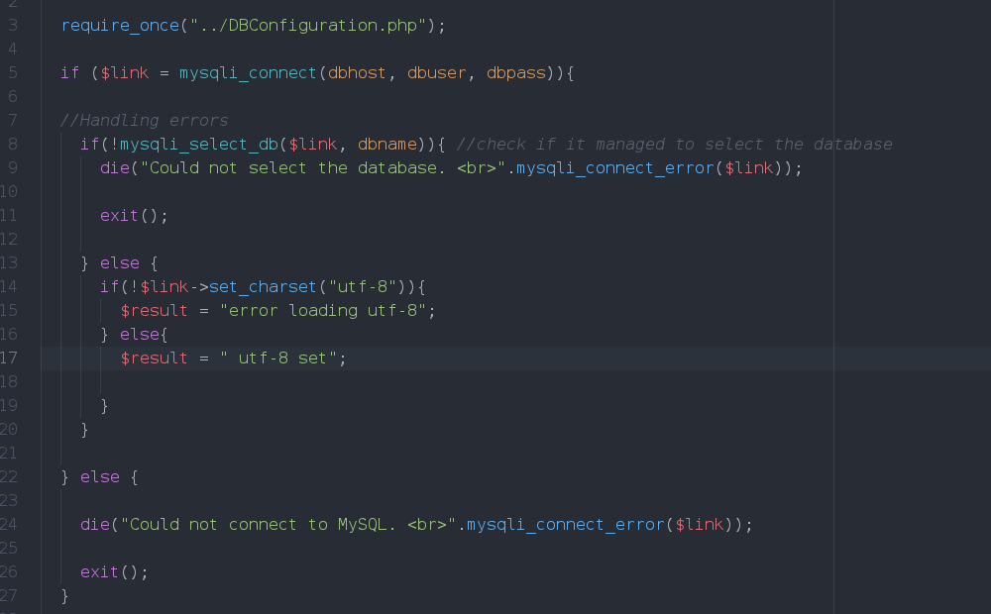

Figure 34 – File to handle connection to MySQL database

Already existing databases and tables have been changed by clicking the tab “Operations” and selecting the encoding format in phpMyAdmin application as shown in Figure 35.

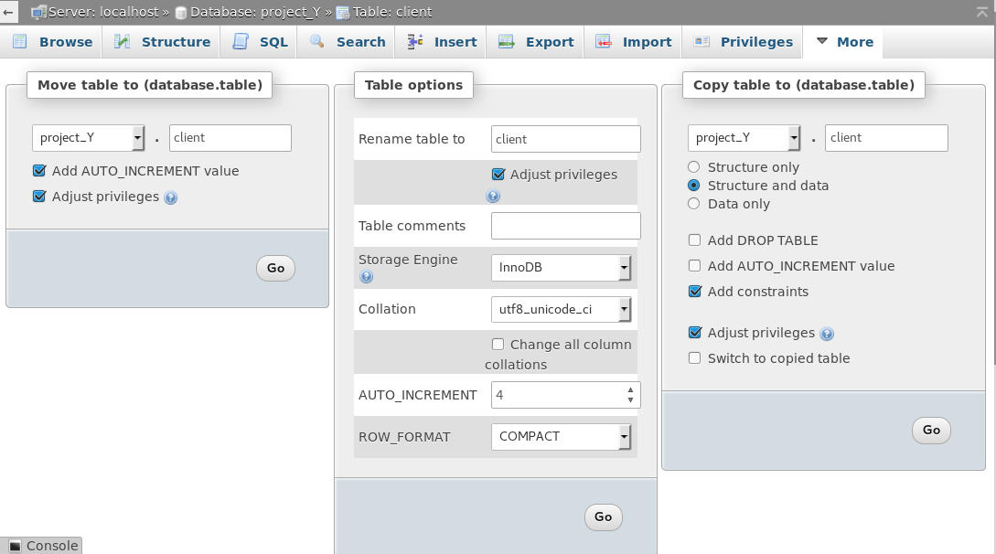

Figure 35 – URL localhost/phpMyAdmin

The result of all encoding processes and alterations is demonstrated in Figure 18 and 19.

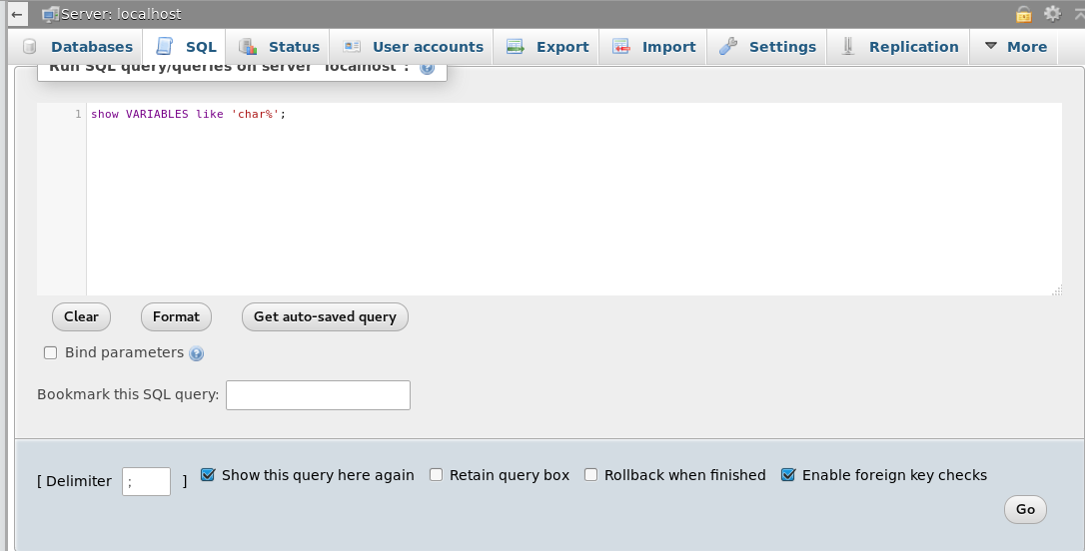

Figure 36 – Viewing changes made with SQL commands

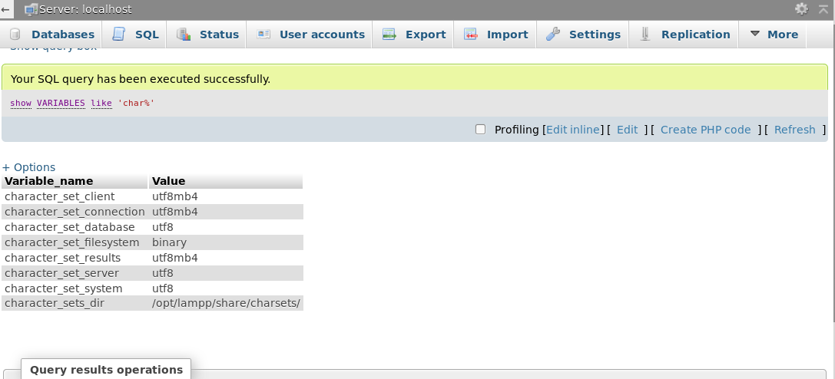

Figure 37 – Viewing changes made with SQL commands

It is plain to see that other changes were made to test if utf8mb4 was supported for the Apache current version.

The difference between UTF-8 and UTF8mb4 is that the last one do support not only, languages characters like UTF-8 does, but also in the byte usage which consent the last one to encode symbols and emoticons as well.

Another way to reduce the risk for Cross-Site scripting attacks is disabling the HTTP Trace method, but this matter will be deepened in the Security Misconfiguration chapter.

### 6.3.3 Broken authentication and session management

It includes flaws in functions that handles the authentication and session of a user.

The method deployed to authenticate a user, is the utilization of a username and password.

#### Project X

In the non-vulnerable website there are severe weaknesses concerning this risk.

For example, the use of unencrypted connections, with Hypertext Transfer Protocol to transmit information in plain text from one node point to the end-point and if, along the way, the data package containing sensitive data. Such as username and passwords gets intercepted by anyone having the right tools to sniff packets going from a client computer to the Apache server, the customer would not be able to know.

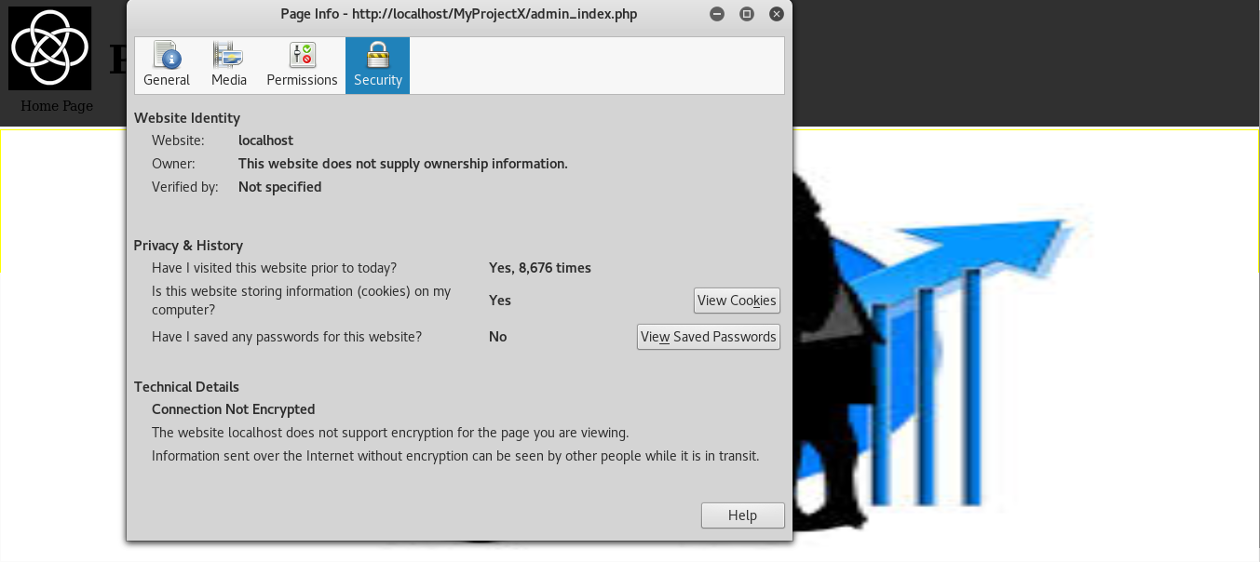

Figure 38 – HTTP connection

There is a strong use of predictable credentials, for instance the administrator username should be named something different rather than the most common admin as pictured in Figure 39.

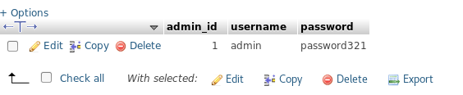

Figure 40 – admin table

The session id never times out and if for any reasons a client forgets to logout from the online-banking system, when he visits back again, he would be already authenticated, having the same session ID.

If an attacker was to somehow get hold of that session ID by using Cross-Site scripting, he or she would be able to impersonate the client.

The reason why there is need of sessions is because HTTP is a stateless protocol and a server cannot remember user activity or identify users in any request received.

The general idea is that the server receives multiple requests at a time and all those packets should contain enough information already on their own.

That is why sessions are indispensable to store information regarding user’s activities on a server, so for instance if a client was to login in a system, this detail would be stored on the server and when a user requests another page where he can make a payment transfer, he will not need to be re-authenticate again.

Users credentials are not stored using hashing or encryption, but we will discuss about this risk in the sensitive data exposure chapter.

#### Project Y

In the more secured prototype version, it was ascertained that any incoming/out coming connection were encrypted by specifying port 443 (HTTPS) to be used by default which is an extension of HTTP (port 80) that also use SSL/TLS.

The file handling connections for virtual host named “httpd-vhosts.conf” was edited to support HTTPS.

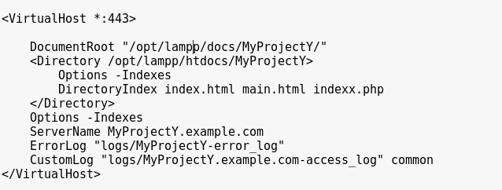

Figure 40 – pwd /opt/lampp/etc/extra/httpd-vhosts.conf

The use of weak credentials by users has been enforced using encryption, for instance clients have been compelled to strengthen their passwords using the by inserting at least one letter uppercase and lowercase and one number, using the same paradigm introduced earlier (regular expressions).

New files where created handle the session id expiration and to examine if an end user logged.

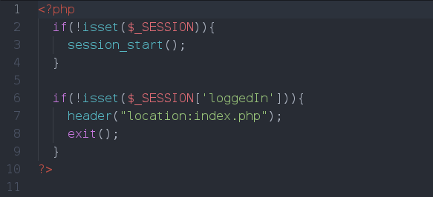

Figure 41 – verify user session

As illustrated in Figure 41, the php file task is to start a session if a session has not been initiated yet from line 2 to 5.

On line 6 to 8 the program check if the user has logged in, by checking if the variable, which is initialized as portrayed in Figure 20 on line 70, is set to true; on a false condition statement, the user will be redirected to the index page and be logged out.

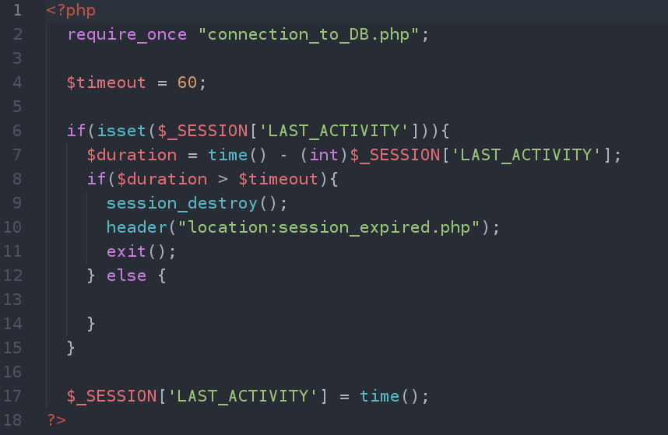

Figure 42 – Expire Session code

On line 4 of Figure 42 it is clear to see that the timeout of a session has being set to 60 seconds and from line 6, the program will verify whether the last activity of a user is less than the timeout variable value, on the assumption that is not then the session will be destroyed and the client will be redirected to another page to inform him that he has been logged out for inactivity as pictured in Figure 43.

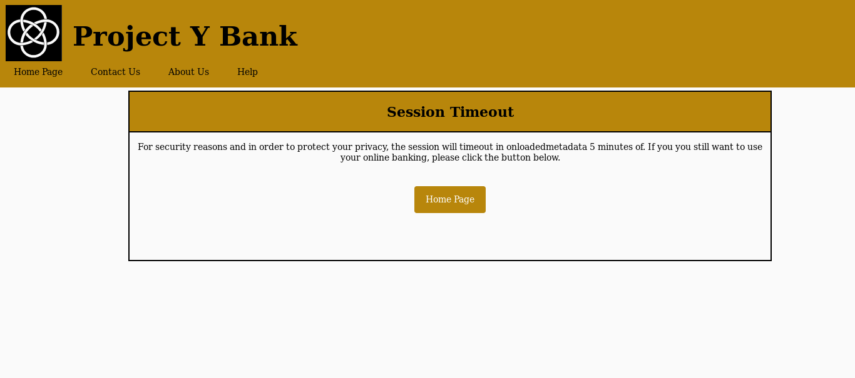

Figure 43 – Session expired

### 6.3.4 Security Configuration

At fresh installation of Apache Server LAMPP for linux, the default configuration is insecure.

It is essential for an administrator to be aware of those vulnerabilities and to set up correctly a better security system.

#### The disclosure of sensitive information

As illustrated in Figure 44, the Apache version, the operating system as well as what modules are installed on the server are available to anyone to view. These are sensitive information that an attacker can use to formulate a hacking strategy.

To view them, any individual could type in the URL and request a file which does not exist in the server, to cause apache to display a HTTP 404 standard response code which stands for “Page not found” or to use the browser developer tools and click on the headers tab and inspect the response headers.

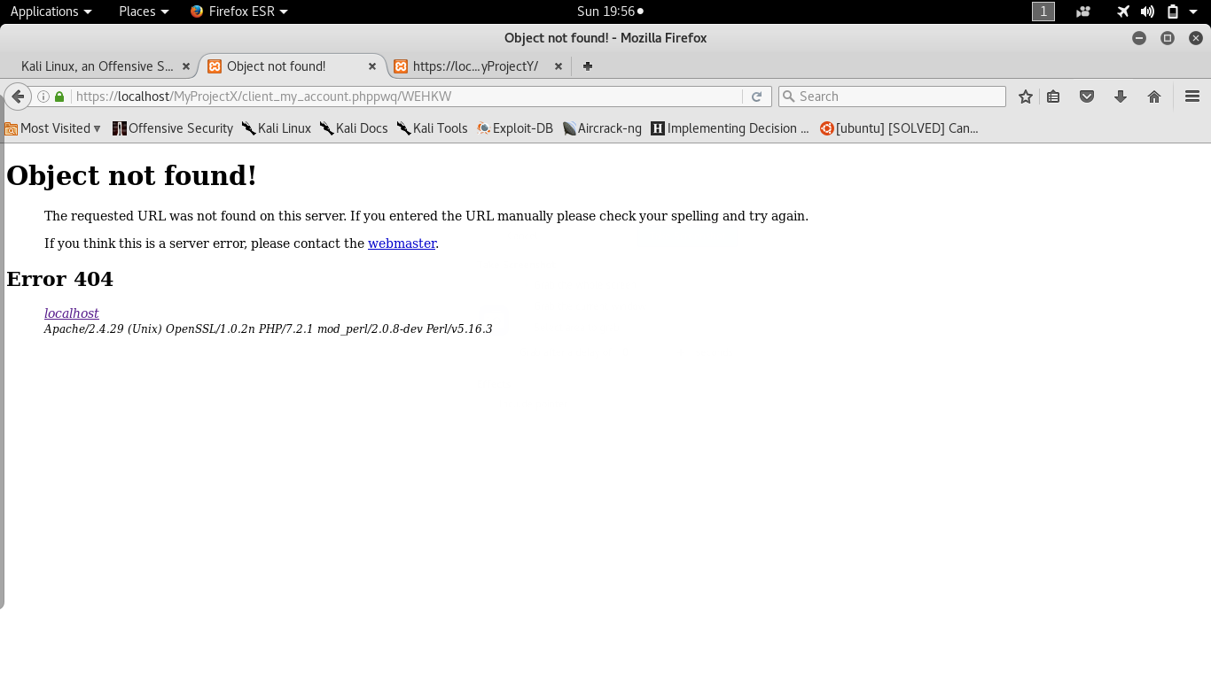

Figure 44 – Object not Found

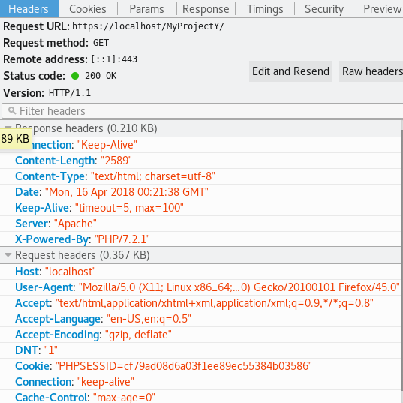

Figure 45 – Browser developer tools, headers

To avert such event to occur, it is necessary to make some changes in the configuration file “httpd.conf”, as evident to see in Figure 46 and 47.

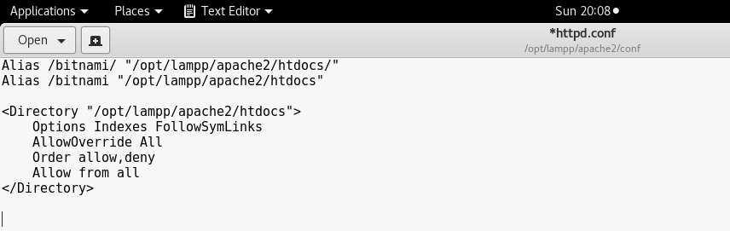

Figure 46 – Default configuration

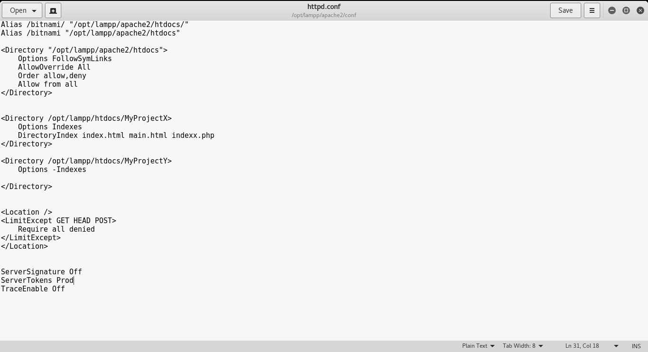

Figure 47 – Configurations adjusted

The changes that were made to hide sensitive information, the “Server Signature” previously On was turned to Off and ServerTokens was added to just display “Apache” and nothing else.

In the php.ini file the expose command has been turned off to not display the php version as demonstrated in Figures

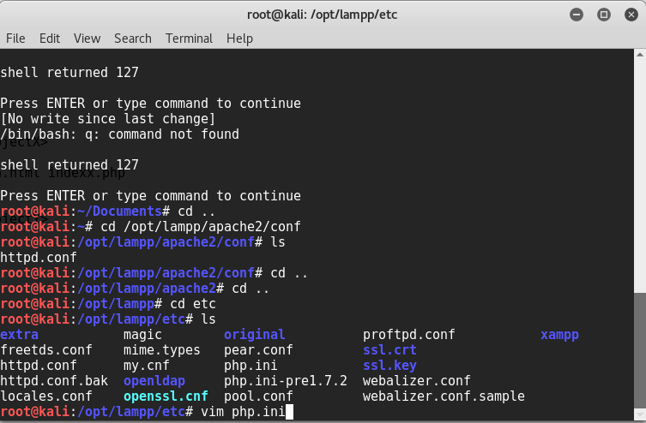

Figure 48 – Exposure of php version stage

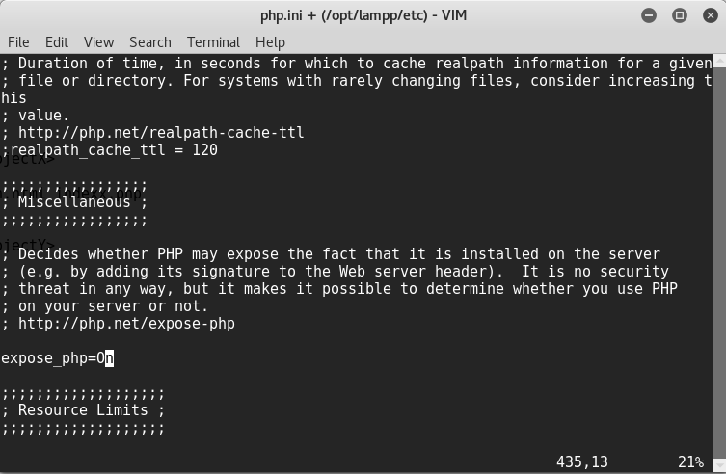

Figure 49 – Exposure of Php version stage 2

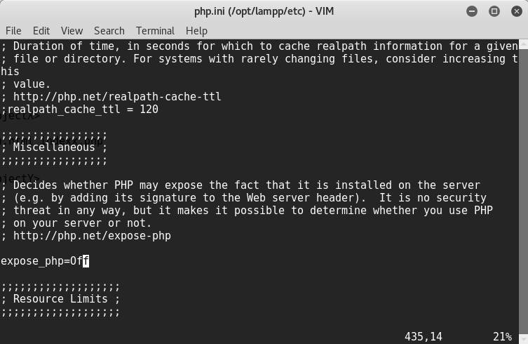

Figure 50 – Exposure of php version stage3

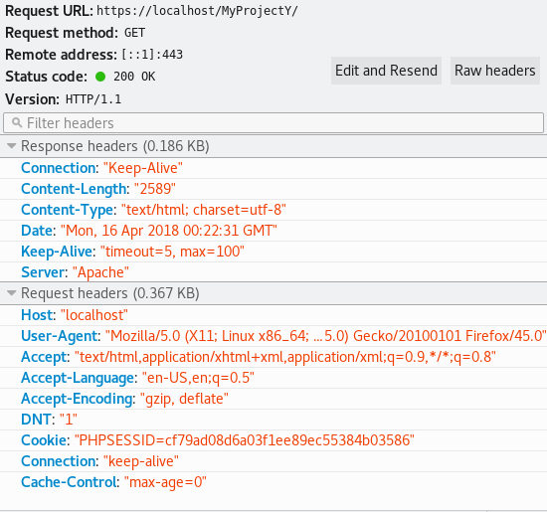

Figure 51 – Demo

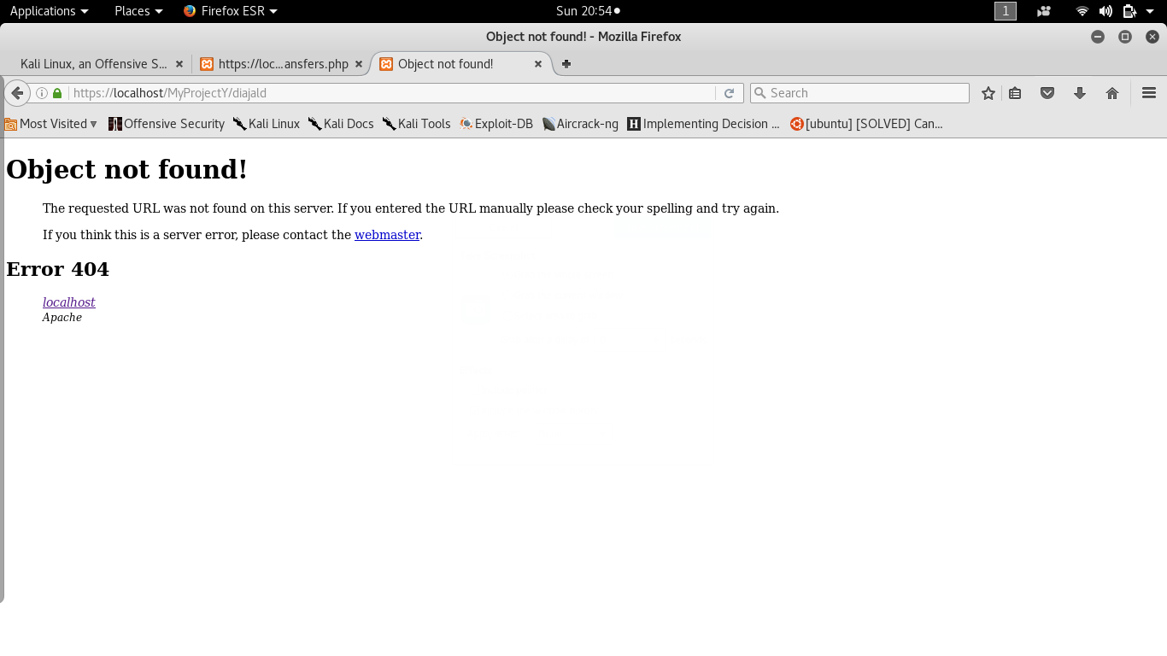

Figure 52 – Demo 2

#### Directory listing

This vulnerability can be exploited by not specifying which file to request in the URL of a specific directory in the server.

By default, if there is an index.php file in the folder, Apache will return that page, but in the weaker prototype the index page was named “indexx.php” and that causes the server to display all the contents of Document root directory as portrayed in Figure 53.

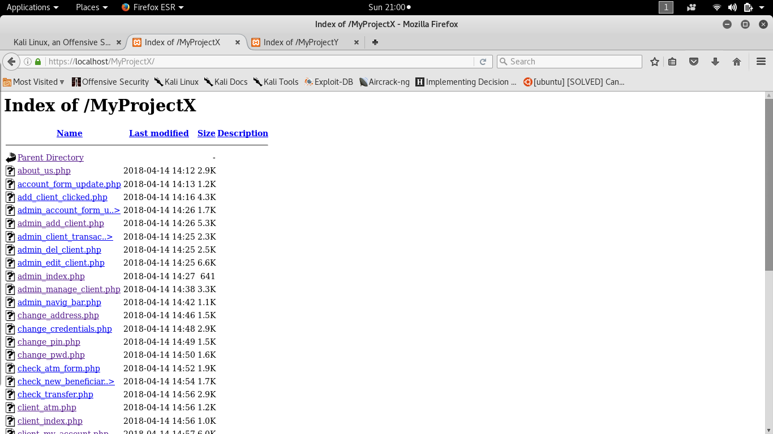

Figure 53 – Listing files of a directory

The default configuration files are shown in Figure 54.



Figure 54 – Default configuration

To avert that from happening, in the same file the character minus was inserted right after Indexes and the below line to instruct Apache to display one of the specified file names as index default page in the event where “index.php” does not exist as pictured in Figure 55 and demonstrated in Figure 56.

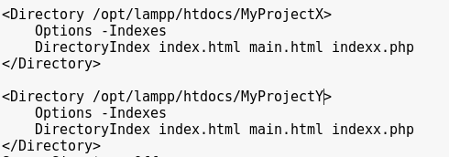

Figure 55 - Configurations adjusted

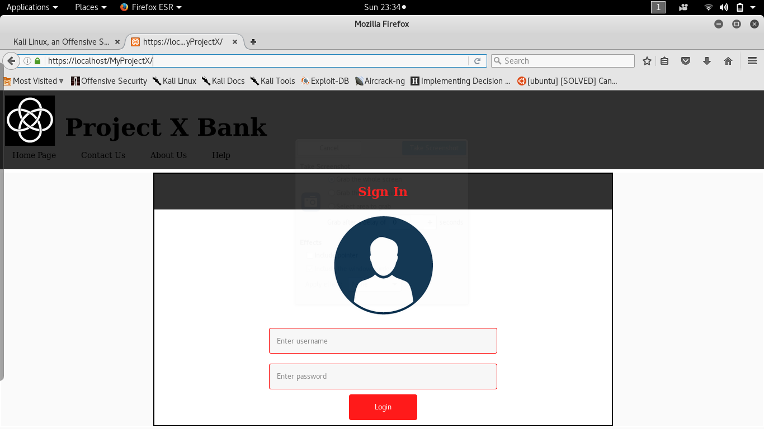

Figure 56 - Demo

#### Update of Apache

Apache frequently release new updates to deal with security issues discovered and as an administrator it is important to do so.

To update apache version this following command was run:

yum update httpd

apt-get install apache2

Updating Apache is as important as keeping up-to-date with the operating system in which your web server is running on.

#### Disable Trace Off

The trace method is a HTTP request method that echoes back to the client the message content obtained.

It is enabled by default and afterwards disabled as demonstrated in Figures 57, 58, 59, 60.

It was created for debugging reasons to use during the development stage.

However, it is also a threat that an administrator should remove, otherwise it is an open door for an attacker to use this method to steal session cookies with Cross-Site scripting attacks, although the cookie has been set with httponly and secure flag.

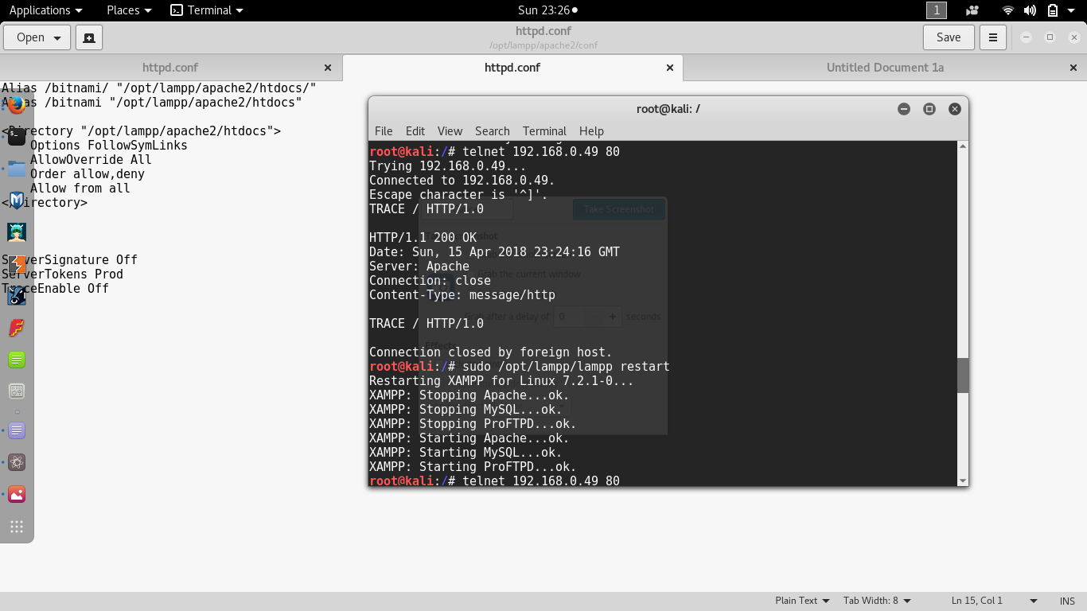

Figure 57 - Demo

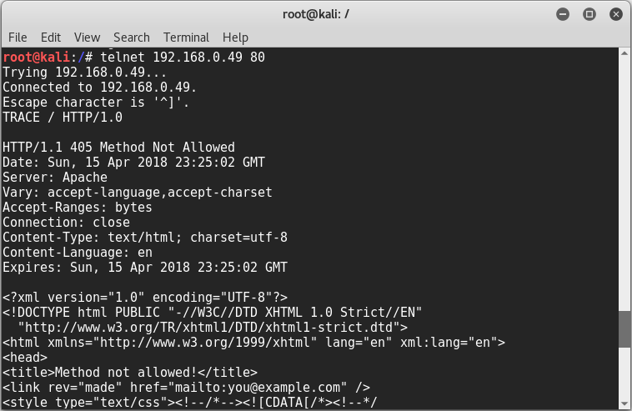

Figure 58 – Demo 2

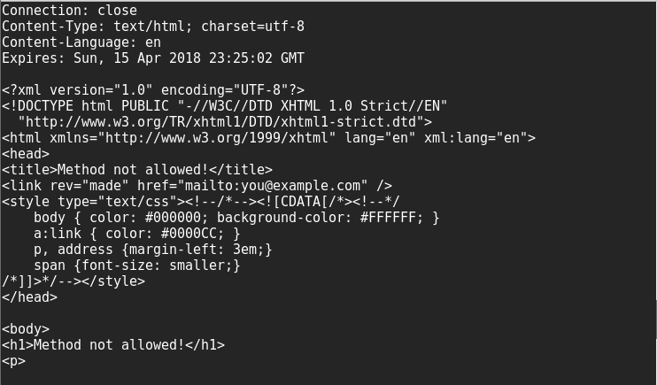

Figure 59 – Demo 3

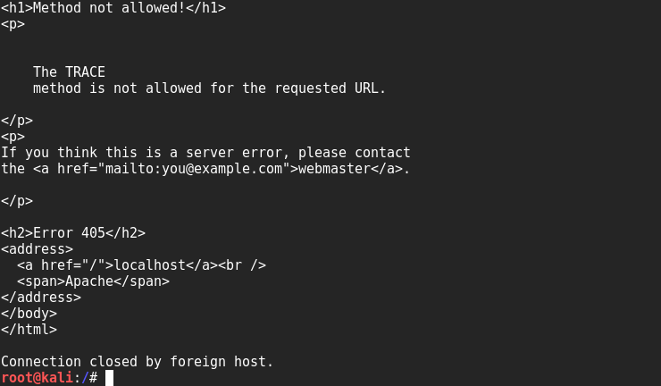

Figure 60 – Demo 4

In order to set the httponly flag for session cookies the code below was added before starting any session visible in Figure 61 on line 3.

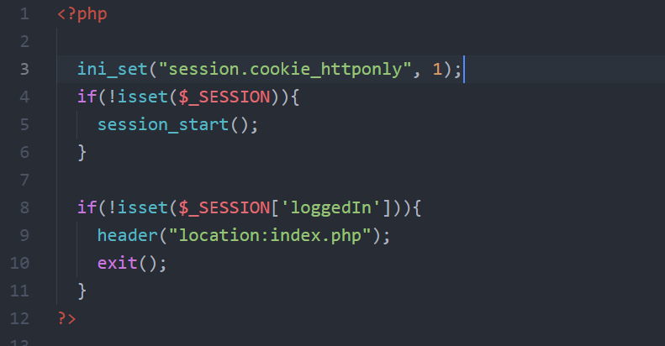

Figure 61 – httponly flag

#### Restrict HTTP Methods

All HTTP methods: GET, HEAD, POST, PUT, DELETE, CONNECT, OPTIONS, TRACE and PATCH are by default allowed.

The DELETE method is used for demonstration purposes as illustrated in Figures 62, 63, 64, 66, 67, 68, 69; the only method now allowed are pointed out in Figure 65.

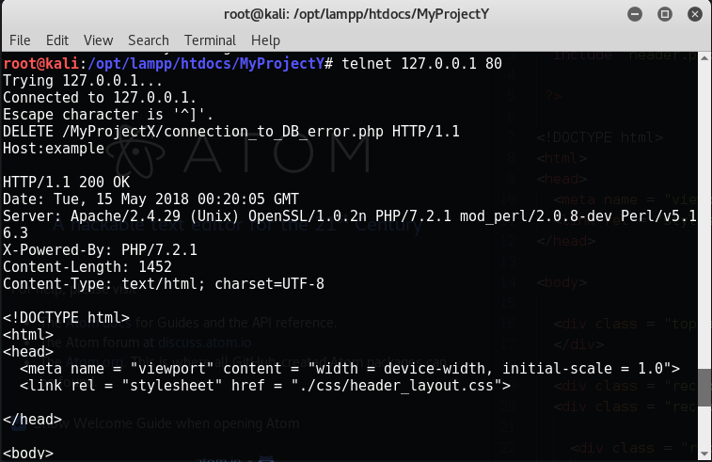

Figure 62 – Demo allowed

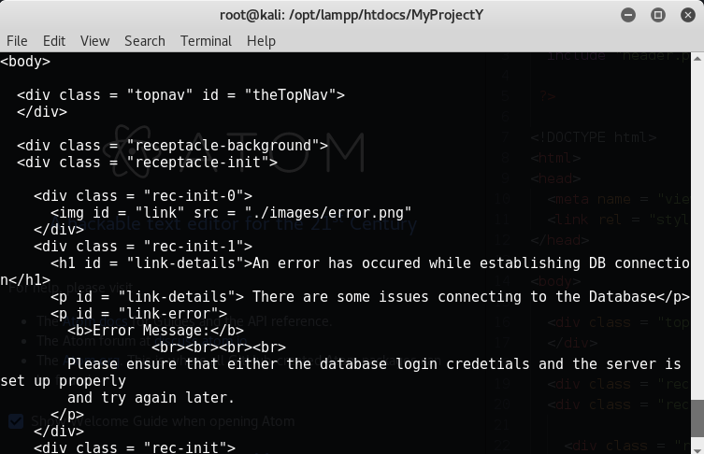

Figure 63 – Demo allowed 2

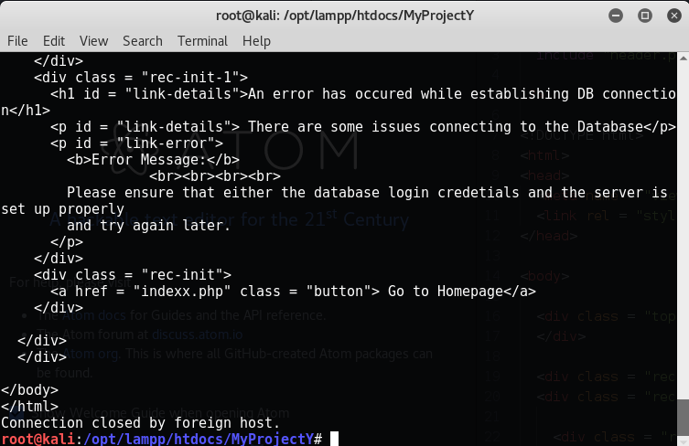

Figure 64 – Demo allowed 3



Figure 65 – Configurations adjusted

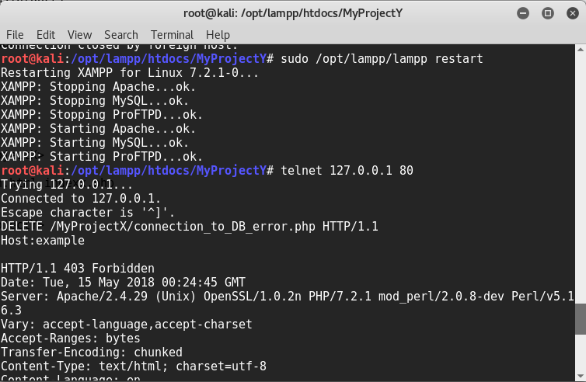

Figure 66 – Demo not allowed 1

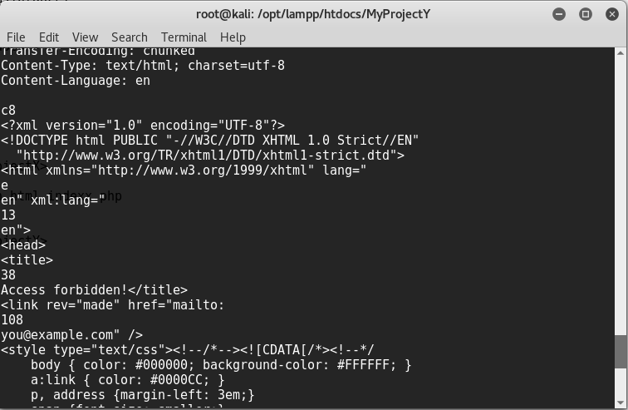

Figure 67 – Demo not allowed 2

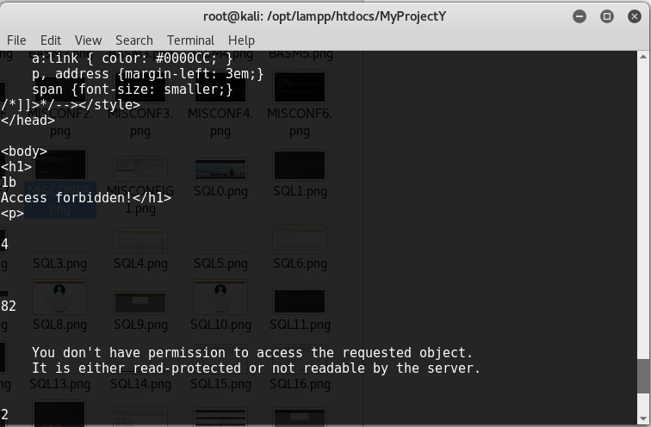

Figure 68 – Demo not allowed 3

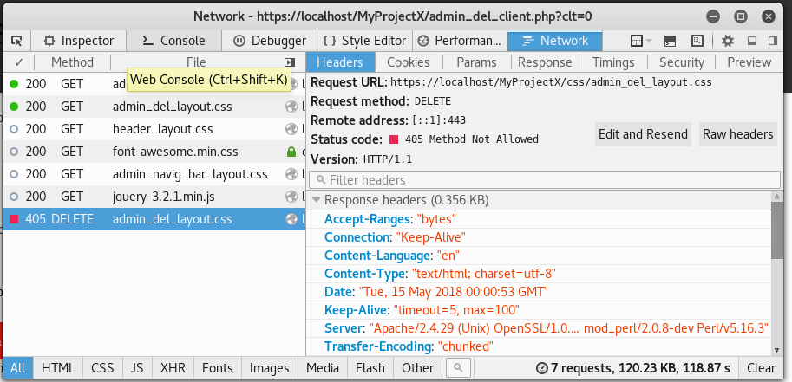

Figure 69 – Demo not allowed 4

#### Apache user and group

By default, the user is nobody or daemon and for security reason a new MySQL user was created for the application to conform to the principle of the least privilege.

As you can see from the command on line 48 of Figure 70 the Apache user is daemon, displayed in Figure 02-00.

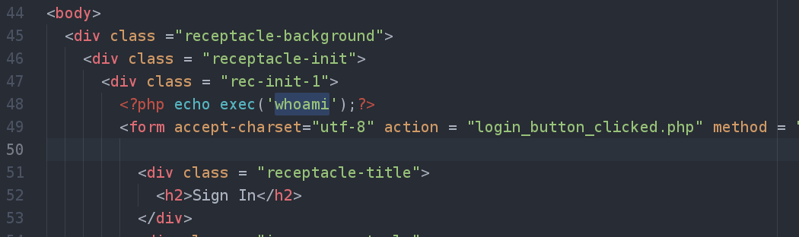

Figure 70 – command to find out the user

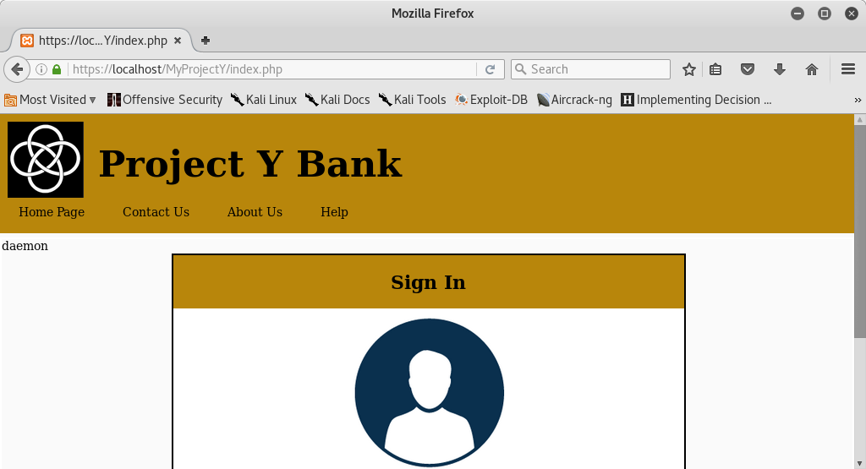

Figure 71 – MySQL user

When running Apache on a machine it is important to not run as root, failure to do so if an attacker successfully exploit a vulnerability to take over the server and machine where Apache is running, he would gain the same privileges as a superuser.

As it is plain to see in Figure 72, this could be a potential risk.

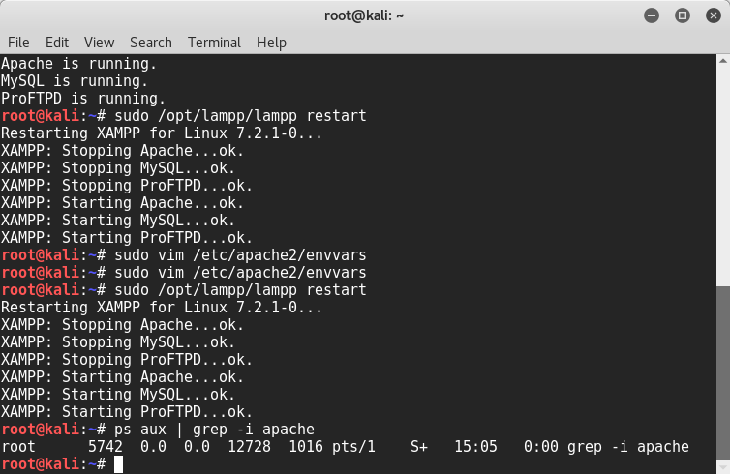

Figure 72 – Machine user running Apache as root

As it is shown in Figure 73, the file named “envvars”, which File System location is shown in Figure 72, here Apache exports a user in which the server is going to be running as when started.

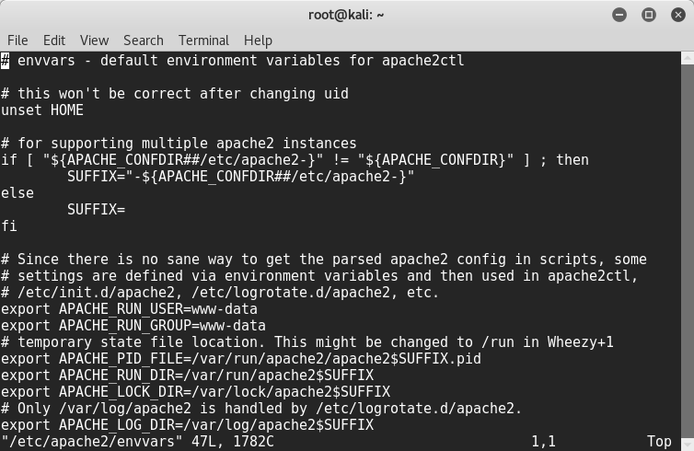

Figure 73 – User for Apache

This file has only write permission for the owner of the file itself which was previously root.

In the case scenario where, the web server is being controlled from a malicious user, the attacker would gain full access to the system.

Firstly, to avoid that from happening, a new user was created named Bob as illustrated in Figure 74.

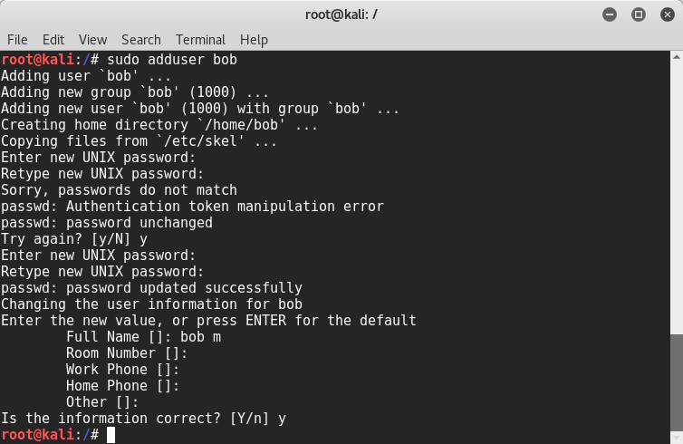

Figure 74 – Create new user

Secondly, the ownership of the file envvars was assigned to Bob as demonstrated in Figure 75 and 76.

Next in order, Bob user id was defined, by adding his account to the group “www-data” to force the server to run without sudo privileges as pictured in Figures 74.

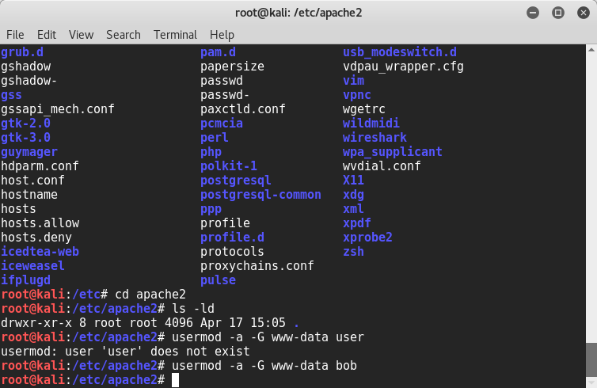

Figure 74 – Adding user to www-data group

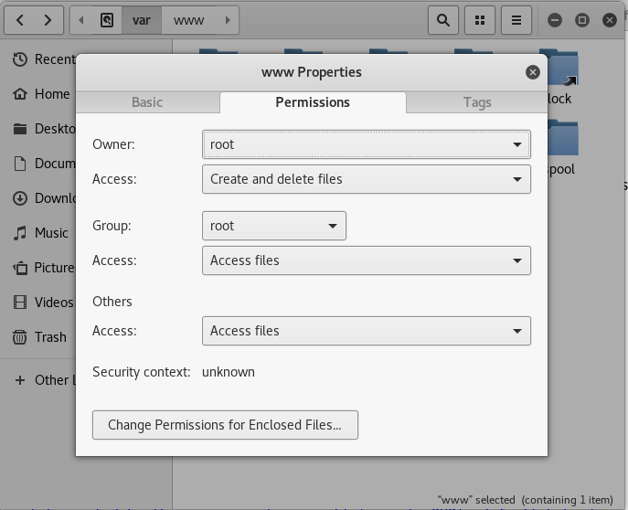

Figure 75 – Previous ownership: root

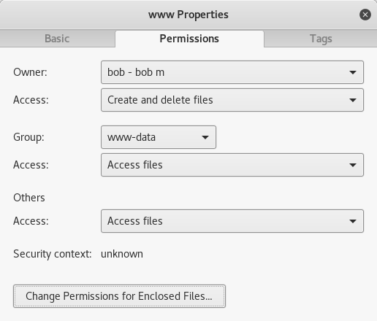

Figure 76 – Ownership changed: bob

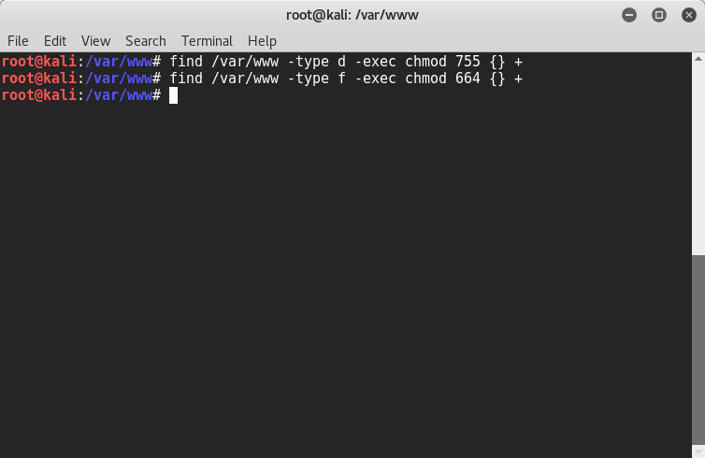

Figure 77 – chmod permissions

Evident to see in Figure 77, the linux command chmod was used to change permissions to folders recursively giving to the owner read, write, execute permissions; to group and others read and write permissions.

Regarding files read and write permissions to the owner and group; for others read-only.

To run the server without privileges, at this point, it was necessary to logout from the root account and login and run Apache server as Bob illustrated in Figure 78.

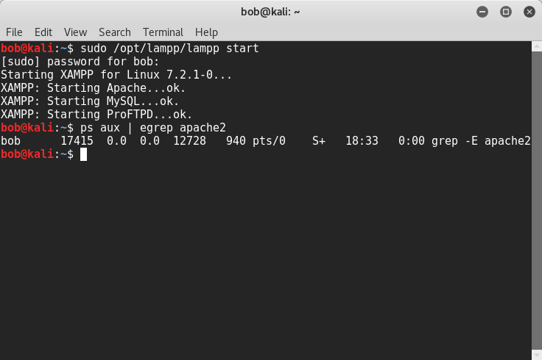

Figure 79 – Apache started as Bob

As you can see Bob do not have privileges to write into Apache files, but only read-only as shown in Figure 80 and 81.

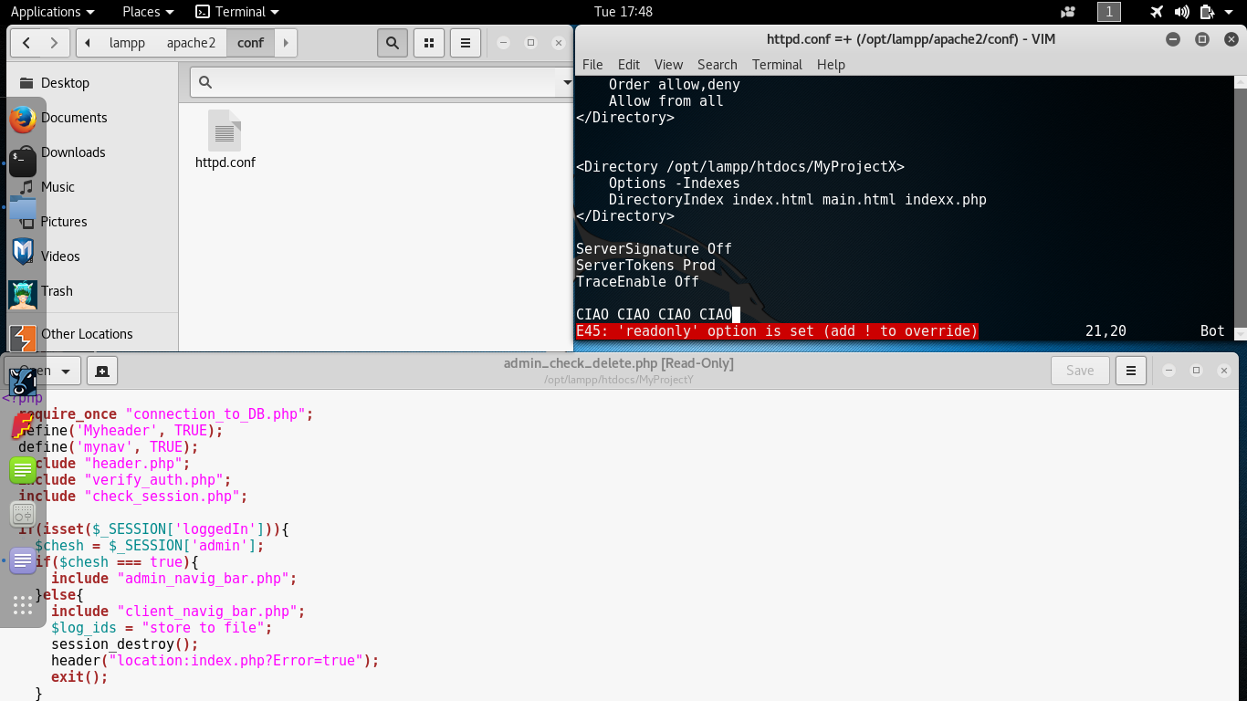

Figure 80 – Demo 1

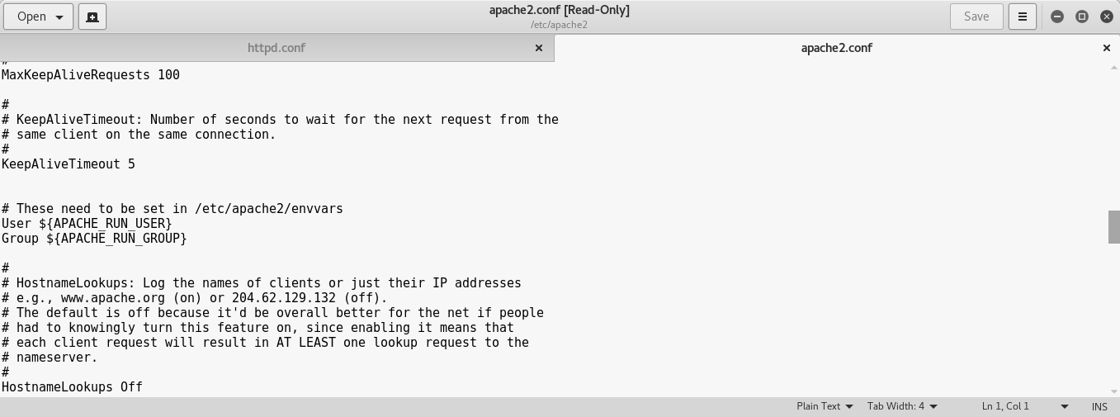

Figure 81 – Demo 2

A problem occurred when the online-banking website was accessed in ProjectY; as the API could not load as pointed out in Figure 82, because only root can bind ports below 1024 and Bob does not even belong to the sudo group.

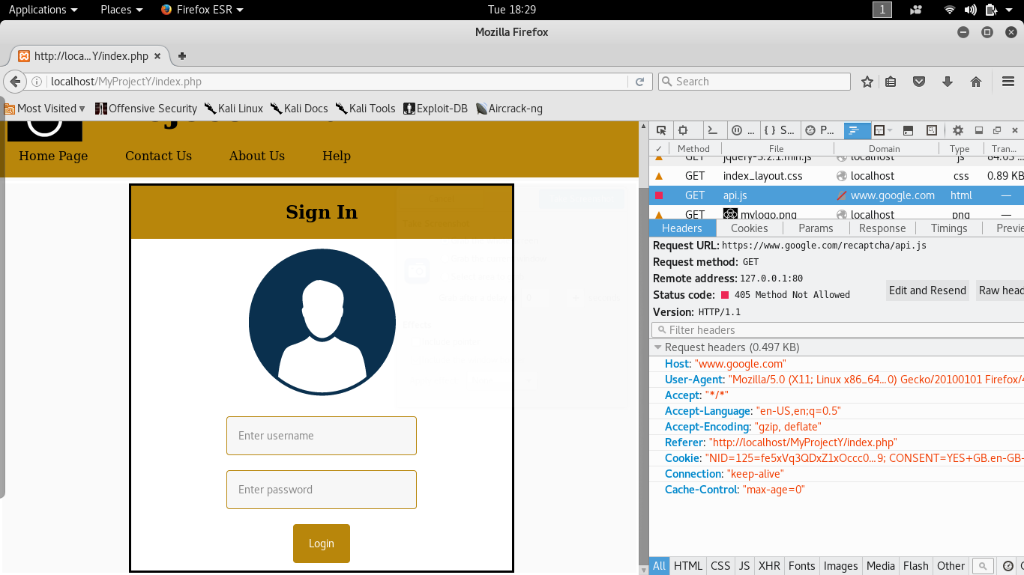

Figure 83 – Method not allowed for current user

The way the web server is configured, does not consent GET method and others to non sudo users, causing the online banking website which uses this method to retrieve reCAPTCHA from google, to fail.

To remediate this issue, Bob was added to the sudo group users.

It is more secure this way, it complies with the concept of least privilege, in fact all sudo commands gets registered into audit log files and in the case scenario where the system has been compromised by an attacker, who did not managed to erase the evidence, will help the administrator to examine and dissect the files to determine what occurred.

#### MySQL User

In the early stages MySQL root user was used to access the database through the web application ProjectX as shown in Figure 84 on line 3.

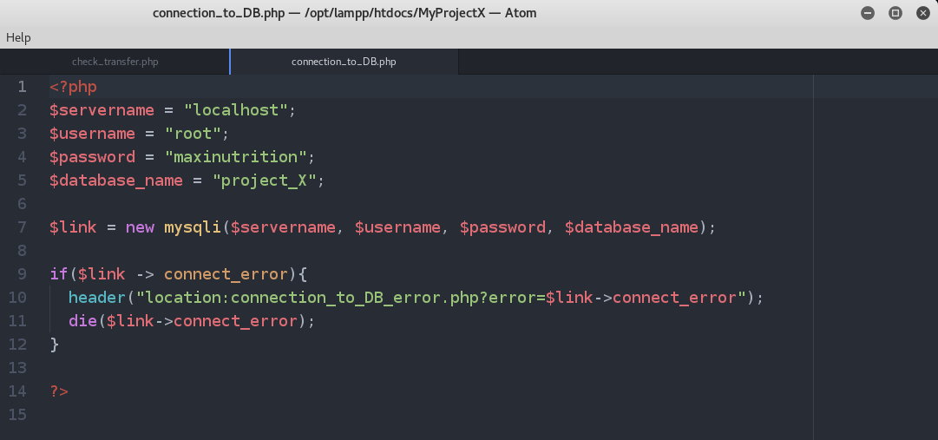

Figure 84 - php file to connect to the database

In order to mitigate this risk a designated user was created and assigned limited privileges as shown in Figure 85, 86, 87, 88, 89, 90, 91 and 92.

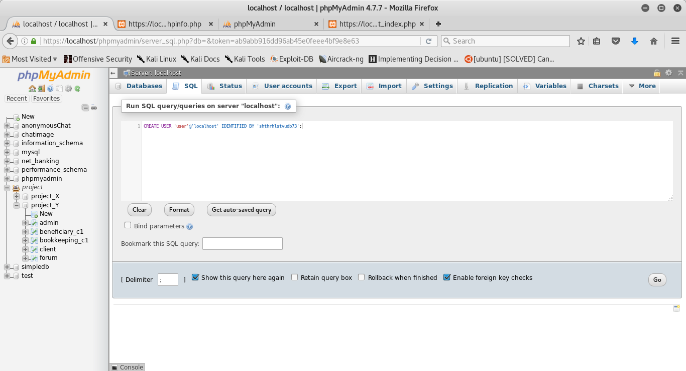

Figure 85 – Demo 1

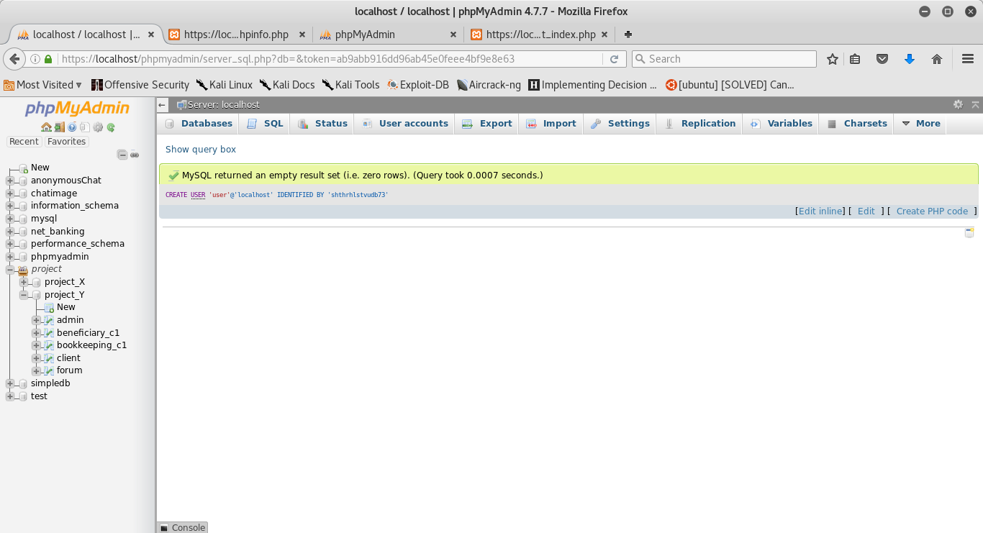

Figure 86 – Demo 2

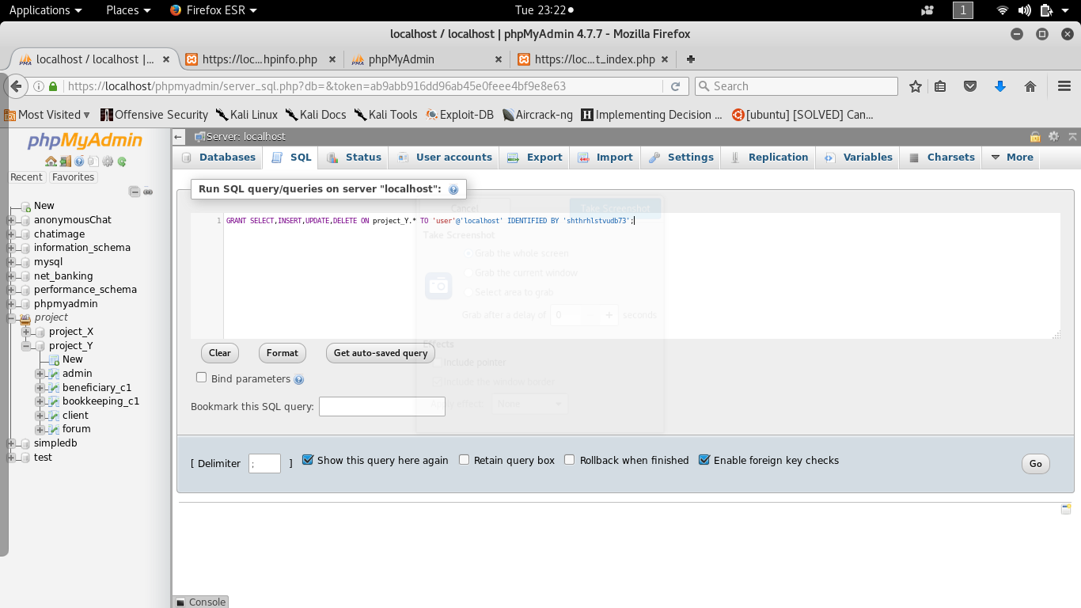

Figure 87 – Demo 3

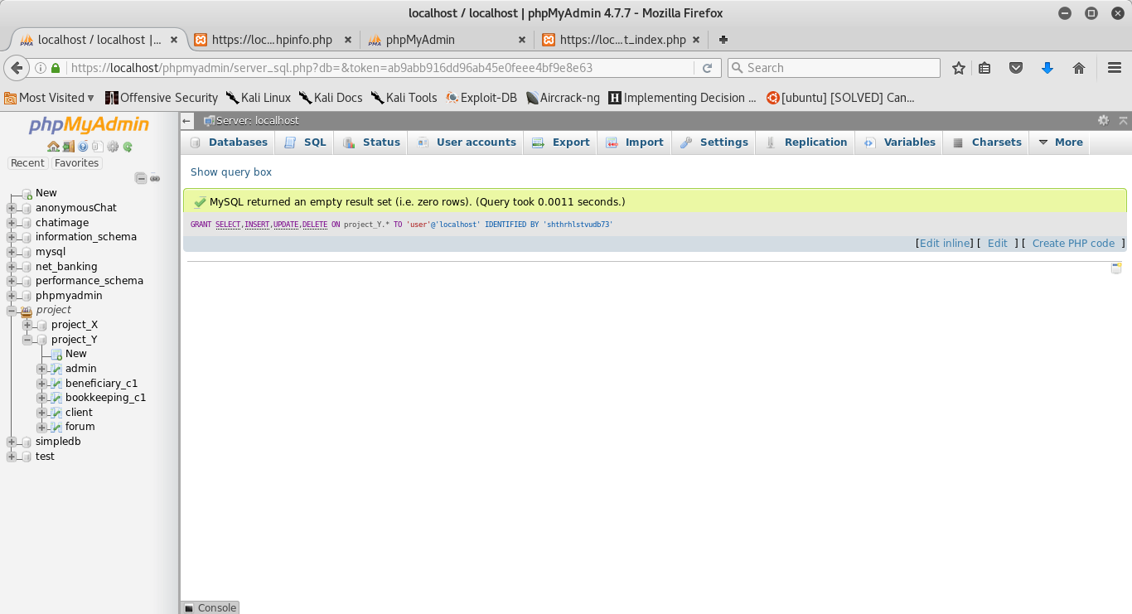

Figure 88 – Demo 4

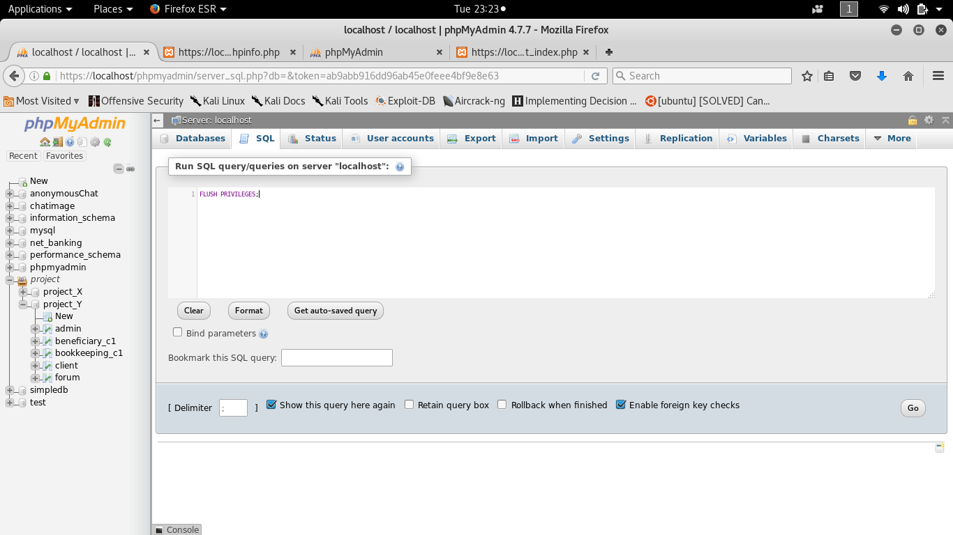

Figure 89 – Demo 5

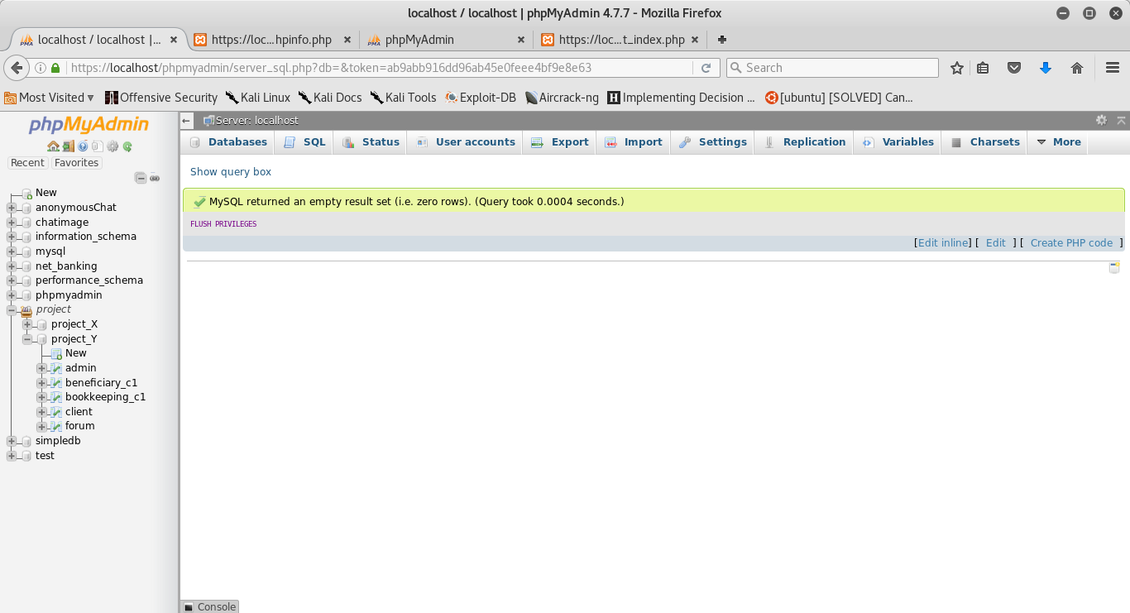

Figure 90 – Demo 6

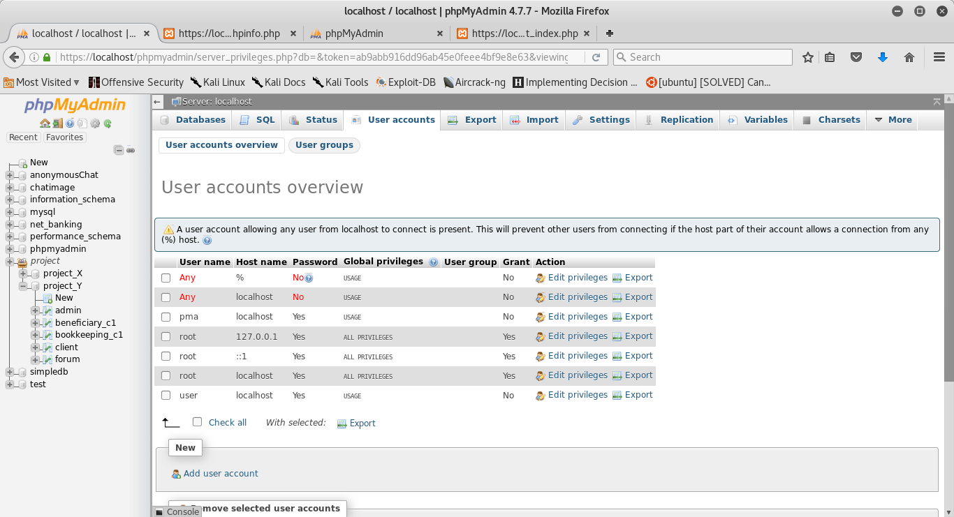

Figure 91 – Demo 7

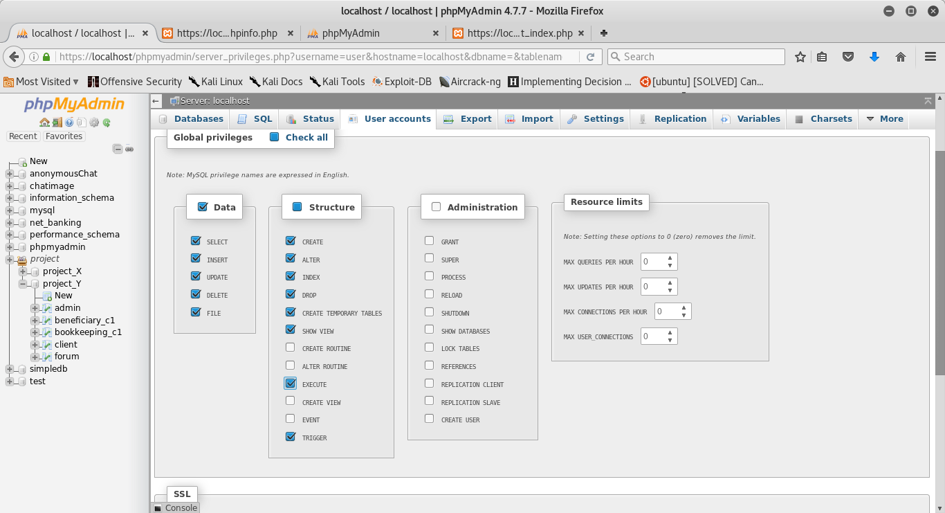

Figure 92 – Demo 8

The connection file was changed accordingly and placed outside of the web root of ProjectY for security reasons as pictured in Figure 93.

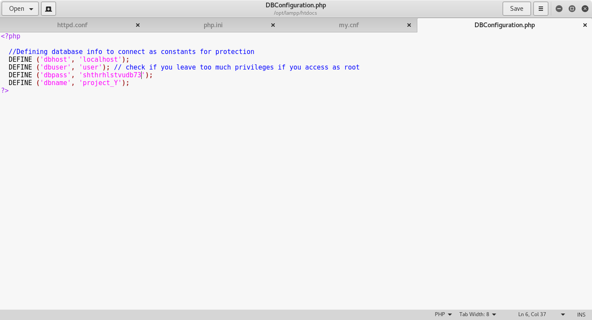

Figure 93 – credential file to connect to the database

#### PhpMyAdmin

With an outdated version of Apache, a user connected to the apache server in a LAN network, was able to view the dashboard and if possessing of the correct credentials, he could to login to PhpMyAdmin, but after the update this is not anymore allowed for virtual host, but only for localhost as shown in Figure 94.

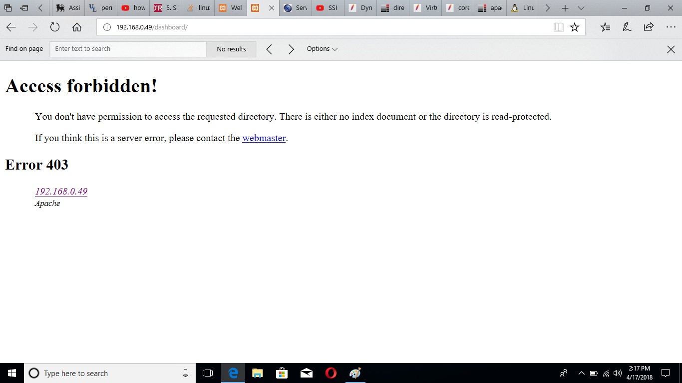

#### Figure 94 – Dashboard Access forbidden

To harden the access of subdirectories of “localhost/dashboard” and important files such as “phpinfo.php”, “php.ini”, “my.cnf”, “httpd.conf”, permission to read, write or execute have been given to only root, for instance in Figure 95 the file “phpinfo.php” which contains highly sensitive about apache.

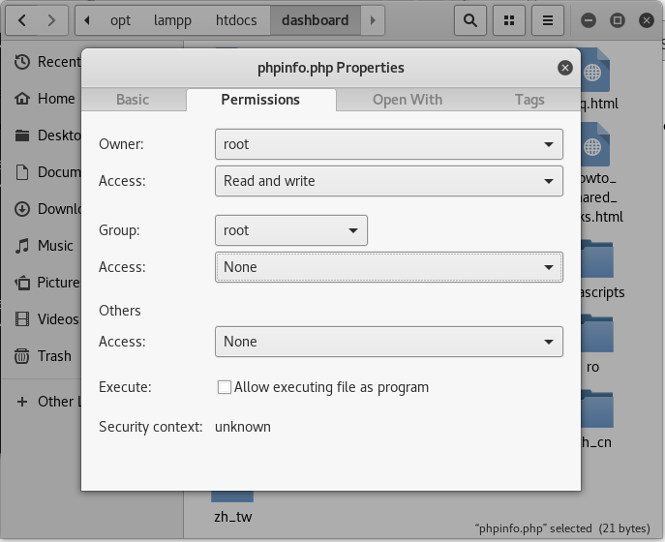

Figure 95 – phpinfo.php file permissions

#### Disable Local INFILE

If this feature left enabled allows anyone to upload a file on the server host and presuming that an attacker is able to run any SQL COMMAND to the server, the attacker would be able to read access files that the Web Server hold.

This can be prevented by replacing the digit 1, which stands for true or enabled, to 0 (false or disabled).

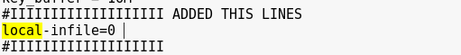

Figure 96 – pwd /opt/lampp/etc/my.cnf

#### Restrict files and directory access

As the title may suggests users have been restricted to access only certain files and directories (Figure 97).

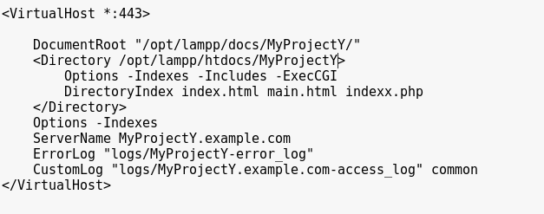

Figure 97 - pwd /opt/lampp/etc/extra/httpd-vhosts.conf

#### Disable Server Side Includes and CGI

If enabled this feature can allow an attacker to dynamically include and run external scripts.

To disable it, a minus sign is placed in front of the keywords ExecCGI and Include for users as shown in Figure 97. In Figure 98 is an example of the features enabled.

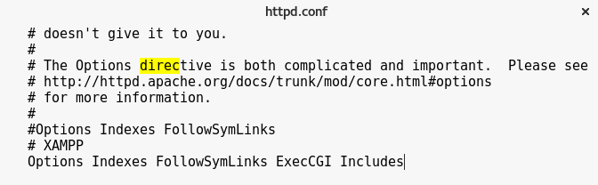

Figure 98 – pwd /opt/lampp/etc/httpd.conf

#### Disable Remote Code Execution

This function, if not used should be disabled (Off), but because of the use of reCAPTCHA it has been left enabled (On).

It involves functions that can fetch data from Hyper Text Transfer Protocol or File Transfer Protocol and run code.

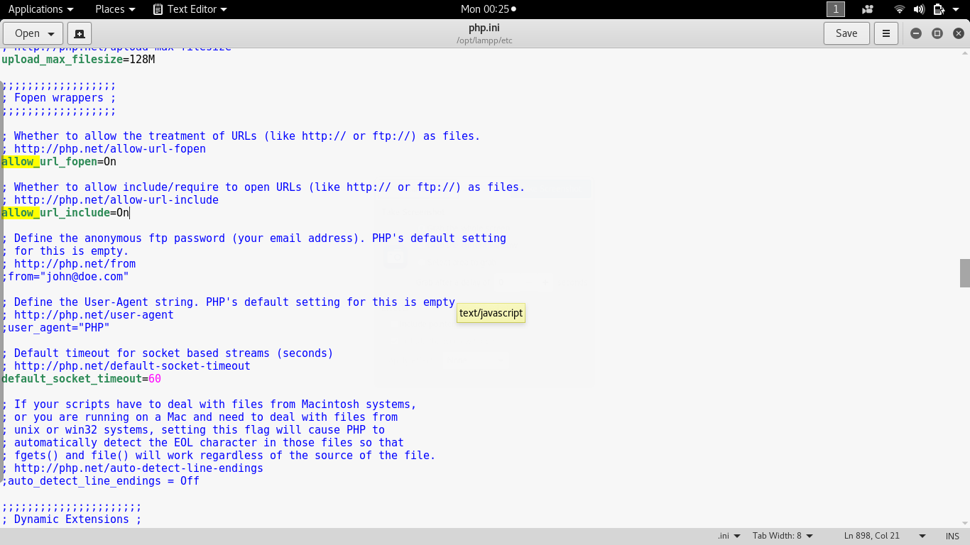

Figure 99 – Default configuration

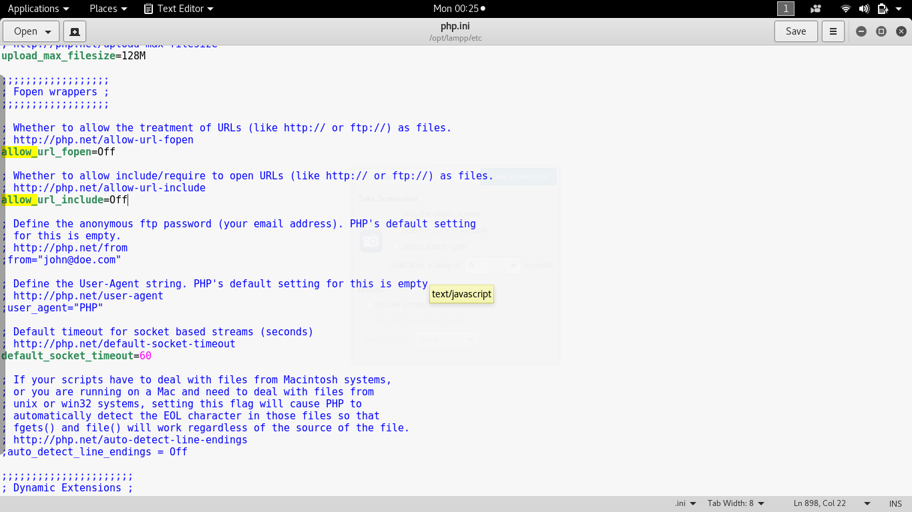

Figure 100 – Configurations adjusted

#### Disable risky php functions

It is good behavior to remove threatening functions which are not used by the banking site.

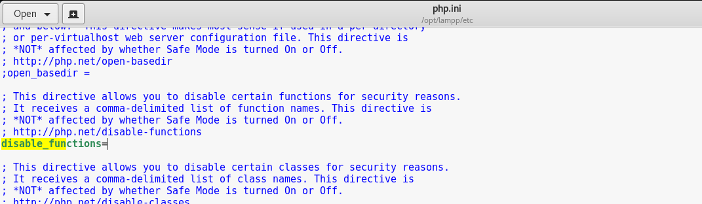

Figure 101 – Default configuration



Figure 102 – Configurations adjusted

#### Limit PHP Access to the File System

Applying theory of least privilege.

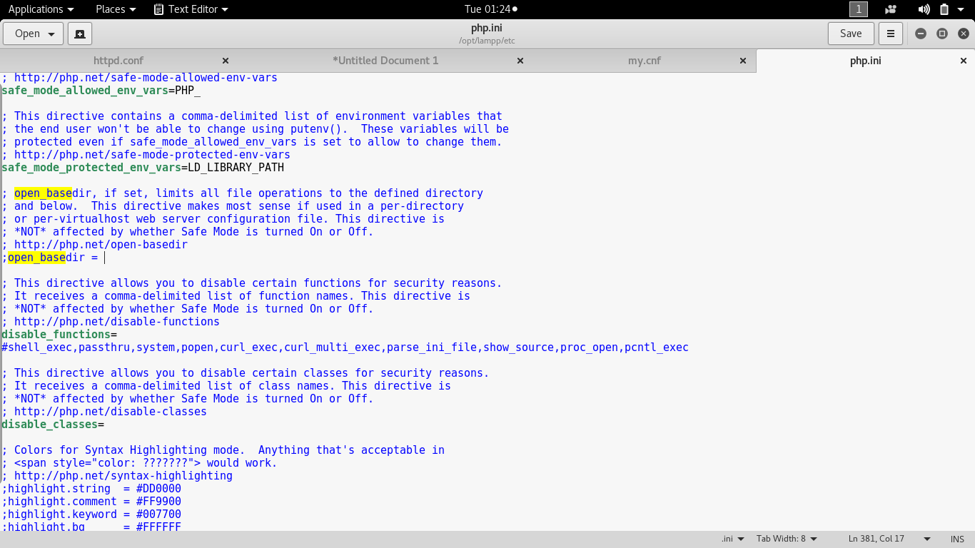

Figure 103 – Default configurations

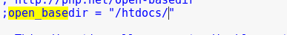

Figure 104 – Configurations adjusted

#### Set restrictions for PHP in the past tense

Even though, the features to upload files to the server has been disabled, it is good practice to reduce the maximum size of a file that a user can upload; set a maximum execution time for a script to run and time for parsing the demanded data.

#### Disable Remote MySQL access

A line of code has been added to only allow a localhost to connect to MySQL as shown in Figure 105.

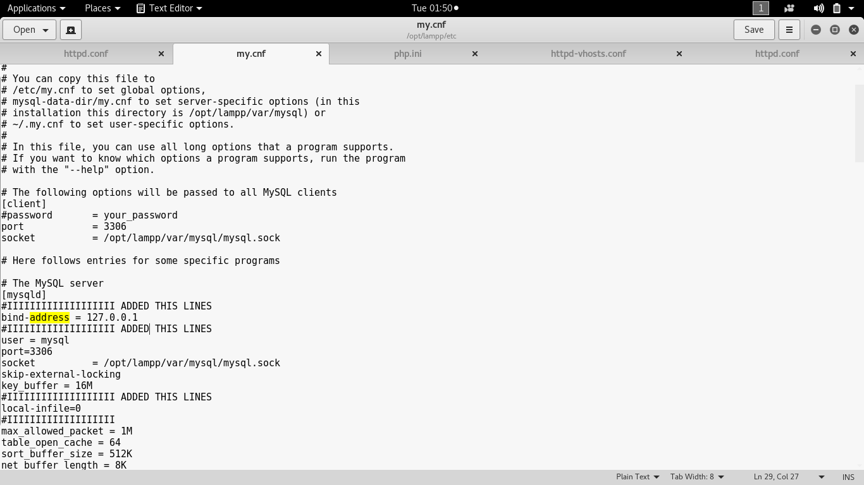

Figure 105 – pwd /opt/lampp/etc/my.cnf

### 6.3.5 Sensitive data exposure

It regards banking details, personal information, user accounts and passwords; basically, anything that a client of this banking website could consider sensitive.

The side-effects of this are capital loss, identity theft or hi-jacked.

A simple method an attacker can capture our data is by listening on the wire, there are tools available to do so, such as Wireshark, TCPdump or NetCat.

It is important to take some measures in advance to prevent unpleasant events.

#### Project X

In the weaker prototype, the input of the password field is visible as shown in Figure 106.

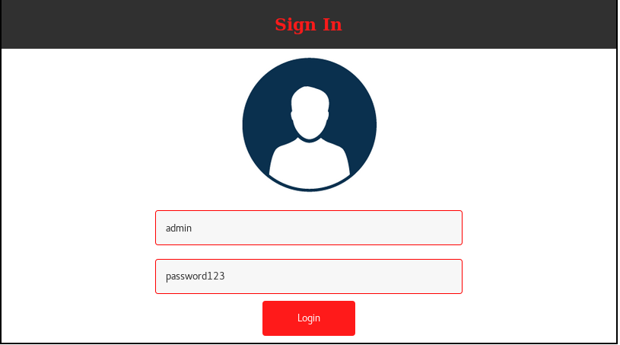

Figure 106 – Password visible

Data that should not be displayed in plain text such as the Primary Account Number (PAN), the Pin for the ATM Simulator and the password to login to the online banking website.

The data is transmitted over an unencrypted medium channel and anyone with the right tools can eavesdrop this communication and retrieve access to the data in it.

This infringement can occur during the physical Layer of the Open System Interconnection model (OSI), where the signal of the node where the message is coming from is captured by another node, that was not meant to receive it at all.

As illustrated in Figure 107, the machine is connected over HTTP.

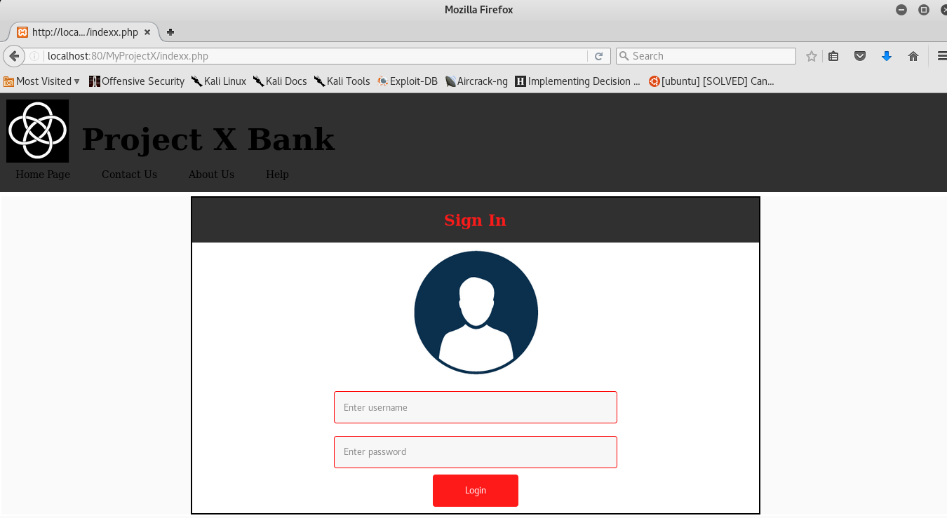

Figure 107 – HTTP connection

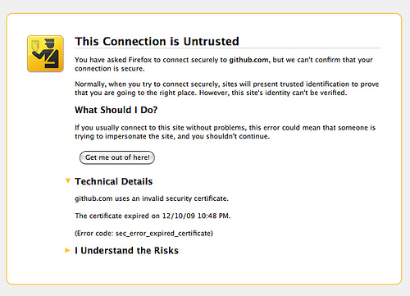

Figure 108 – Untrusted connection

Bear in mind that, HTTPS is not always trustworthy.

When using this channel, the browser task is to examine the server identity by inspecting the authenticity of the SSL certificate, because the last could be signed by a non-reliable entity or even self-signed. Behind the scene, the communication with this site could be easily sent to a proxy and someone could be listening to the traffic.

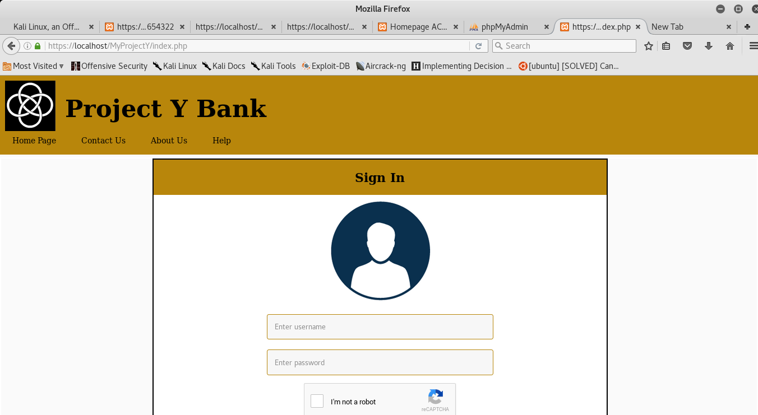

Figure 109 – HTTPS (padlock green)

Another risk of this kind could be found on the database, as sensitive data are stored in plain text.

In the case scenario an attacker successfully injects some Sql command to retrieve all passwords, he would acquire them, without the need to decrypt them as shown in Figure 111.

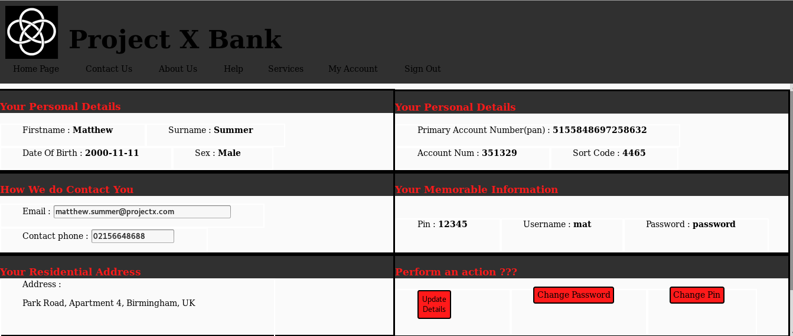

Figure 110 – Unnecessary sensitive data displayed to the user

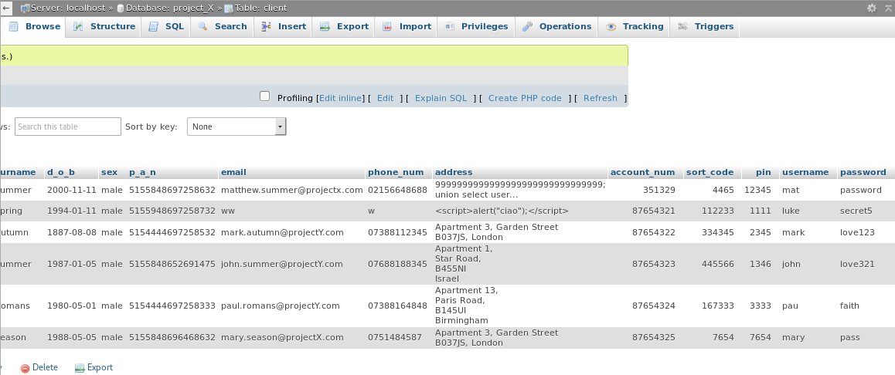

Figure 111 – ProjectX table client

#### Project Y

In the weaker prototype, unnecessary data is displayed to the user, for example the PAN, shown in Figure 110.

In the second model, sensitive data that was unnecessary to display and dangerous was removed as shown in Figure 112.

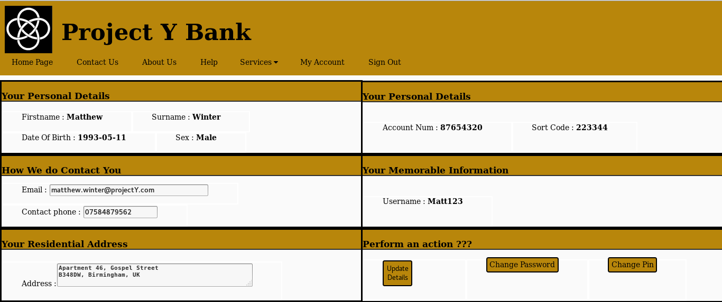

Figure 112 – Only necessary data are displayed to the user

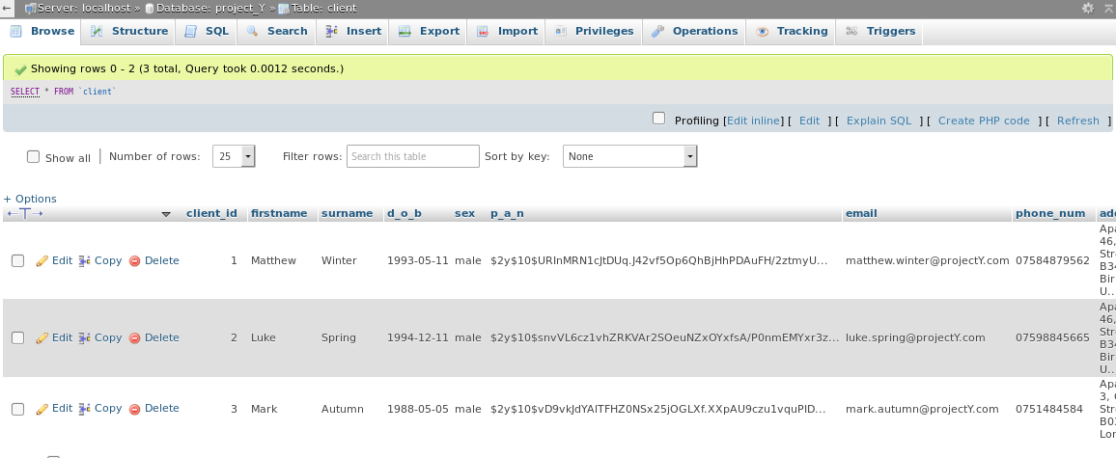

Figure 113 - ProjectY table client

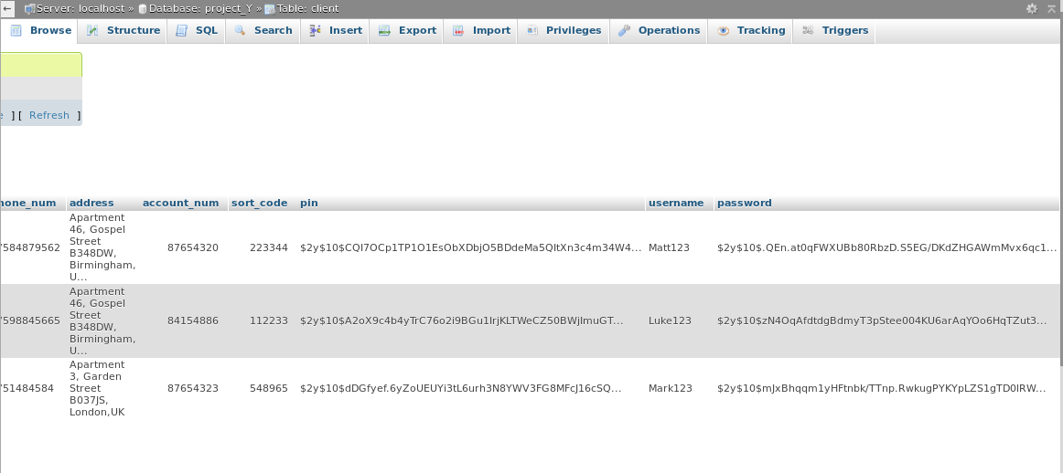

Figure 114 – ProjectY table client 2

As it portrayed in Figures 113 and 114, sensitive data have been encrypted.

Below, in figure 115, is the code to encrypt sensitive data at rest.

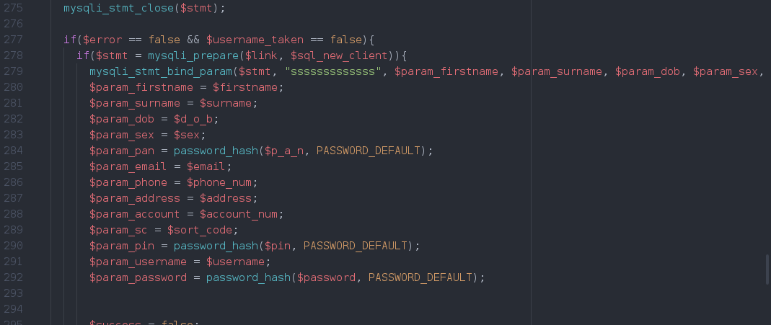

Figure 115 – Encrypt passwords, PANs, and PINs

The “password_hash” function of php generates a new password hashed using PASSWORD_DEFAULT algorithm, which uses bcrypt algorithm.

It was used, because is a function that keeps up-to-date with more potent algorithms.

To encrypt the Pin digits, the length required in the most vulnerable prototype was 4 minimum and it has been increased to 8 to be more secure from brute-force attacks, to be able to have enough time to log events and block a user after more than 3 failed attempts.

An HTTPS connection was set to protect data in transit (Figure 109).

### 6.3.6 Cross-Site Scripting

It occurs when an attacker forces a user to accomplish an unwanted action without his knowledge or consent in a website in which he happens to be already logged.

#### Project X

A scenario-based approach is used to demonstrate the potential risk that resides in Project X and mitigated in ProjectY.

##### Scenario

Matthew: victim

John: attacker

The user Matthew, customer of ProjectX bank, log in to the website to view his balance.

John sends him a link by email, inviting him to visit a website.

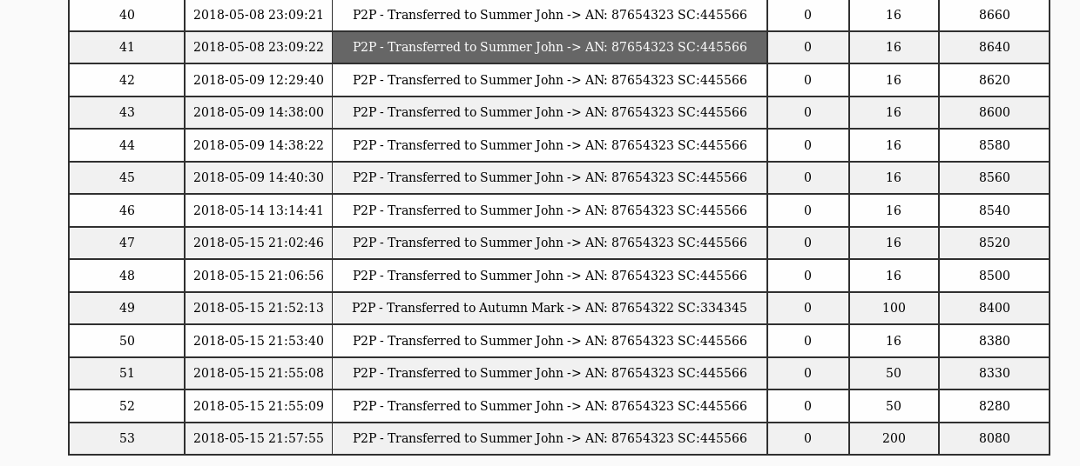

Figure 116 – Current balance of the client

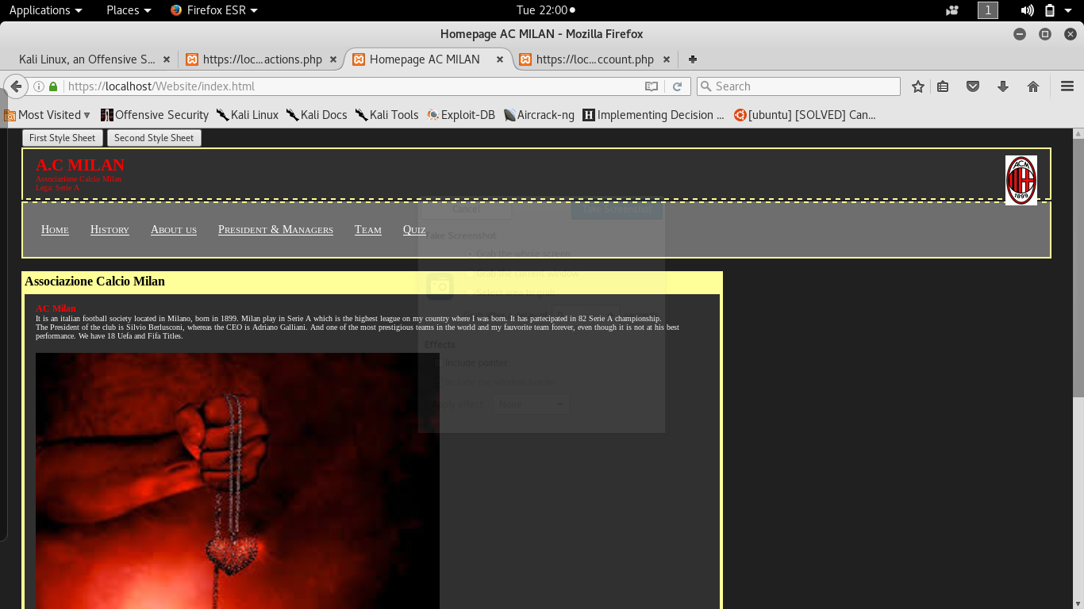

Figure 117 – Website which appears to be legitimate, sent by John

Matthew does not log off in his online-banking account and in clicks the email. The client starts browsing the site.

He remembers that he has not log off.

He goes back to its banking account to log off, but before he does that, he realizes, that his balance has changed; so, he views his table transactions and sees that an amount of 200.00 pound has been transferred from his bank account, to his own account. (vulnerability fixed in the second prototype).

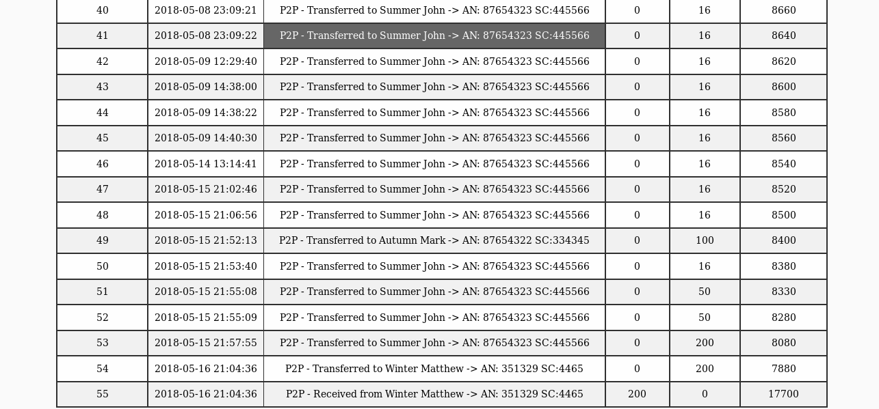

Figure 118 – Balance of client changed

To find out how this occurred Matthew uses the Web Developer tools (Figure 119).

He goes back to Ac Milan website and press on the network tab to view requests that have been generated.

He sees that a GET request method was sent from his own PC to the ProjectX bank, in which he was already authenticated.

He notices that the server replied back with a status code of 200.

Afterwards, he sees another request GET method which explains why he received the money back.

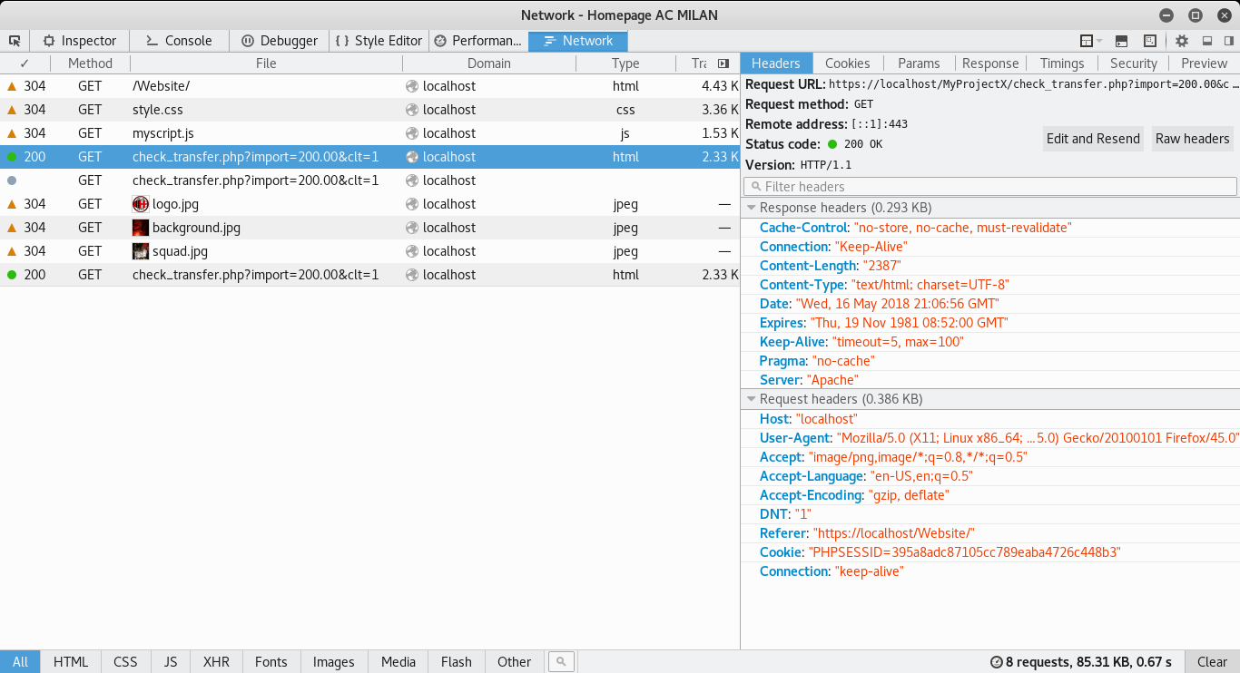

Figure 119 – Web Developer Tools/Network

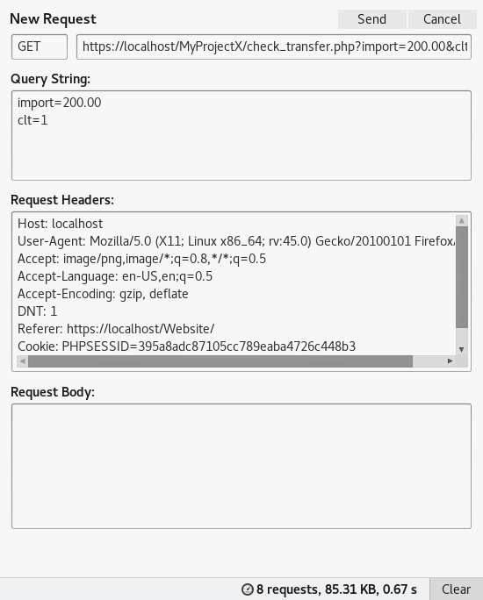

Figure 120 – Request header

He analyzes the query string and he sees that there are two parameters, one for the amount of money transferred named import and one for the client id, himself (recipient).

He comprehends that the request, was originated from the index page of AC Milan.

He views the source of the page “index.php” and search for the keyword “ProjectX” and finds out why that request took place.

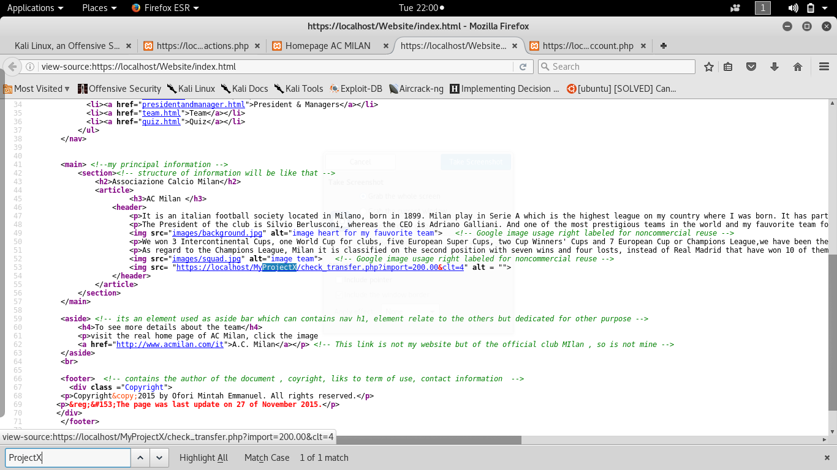

Figure 121 – Source code of Ac Milan

A link was embedded in the image tag of the page and since there was no image to display, therefore an ALT tag was outputted to the screen, which apparently, was left empty.

End Of Scenario

There is no need for clicking the image or link to initiate the HTTP request.

In this occasion the web browser, Mozilla, identifies the HTML code in the image tag and transmits the HTTP request.

Its intention was to retrieve the image to display to the user, but the source of the image, does not load a picture.

The server on the other side, does not recognize that it is not a legitimate request, originated from the account holder, and thus transfers the moneys.

By analyzing the source code, (Figure 122, 123) it is clear to see that, the parameters are passed to the Sql query and gets executed without token to identify that, the user performing the action is unware.

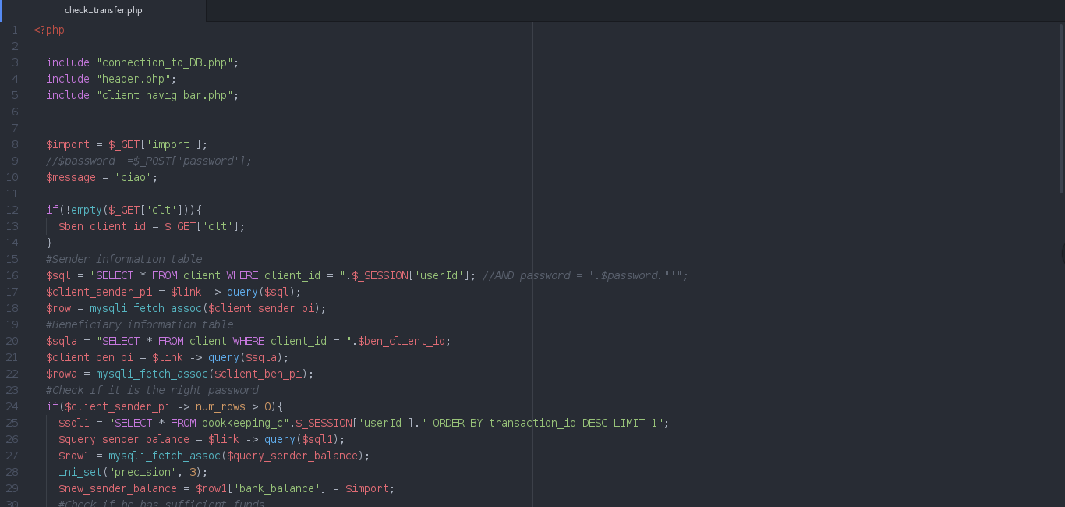

Figure 122 – Source code to transfer money

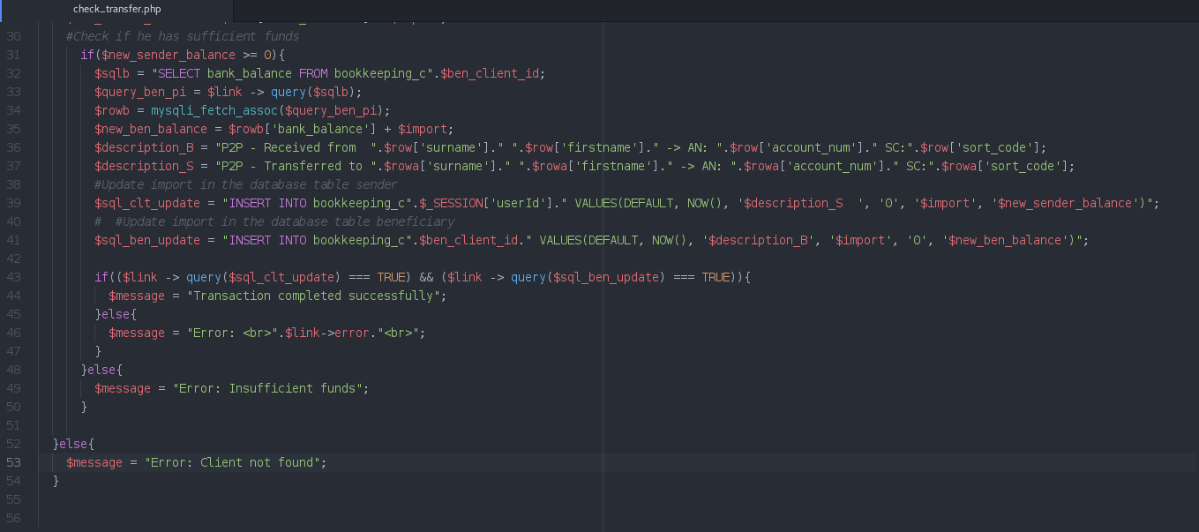

Figure 123 – Source code to transfer money 2

ProjectY

To defend against this kind of attack, in the more secure version, what has been added are secret tokens to validate requests and encryption of GET parameters.

As illustrated in Figure 124, the XSRF attack has changed parameters because the User Matthew has only one recipient he can send the money to and it is not allowed to send it to himself as it is permitted in ProjectX. (Figure 123)

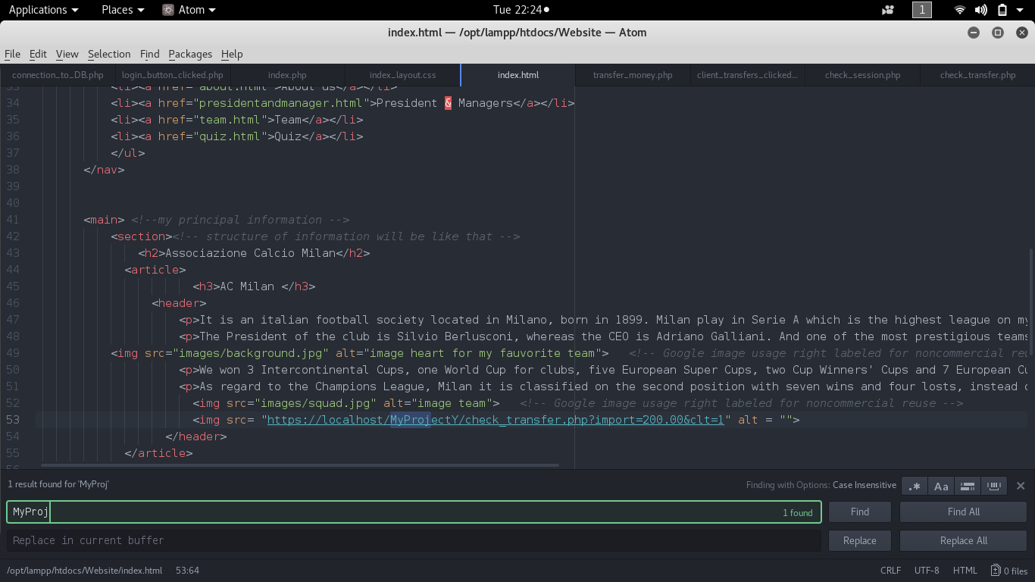

Figure 124 – Attack adjustment

The client parameter has been changed to Luke, his only recipient, to test if the attacks succeed.

Nevertheless, the attempt failed. (Figure 125, 126, 127, 128)

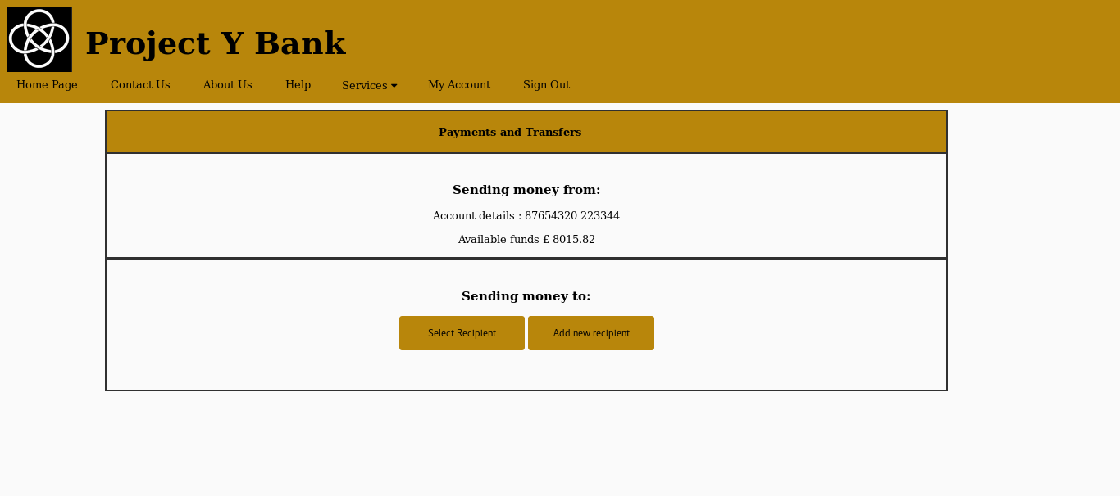

Figuere 125 - Demo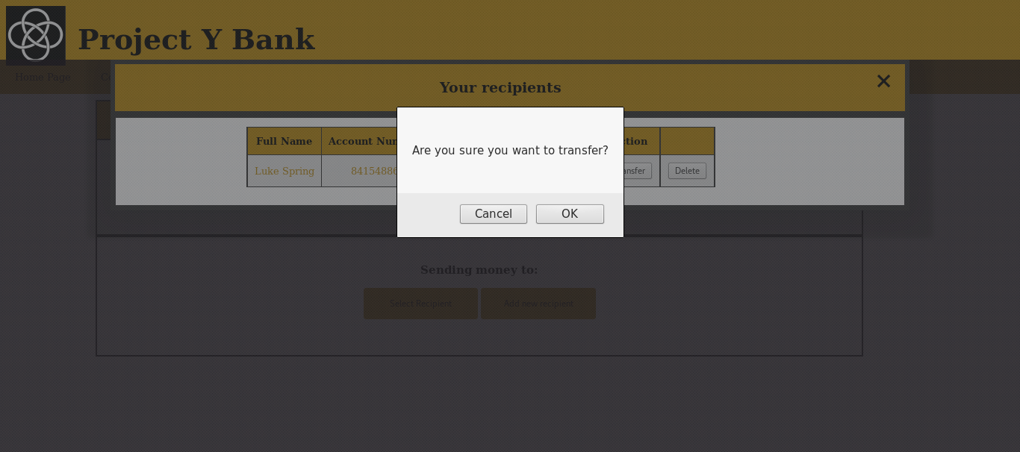

Figure 126 – Demo stage 2

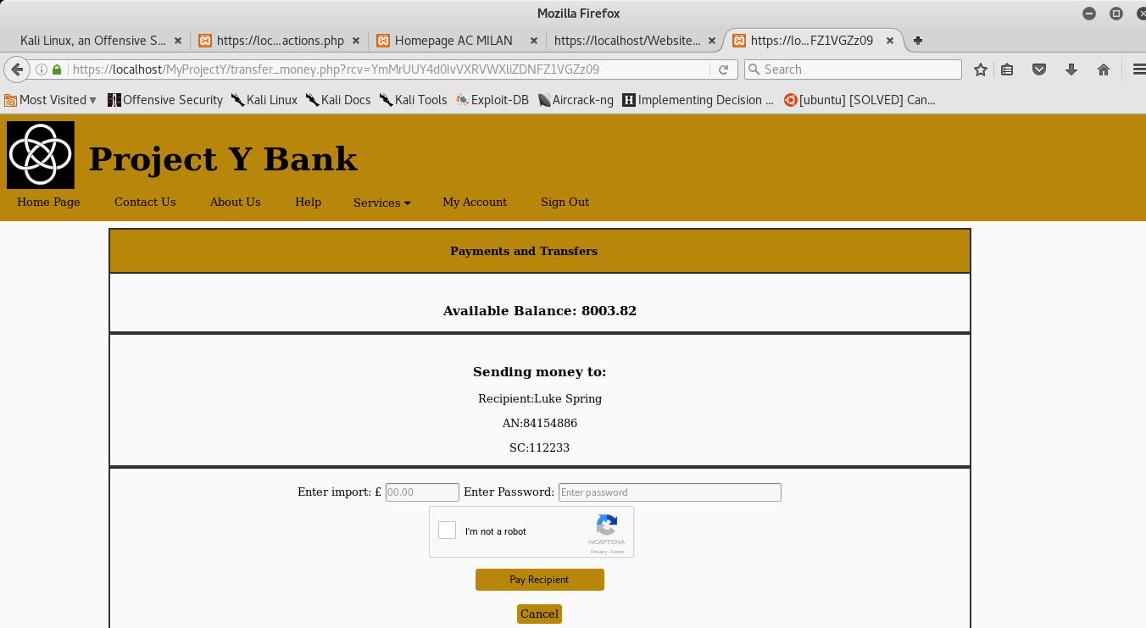

Figure 127 – Demo stage 3

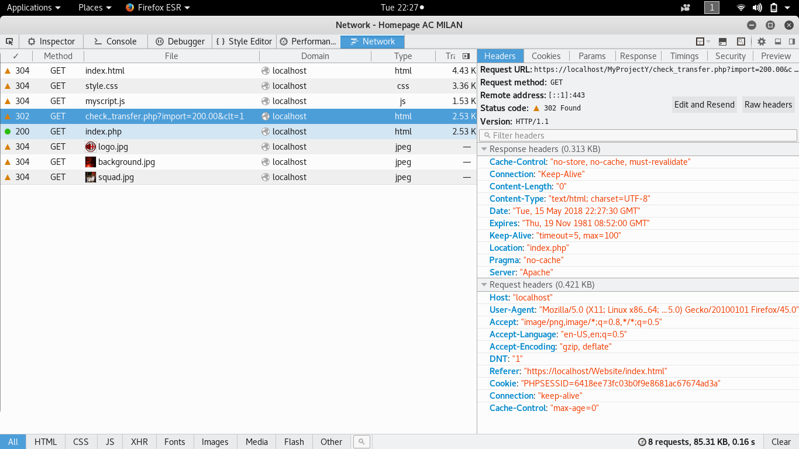

Figure 128 – Demo Failed, Status code 302

In the case scenario that an attacker is able to discover the salt and adjust his attack, it would fail because of reCAPTCHA. (Figure 129) 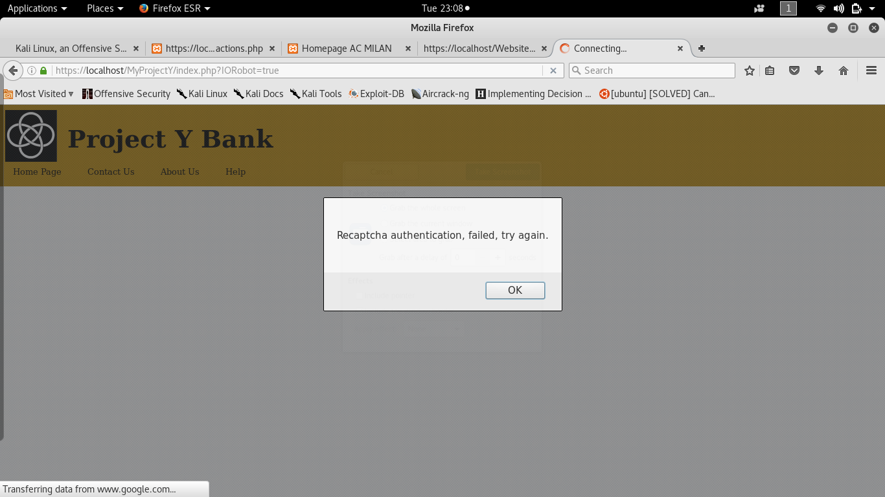

Figure 129 – Demo attack scenario2, Recaptcha failed

Firstly, because the parameters in the URL are supposed to be received encrypted as pointed out in Figure 130.

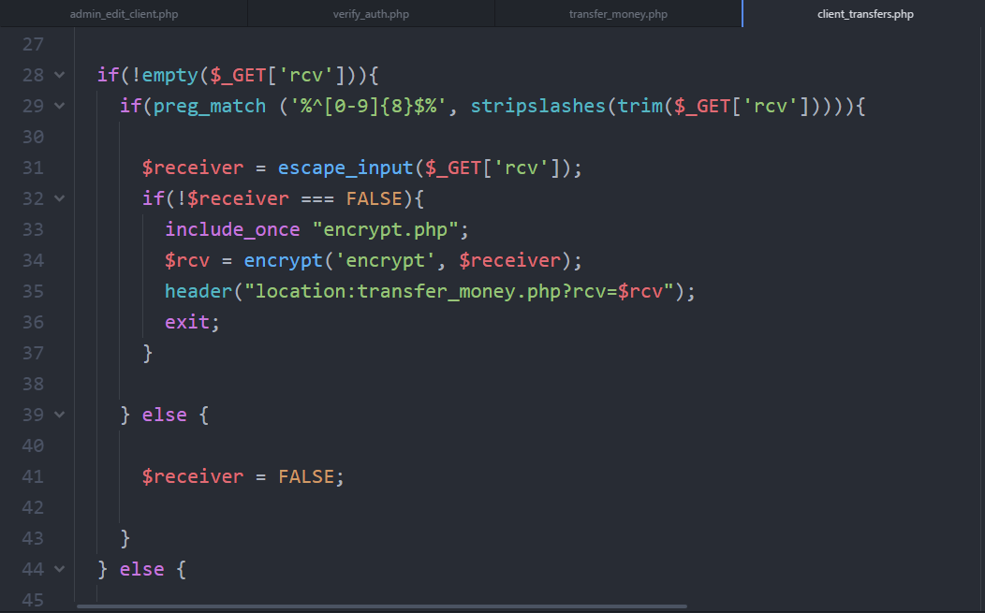

Figure 130 – Token encrypted

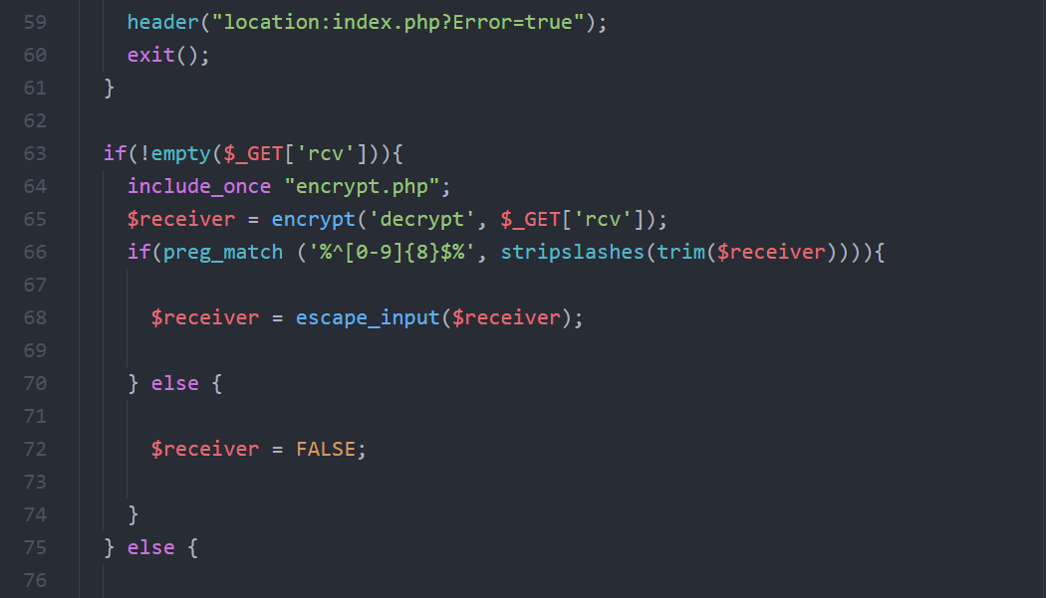

Figure 131 – Token decrypted

The function can perform encryption and decryption based on the parameter received, as it is plain to see that the parameters are encrypted with AES 256-bit key using a Cypher Block Chaining Mode (CBC).

The iv for variable is a random text string that is going to be mixed up within the string to make the cipher text more difficult to decrypt. (Figure 132)

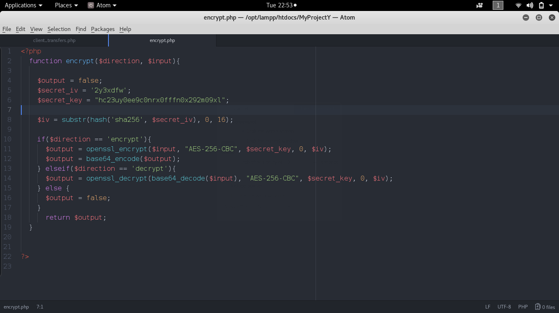

Figure 132 – encrypt/decrypt function

Another reason is the request of a password to re-authenticate the user one more time, which is going to be encrypted and compared with the cipher text stored in the database. (Figure 127)

Lastly, the use of reCAPTCHA to verify that the request is not a result of an automated action as shown in Figure 129.

In Figure 133, the API is loaded on line 141 and on line 178 we have a hidden input field which is equal to true in the file “check_transfer.php” only if the user has submitted the form of the previous page as shown in Figure 135 on line 62.

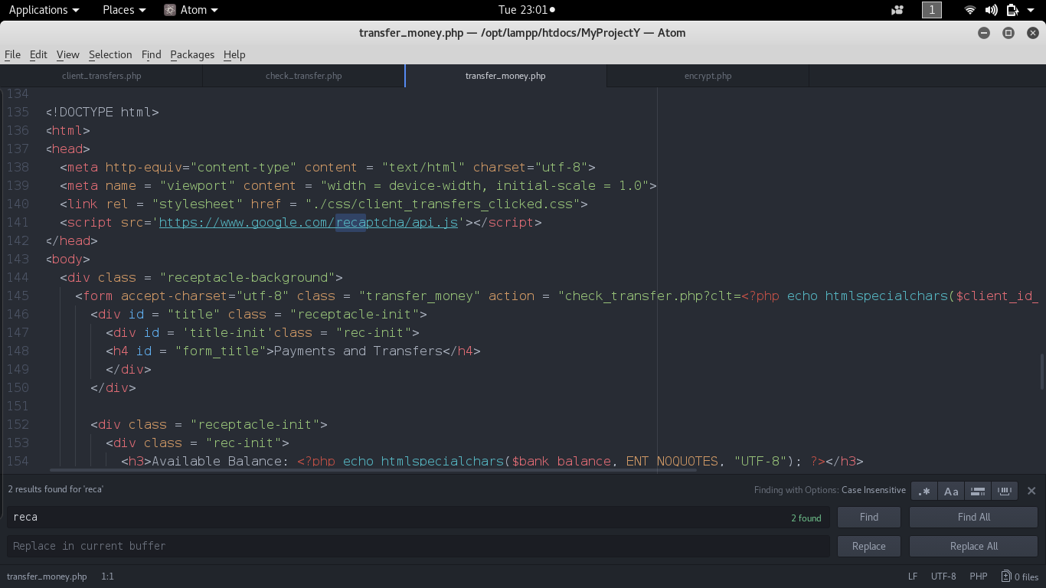

Figure 133 – Google reCAPTCHA API

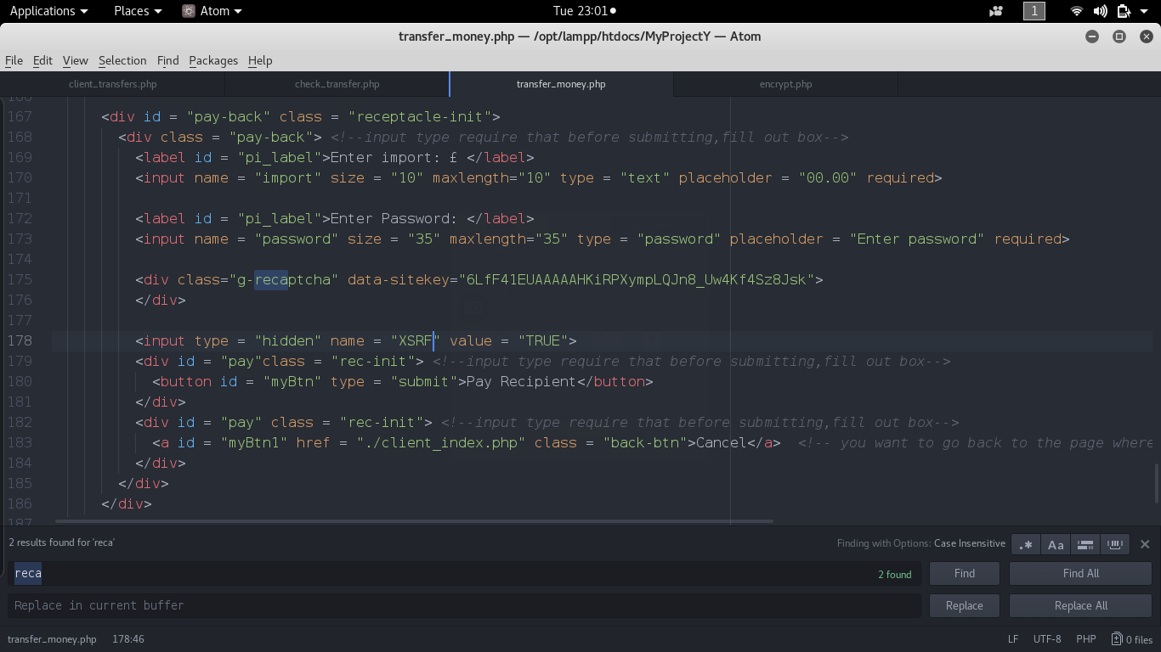

Figure 134 – Google reCAPTCHA source code

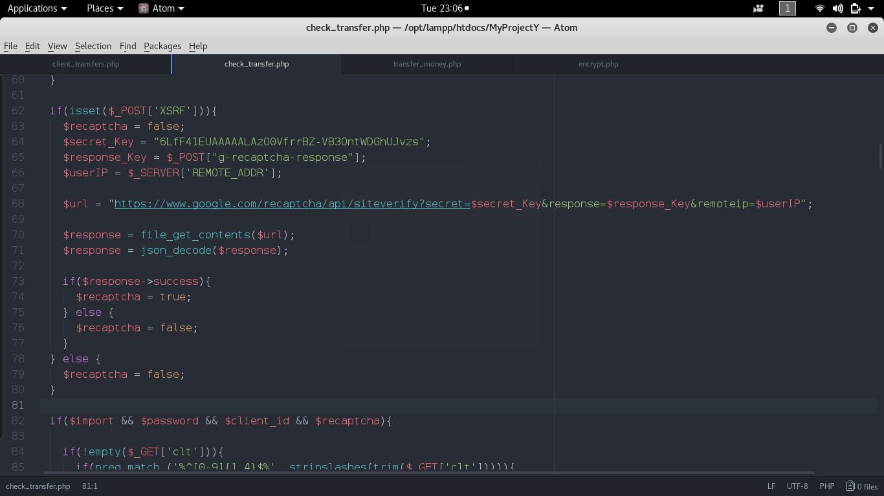

Figure 135 – Google reCAPTCHA source code 2

### 6.4 Broken Access control

It occurs when a user can access a resource in an unexpected way and the application lacks functions to verify if a specific user is authorized to retrieve that information.

#### ProjectX

A user can directly access a page by inserting the URL of a page, he does not have to be authenticated to either access resources of an administrator or client as shown in Figure 136 and 137.

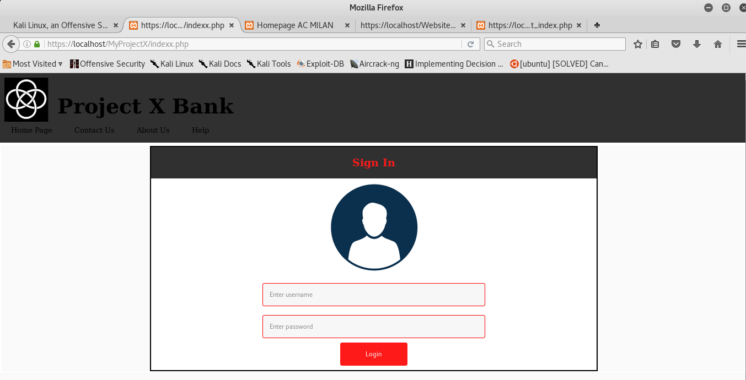

Figure 136 – Demo

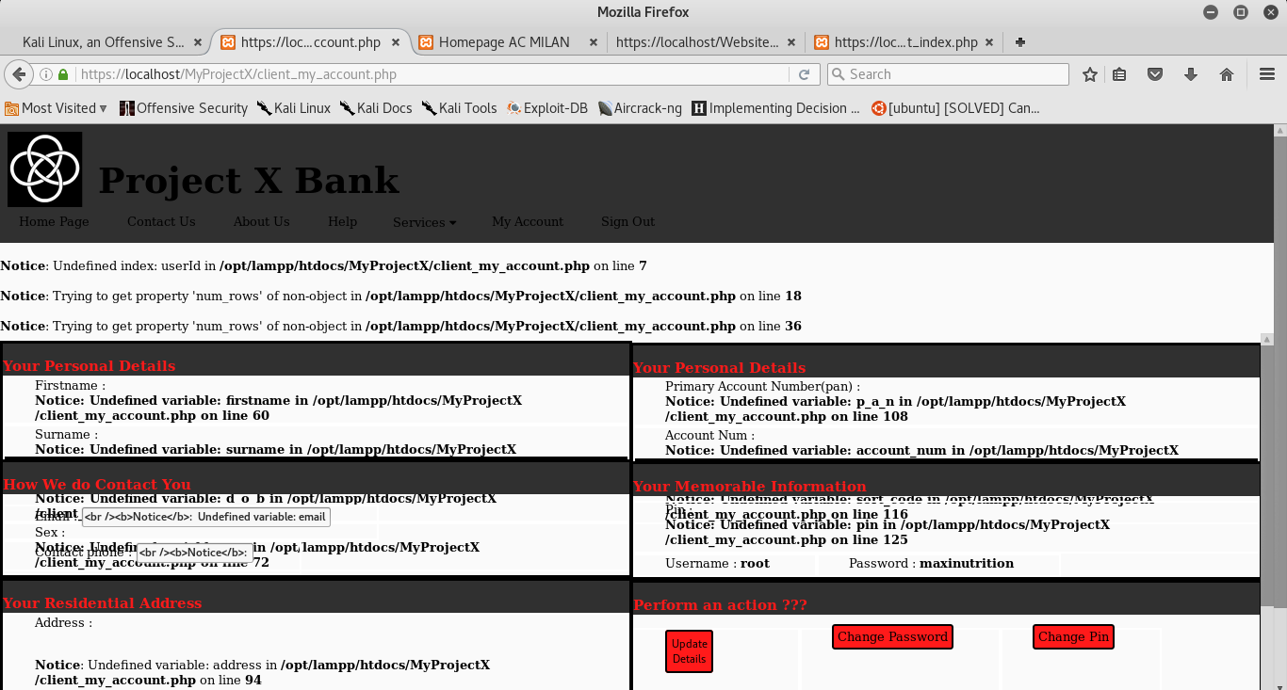

Figure 137 – Demo 2

In figure 137, errors and notices are displayed on the screen, because the user has not been authenticated.

When the application is trying to retrieve the personal details, for instance, the necessary data to query the database are non-existent.

The only data relevant to the parameters that the application could found somehow related to the empty fields are username field and the password field located in the file “connection. DB, include on line 2 of Figure 138.

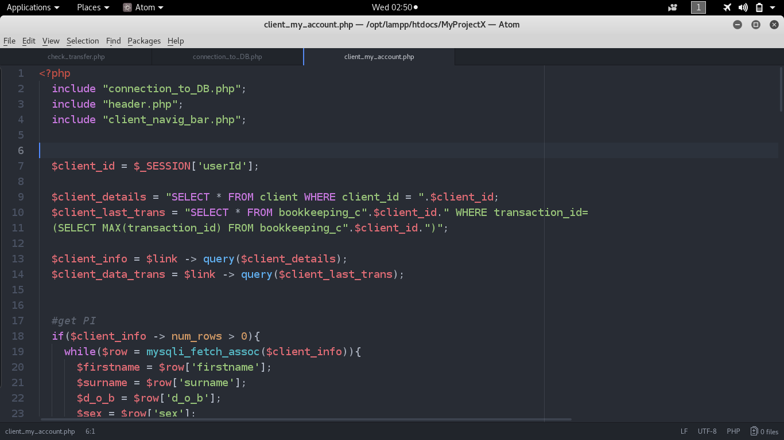

Figure 138 – Source code for the client account page

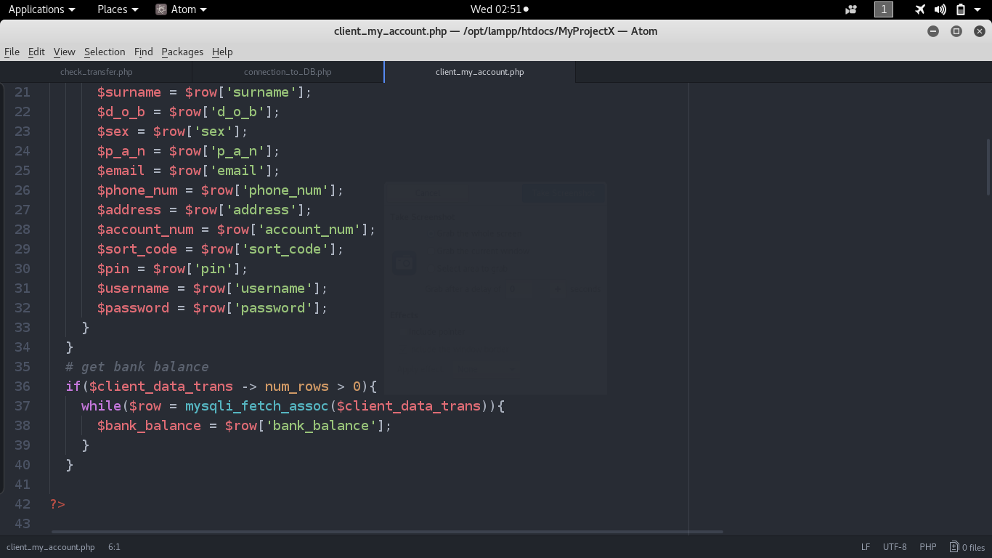

Figure 139 – Source code for the client account page 2

Another issue is that, the navigation bar can be accessed and view on the browser, which provides links to resources pertinent to an administrator account. Therefore, escalating privileges and being able to perform administrator’s actions to update user details as shown in figure BAC5-6-7 even though we have not been authenticated as the navigation bar of BAC6 show.

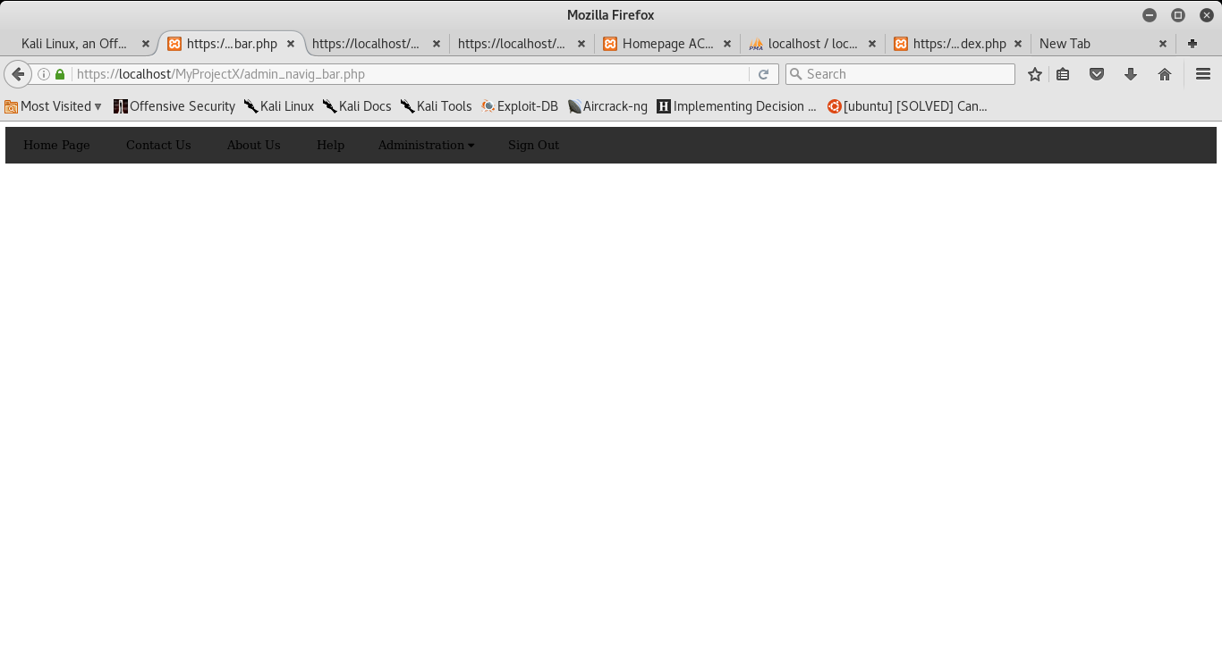

Figure 140 – Admin navigation bar

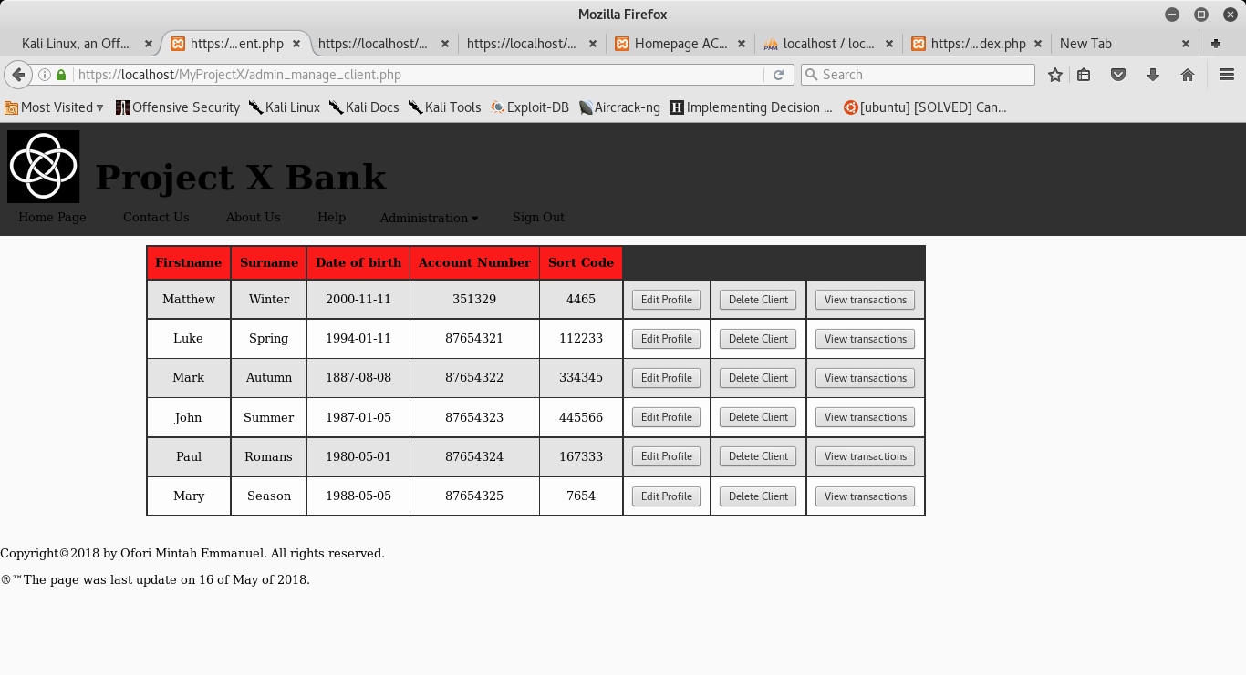

Figure 141 – Admin page to manage clients

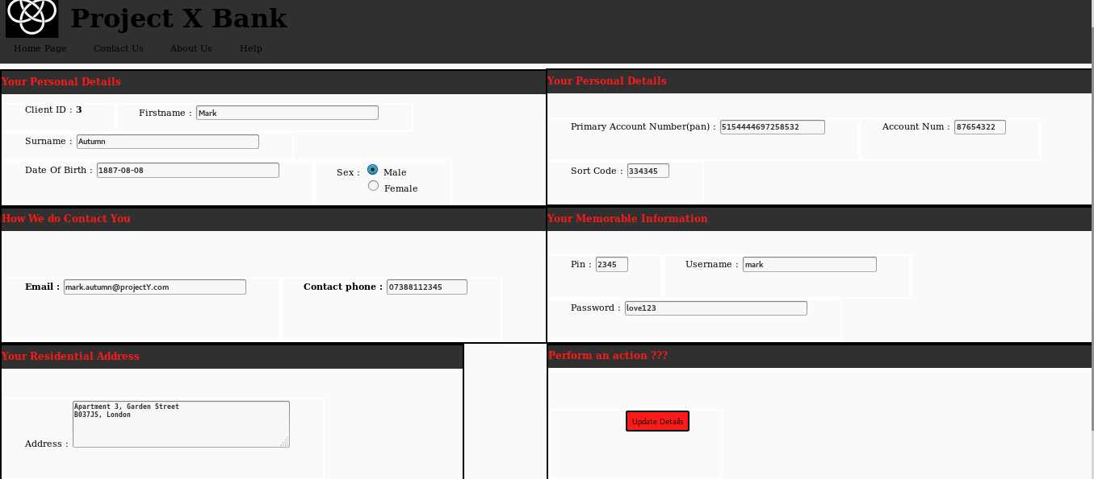

Figure 142 – Admin page to manage clients

#### ProjectY

To mitigate the risk, if and else statements were constructed to check if a user has rights to access a specific resource as shown in Figure 143 from line 10 to line 27, by firstly verifying if the user has been logged.

Secondly, by verifying if the variable named “capo” which holds a boolean value of true if the user is an admin; or false if the user is a client, to include the correct navigation bar.

In case he is not authenticated or not authorized to access a specific resource, his session is destroyed. Then he’s redirected to the login page as portrayed in 144.

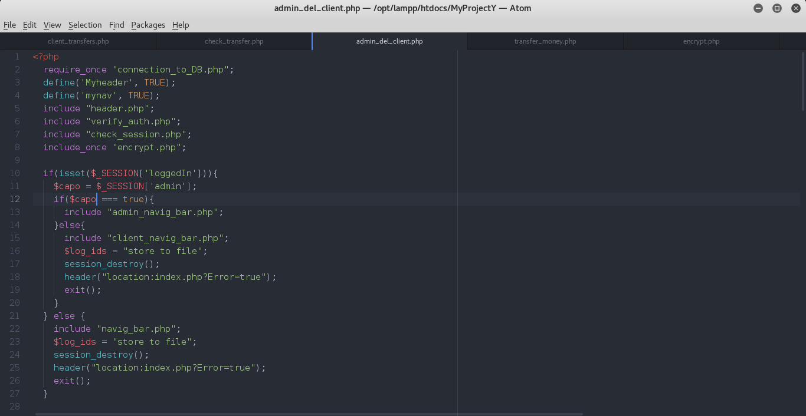

Figure 143 – Check user rights, before displaying resources

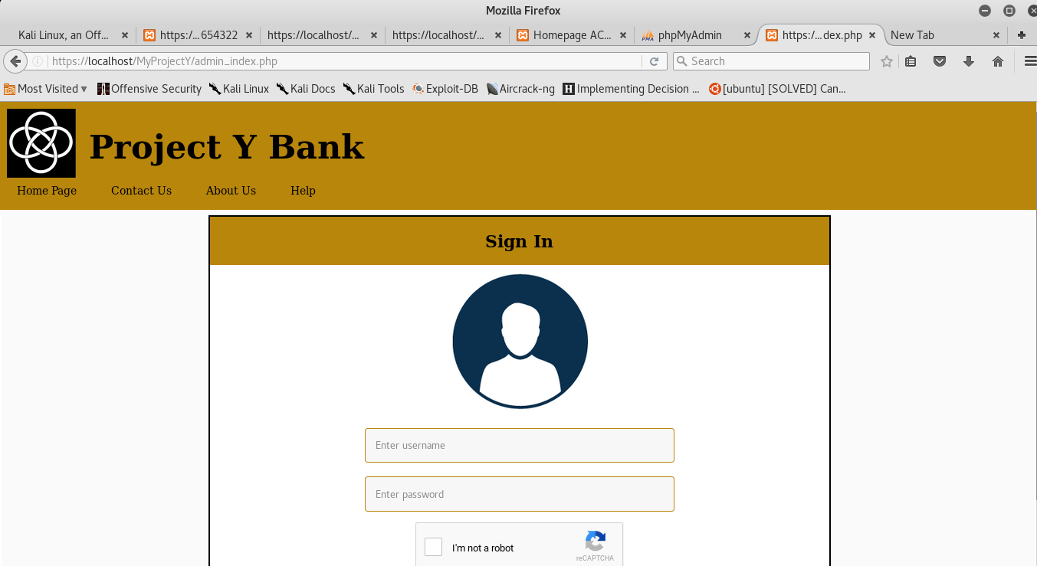

Figure 144 - Demo



Figure 145 – Demo stage 2

On line 3 and 4 of figure 146, to prevent the direct access to single php files requested through URL, have been secured, by defining constants set to true only to pages which includes them.

On attempt to escalate privileges a message will warn the user as illustrated in figure 147.

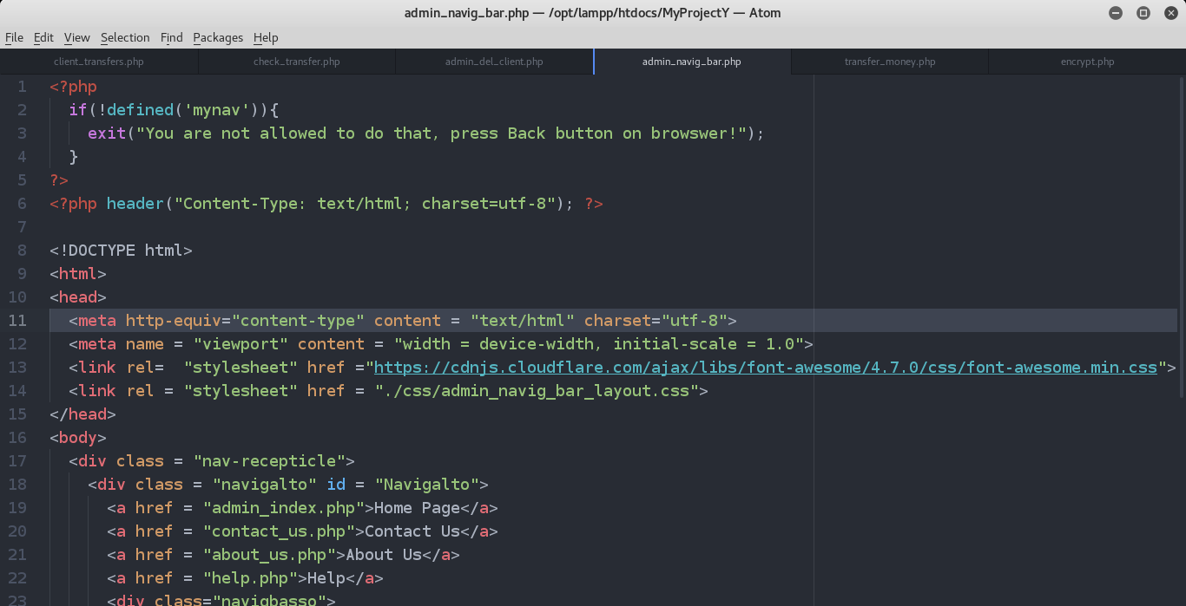

Figure 146 – Defining constants for navigation and header files.

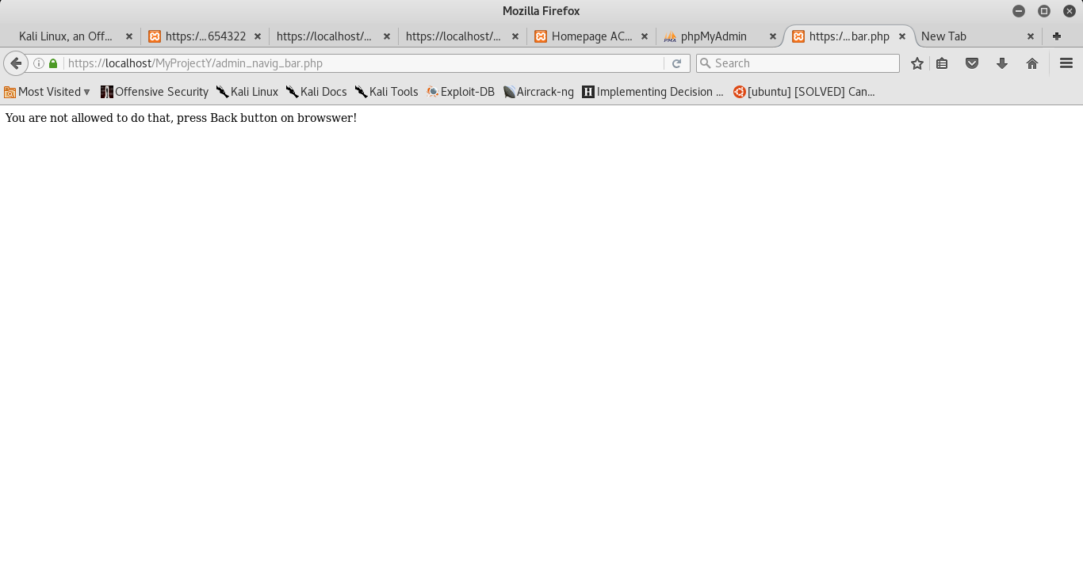

Figure 147 – failed attempt, user being warned

### 6.5 Database

#### ProjectX

The database for ProjectX contains incorrect column types. These problem causes the application to miscalculate balance transactions as illustrated in Figure 149.

Too many characters can be entered by the user and stored in the database, because the maximum length of variables are set too high. For instance, it is visible in Figure 150, the length set for a client sex is thirty characters, which would require six.

All variables except the primary key can be stored as null, this could cause errors and notices been displayed on screen. (Figure 148)

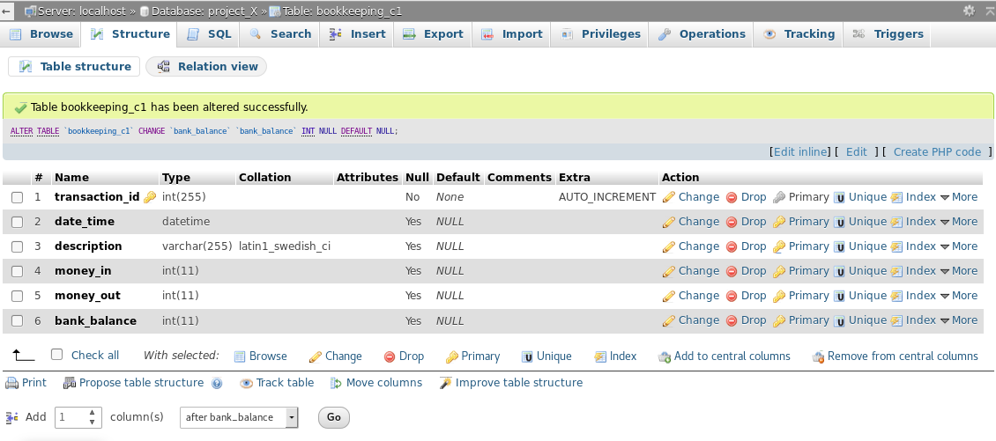

Figure 148 – Recipient table ProjectX

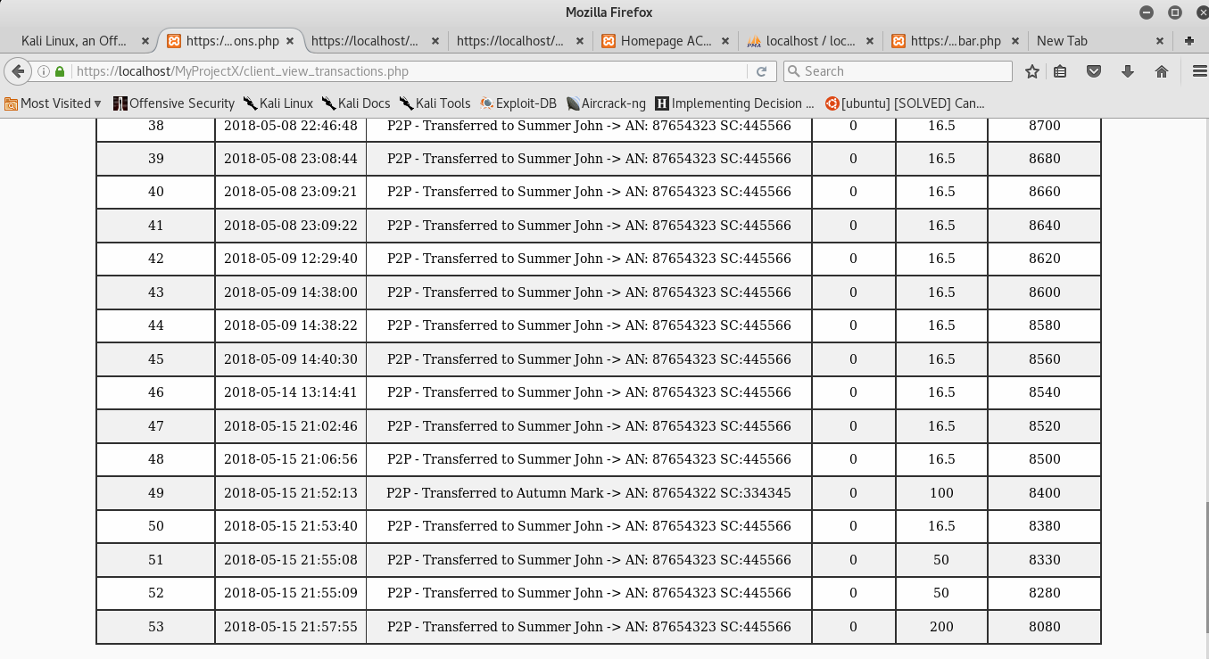

Figure 149 – Table transaction

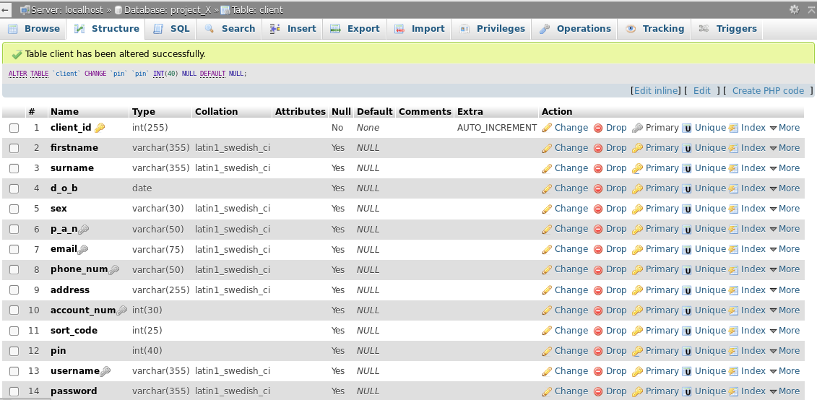

Figure 150 – Client table ProjectX

It is important to still follow the concept of the least privilege; by limiting the user input, so a malicious code, which may require lines, and lines of code would not be saved.

When a variable is received, the database will store only a substring of characters. This substring of the input characters limits the quantity being written and discards the rest.

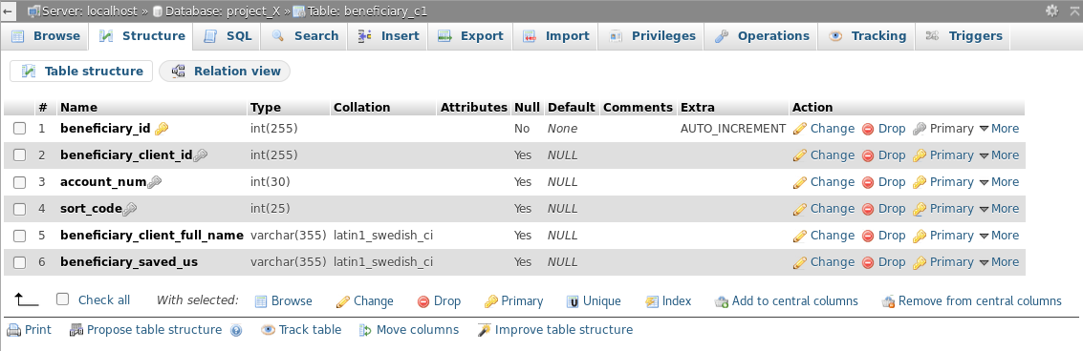

Figure 151 – Recipients table ProjectX

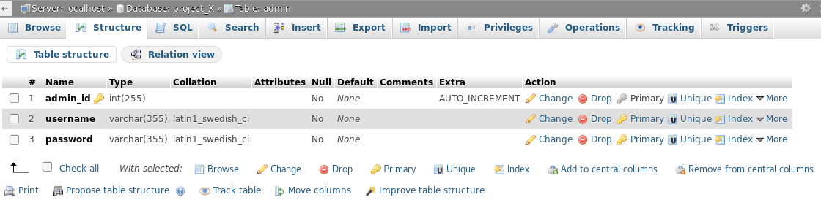

Figure 152 – Admin table ProjectX

#### ProjectY

In the database of the second prototype limits have been set to prevent issues stated in the weaker model.

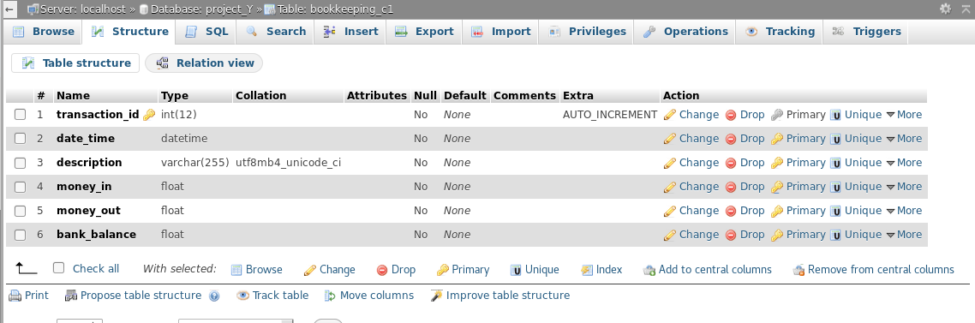

Figure 153 – Recipient table ProjectY

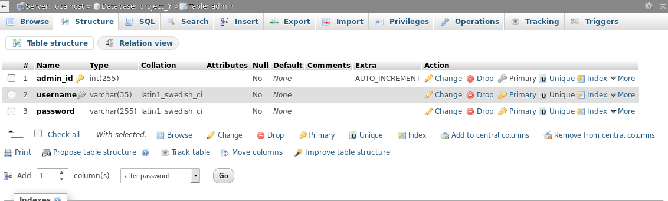

Figure 154 – Admin table ProjectY

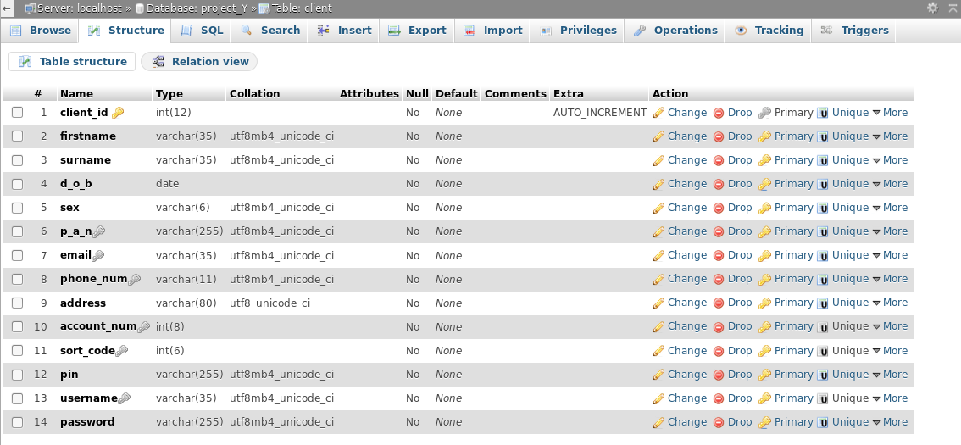

Figure 155 – Client table ProjectY

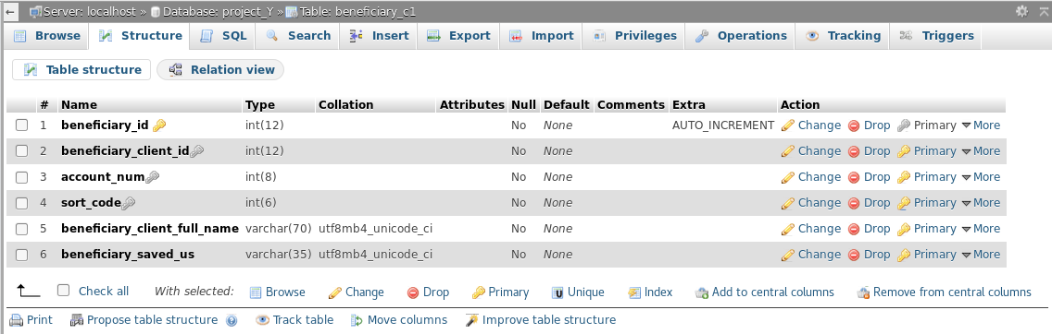

Figure 156 – Recipient table ProjectY

## 6.4 ABOUT SECURE CODING

A better way of programming with php has been applied in ProjectY.

Such as the “require_once” and “include_once” which performs the same task as require and include except before doing their function, they check if the file has already been included, if so they will not. This reduce the risk of errors such us “duplicate file included”. (Figure 157, 158)

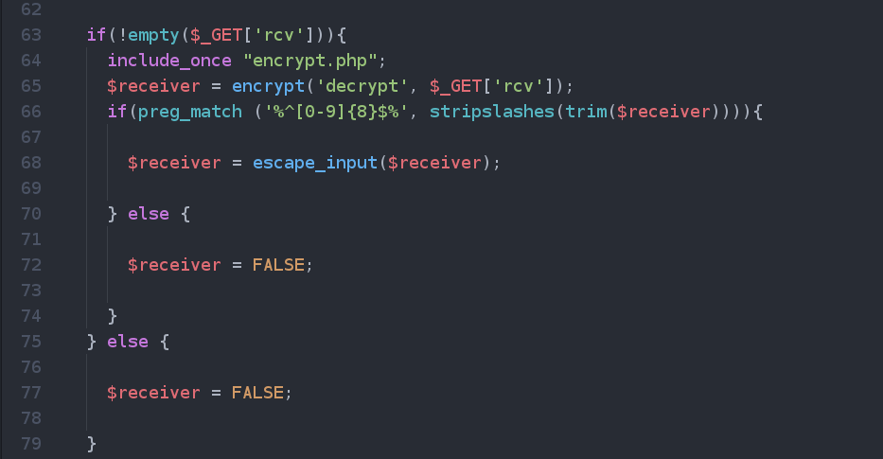

Figure – 157 Include_once

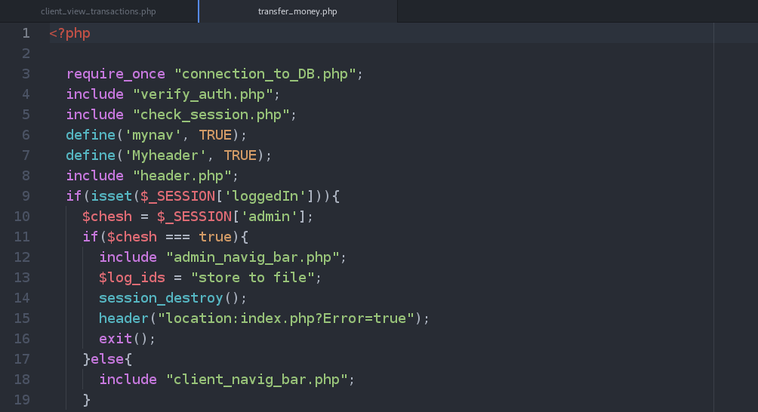

Figure 158 – Require_once

The exit command was inserted after every call made to the function header as shown in Figure 160. In the weaker prototype, the absence of that command on line 20, would not stop the script to execute, when redirecting the user into a different page, but keep executing from line 23.

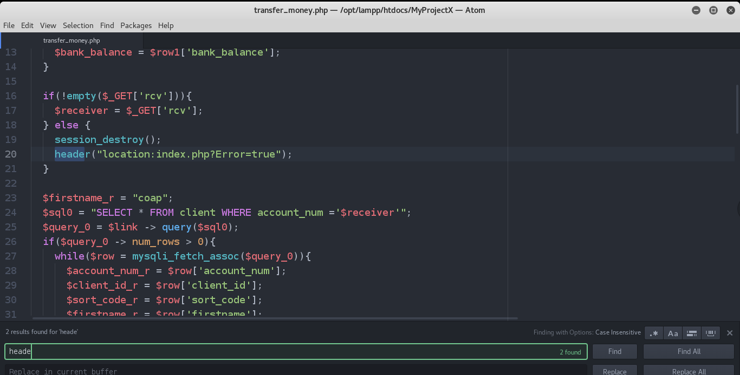

Figure 159 – Exit missing

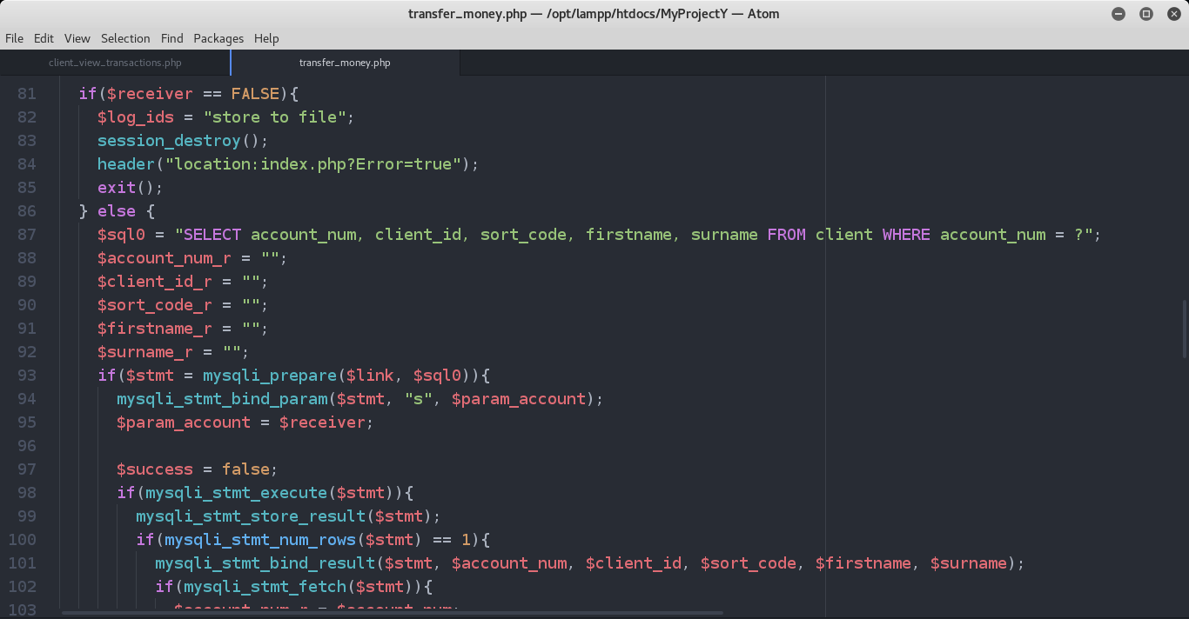

Figure 160 – Exit present

Every if and else statement has been handled properly in the protected model.

## 6.5 AUTOMATED TESTING TOOLS

An automated web application analysis tool named owasp-zap was used to just to test if the first prototype met the criteria planned, which it did.

Figure 161 and 162 shows the results.

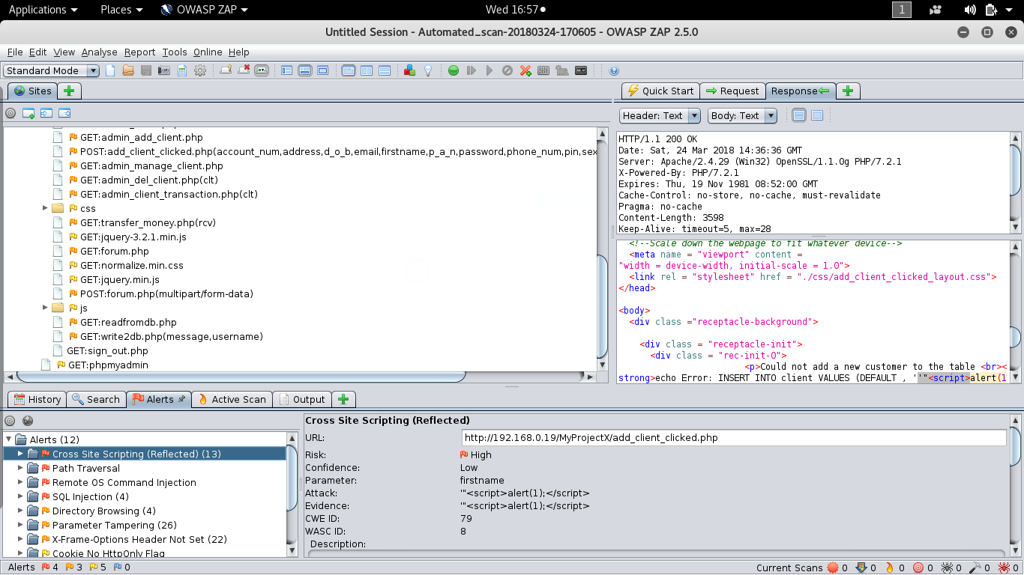

Figure 161 – Owasp Zap

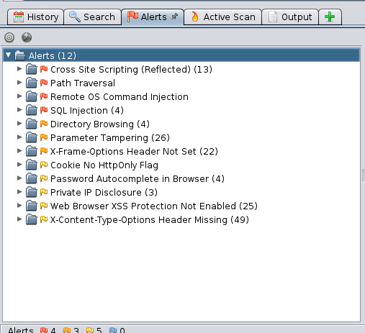

Figure 162 – Owasp Zap alerts

# Chapter 7.0: Evaluation

## 7.1 evaluation

The first prototype developed was able to demonstrate all selected vulnerabilities.

Therefore, suitable for students to deploy it as a learning tool for web application vulnerabilities.

The counter measures put in place for the protected model are strong, but not unbreakable, as to secure it is a holistic process.

The whole structure of the system conserves the CIA triad: confidentiality, integrity and availability.

ProjectY could be improved by making two different login php file to separate the clients from the administrators.

The use of POST methods instead of GET methods with parameters encrypted.

This report supplies information acquired through application security risks analysis.

It will focus on selected categories of the top 10 Owasp: Sql Injection, Cross-Site scripting, Broken Authentication and Session Management, Security Misconfiguration, Sensitive Data Exposure and Broken Access Control.

It will point up weaknesses and strengths of two similar websites, followed by the recommendation of best practices to mitigate the risks.

It includes step-by-step examples of how to exploit and rectify those vulnerabilities.

# Chapter 8.0: CONCLUSION

## 8.1 Conclusion

This report covered web application vulnerabilities.

It looked at the diverse thoughts and methodologies, to help the reader interested in learning about web security flaws, but does not have no knowledge or experience in demonstrating selected vulnerabilities of the top 10 Owasp.

This report explained bit-by-bit how to identify, exploit and address Sql Injection, Cross-Site Scripting, Broken Authentication and Session Management, Security Misconfiguration, Sensitive Data Exposure and Broken Access Control vulnerabilities.

# REFERENCES

[Swati Khandelwal](https://thehackernews.com/2018/04/linkedin-account-hack.html#author-info) (2018) [Flaw in LinkedIn AutoFill Plugin Lets Third-Party Sites Steal Your Data](https://thehackernews.com/2018/04/linkedin-account-hack.html).

The Hacker News. Available at: https://thehackernews.com/2018/04/linkedin-account-hack.html

[Accessed 12/05/2018]

Rene Millman & Danielle Correa (2016) Security researchers defeat reCAPTCHA. SC Media UK. Available at: https://www.scmagazineuk.com/security-researchers-defeat-recaptcha/article/531691/

[Accessed 12/05/2018]

OWASP, Security Affairs (2017). *2017 OWASP Top 10*. [image] Available at: http://securityaffairs.co/wordpress/57938/hacking/2017-owasp-top-10.html

[Accessed 12/05/2018]

Sushila Madan & Supriya Madan (2010) Security Standards Perspective to Fortify Web Database Applications from Code Injection Attacks. IEEE Conference Publication, Available at: <http://ieeexplore.ieee.org/stamp/stamp.jsp?arnumber=5416091> [Accessed 13 December 2017]

Linghuan Xiao, Shinichi Matsumoto & Tomohisa Ishikawa (2016) SQL Injection Attack Detection Method Using Expectation Criterio. IEEE Conference Publication, Available at: <http://ieeexplore.ieee.org/stamp/stamp.jsp?arnumber=7818686>

Amit Banchhor &Tushar Vaidya (2015) SQL INJECTION: SURVEY PAPER. International Journal of Advanced Technology in Engineering and Science, Volume No 03, Special Issue No. 01, pp.225-226-227-228.

Hsiu-Chuan Huang, Zhi-Kai Zhang & Hao-Wen Cheng (2017) Web Application Security: Threats, Countermeasures, and Pitfalls. Available at:<http://ieeexplore.ieee.org/stamp/stamp.jsp?arnumber=7945157> [Accessed 13 December 2017]

Sruthi Bandhakavi (2011) Automated detection of injection vulnerabilities in web applications.

Available at: <https://www.ideals.illinois.edu/bitstream/handle/2142/29471/Bandhakavi_Sruthi.pdf?sequence=1&isAllowed=y> [Accessed 14 December 2017]

William G.J. Halfond and Alessandro Orso (2005) AMNESIA: Analysis and Monitoring for

Neutralizing SQL-Injection Attacks. Available at: <http://citeseerx.ist.psu.edu/viewdoc/download?doi=10.1.1.89.6224&rep=rep1&type=pdf> [Accessed 13 December 2017]

Rahul Shrivastava, Joy Bhattacharyji & Roopali Soni (2012) SQL INJECTION ATTACKS IN DATABASE USING WEB SERVICE: DETECTION AND PREVENTION –REVIEW. Available at:<http://www.innovativejournal.in/index.php/ajcsit/article/viewFile/301/289> [Accessed 13 December 2017]

William G.J. Halfond and Alessandro Orso (2005) Combining Static Analysis and Runtime Monitoring to Counter SQL-Injection Attack. Available at: https://pdfs.semanticscholar.org/fd6d/b27cb5bb730db74822decd1c84612197c9fc.pdf

[Accessed 13 December 2017]

Gregory T. Buehrer, Bruce W. Weide & Paolo A. G. Sivilotti (2005) UsingParse Tree Validation to Prevent SQL Injection Attacks. Available at:

<ftp://ftp.cse.ohio-state.edu/pub/tech-report/2005/TR38.pdf> [Accessed 13 December 2017]

M.Amutha Prabakar, M.KarthiKeyan & K. Marimuthu (2013) An Efficient Technique for Preventing SQL Injection Attack Using Pattern Matching Algorithm. Available at:

<http://ieeexplore.ieee.org/stamp/stamp.jsp?arnumber=6528551> [Accessed 13 December 2017]

Swapnil Kharche, Jagdish patil, Kanchan Gohad & Bharti Ambetkar (2015) preventing sql injection attack using pattern matching algorithym. Available at: <https://arxiv.org/pdf/1504.06920.pdf>

[Accessed 13 December 2017]

Sampada Gadgil, Sanoop Pillai & Sushant Poojary (2013) SQL INJECTION ATTACKS AND PREVENTION TECHNIQUES. Available at: <http://www.ijritcc.org/download/IJRITCC_1357.pdf>

[Accessed 13 December 2017]

Indrani Balasundaram & E.Ramaraj (2011) An Efficient Technique for Detection and Prevention of SQL Injection Attack using ASCII Based String Matching. Available at: <https://ac.els-cdn.com/S1877705812008600/1-s2.0-S1877705812008600-main.pdf?_tid=92ac015a-e3ca-11e7-b922-00000aab0f01&acdnat=1513584664_7362919a4bdd377cdaaa787219d793d7>

[Accessed 13 December 2017]

Hussein Alnabulsi, Rafiqul Islam & Quazi Mamun (2014) Detecting SQL Injection Attacks Using SNORT IDS. Available at:

<http://ieeexplore.ieee.org/stamp/stamp.jsp?arnumber=7053873>

[Accessed 13 December 2017]

Abdelhamid Makiou, Youcef Begriche, Ahmed Serhrouchni (2014) Improving Web Application Firewalls to detect advanced SQL injection attacks. Available at: <http://ieeexplore.ieee.org/stamp/stamp.jsp?arnumber=7064617>

[Accessed 13 December 2017]

Daniel Huluka & Oliver Popov (2012) Root Cause Analysis of Session Management and

Broken Authentication Vulnerabilities. Available at:<http://ieeexplore.ieee.org/stamp/stamp.jsp?arnumber=6280203>

[Accessed 13 December 2017]

Ossama B. AlKhurafi & Mohammad A. AlAhmad (2015) Survey of Web Application Vulnerability Attacks. Available at: <http://ieeexplore.ieee.org/stamp/stamp.jsp?arnumber=7478735>

[Accessed 13 December 2017]

Google (2017) What is reCAPTCHA?

Available at: <https://developers.google.com/recaptcha/>

[Accessed 13 December 2017]

Mary-Ann Russon (2017) Artificial intelligence smart enough to fool Captcha security check.

Available at: <http://www.bbc.co.uk/news/technology-41775968> [Accessed 13 December 2017]

Vikas K. Malviya, Saket Saurav & Atul Gupta (2013) On Security Issues in Web Applications through Cross Site Scripting (XSS). Available at: <http://ieeexplore.ieee.org/stamp/stamp.jsp?arnumber=6805456> [Accessed 13 December 2017]

Abdalla Wasef Marashdih & Zarul Fitri Zaaba (2017)Detection and Removing Cross Site Scripting Vulnerability in PHP Web Application. Available at: <http://ieeexplore.ieee.org/stamp/stamp.jsp?arnumber=8109033> [Accessed 13 December 2017]

ikas K. Malviya, Saket Saurav & Atul Gupta (2013) On Security Issues in Web Applications through Cross Site Scripting (XSS). Available at: <http://ieeexplore.ieee.org/document/6805456/>

[Accessed 13 December 2017]

William Robertson & Giovanni Vigna (2009) Static Enforcement of Web Application Integrity Through Strong Typing. Available at: <https://www.usenix.org/legacy/event/sec09/tech/full_papers/robertson.pdf>

[Accessed 13 December 2017]

Prithvi Bisht &V.N. Venkatakrishnan (2008) XSS-GUARD: precise dynamic prevention of cross-site scripting attacks. Available at: <http://citeseerx.ist.psu.edu/viewdoc/download?doi=10.1.1.216.3229&rep=rep1&type=pdf> [Accessed 13 December 2017]

Shadab Siddiqui (2011) Cross Site Request Forgery: A common web application weakness. Available at: <http://ieeexplore.ieee.org/stamp/stamp.jsp?arnumber=6014783> [Accessed 13 December 2017]

P. Samarati & S. De Capitani (2001) Access Control: Policies, Models, and Mechanisms. Available at: <https://security1.win.tue.nl/~zannone/teaching/CS4080/Material/sam-fosad.pdf> [Accessed 13 December 2017]

OWASP (2017) OWASP Top 10 2017. Available at: <https://www.owasp.org/images/b/b0/OWASP_Top_10_2017_RC2_Final.pdf> [Accessed 13 December 2017